VMware Pro Cloud Service for Private Cloud Infrastructure - VMware VCF Automation Standard Operating Procedures 9.x

You can find the most up-to-date technical documentation on the VMware website at:
https://docs.vmware.com/
Broadcom®
3421 Hillview Ave.
Palo Alto, CA 94304
www.vmware.com
Copyright© 2026 Broadcom® All rights reserved. Copyright and trademark information.
Contents
1. Getting Started with the Tools for Building Applications 4
Getting Started with the Self-Service Catalog in VCF Automation 5
Request an Item from the Catalog in VCF Automation for All Apps 6
Request an Item from the Catalog in VCF Automation for VM Apps 11
2. Provision and Manage Virtual Machines 106
Provision a VM Using Self-Service 106
Deploying and Managing Virtual Machines in vSphere Supervisor 108
Creating and Managing Content Libraries for Stand-Alone VMs in vSphere Supervisor 111
Working with VM Classes in vSphere Supervisor 122
Create and Manage VM Classes Using the Data Center CLI 128
Deploying a Stand-Alone VM in vSphere Supervisor 133
Deploying a VM with vGPU and Other PCI Devices in a Supervisor 138
Deploying a VM with Instance Storage in vSphere Supervisor 143
Deploy VMs with Configurable OVF Properties in vSphere Supervisor 149
Import VMs into vSphere Supervisor 151
Monitor Virtual Machines Available in vSphere Supervisor 152
Troubleshoot VMs Using the vSphere VM Web Console 153
3. References 155
References 155

Getting Started with the Tools for Building Applications
Use VCF Automation to provision VMs, Kubernetes workloads and other cloud services by using self-service UI, API, and CLI. The Local Consumption Interface provides an alternative for access to vSphere Supervisor services for users who do not have access to VCF Automation.

Building Applications with VCF Automation
VCF Automation supports two distinct organization types, All Apps organizations and VM Apps organizations, which have different consumption mechanisms. What you can do in VCF Automation depends on your organization membership.
VCF Automation for All Apps provides a user-friendly interface for consuming infrastructure resources as a service, including Kubernetes and other infrastructure components. If you are a member of an All Apps organization in VCF Automation, you have two ways to provision infrastructure:
- Self-service catalog. The catalog in VCF Automation for All Apps is the self-service interface where you can provision workloads from blueprints and other objects that the organization administrator curated and published for you. Blueprints contain resources that can be nested, for example, a blueprint can contain a VM inside a vSphere namespace. See Request an Item from the Catalog in VCF Automation for All Apps.
- IaaS Services. VCF Automation gives you access to modern services enabled by vSphere Supervisor and cloud native applications. You can provision resources including VMs, Kubernetes, volumes, storage, load balancers and networking objects, without involvement from your administrator. See Access the IaaS Services Console or Local Consumption Interface.
Both catalog and services deployments support day 2 operations on workloads and services.
In VCF Automation for VM Apps organizations you deploy catalog items from the VCF Automation for VM Apps self-service catalog. The catalog in VCF Automation for VM Apps is a self-service portal for users to request and manage IT resources from various cloud providers, both private clouds (VMware vSphere) and public clouds (GCP, AWS, Azure), independently through the catalog interface. See Request an Item from the Catalog in VCF Automation for VM Apps.
Catalog items in VCF Automation for VM Apps are pre-configured templates that users can deploy, such as virtual machines, cloud templates, and other infrastructure components. The catalog items are provided to you by your administrator. The items that are available to you and your options at deployment time depend on your project membership.
Important VCF Automation for VM Apps does not support IaaS services.

Building Applications with the Local Consumption Interface
The Local Consumption Interface provides an alternative interface to allow access to modern services enabled by enabled by vSphere Supervisor and cloud native applications. Users can provision resources including VMs, Kubernetes, volumes, storage, load balancers and networking objects, without administrator involvement.
The Local Consumption Interface is a vSphere Supervisor service. It can be made available in environments without access to VCF Automation, such as vSphere Foundation. For more information on installing and configuring the Local Consumption Interface, see Using the Local Consumption Interface.

Getting Started with the Self-Service Catalog in VCF Automation
As a consumer, you use VCF Automation to deploy IT resources using a self-service catalog and then manage your workloads and run day-2 actions like updates and patches independently.

What is the VCF Automation Catalog
The VCF Automation catalog is the streamlined user interface that you use to request and deploy infrastructure on a self-service basis. Catalog items include VCF Automation blueprints, VM images, storage, networks, and so on, that you can request for deployment.
The catalog items are provided to you by your organization administrator. The items that are available to you depend on your project membership. At request time, the information that you must provide depends on how the item was configured by your administrator. When you deploy an item, it is provisioned based on the infrastructure available to the selected project. Projects also determine your options at deployment time.

How does the catalog work
The catalog is the simplified user interface that organization administrators make available to users when the administrator's teams do not need full access to developing and building the blueprints. You use the catalog to deploy blueprints to namespaces associated with projects in the organization.
To provide the blueprints, the organization administrator creates blueprints and configures content libraries, which are collections of VM images, and then publishes these items to the catalog.
- Blueprints are associated with projects. Projects link a set of users with one or more target cloud regions.
- For example, UserA is a member of ProjectA and ProjectB, but not ProjectC. UserA sees only the blueprints that were entitled to ProjectA and ProjectB.
When users request a catalog item, where it is deployed depends on the project selected. Projects might have one or more namespaces.
- If UserA and UserB are members of ProjectA, they see the blueprints as catalog items. At deployment time they can deploy to ProjectA, which determines which namespace the catalog item is deployed to.
The availability of the catalog items is determined by project membership. Projects link users, catalog items, and IaaS resources where the items are deployed. The Build & Deploy tab provides a single point for VCF Automation consumers to access their catalog, deployed instances, and available resources.
After a successful request, your users can then manage their deployments by running actions, including dismiss or delete.

Who works with the catalog
- Provider or organization administrators can create blueprints across all vCenter instances and publish them to the catalog.
- Organization administrators manage the catalog within the organization. They can share blueprints with projects within their organization.
- Application team members request and consume the content in the catalog.

Which catalog do I have
Depending on the VCF Automation environment you have access to, your view of the Catalog might look differently. For example, if you are a member of a VM Apps organization in VCF Automation, you access your catalog and deployments on the Consume tab, where in All Apps organizations, you access the catalog and deployed catalog instances on the Build & Deploy tab.

Request an Item from the Catalog in VCF Automation for All Apps
The catalog in VCF Automation for All Apps contains blueprints, VM images, and other infrastructure objects you can request for deployment. At request time, the information that you must provide or configure depends on how the blueprint was designed by the organization administrator. When you deploy an item, it is provisioned based on the namespaces that are associated with your project.

Using the filter and search to locate a catalog item
Depending on your company goals and project members, the catalog available to you can be extensive. You can use the following tools to locate a catalog item.
- Search. Enter a search term.
- Filter. Opens the left panel where you can filter by content type and projects.
- Sort. If the list is still too long, you can sort in ascending or descending order.

Procedure
The information provided in this article is general because each catalog item is unique. The variation depends on how the blueprint and other items were constructed, including what variables are made available to you at request time.
- Log in to VCF Automation.
- Click the Build and Deploy tab.
- Click Catalog.
The available catalog items are available to you based on the project your selected. If you didn't select a project, all catalog items that are available to you appear in the Catalog.
- Locate the catalog item you plan to deploy.
You can use the filter, search, or sorting options to find the catalog item.
- Click Request.
- Provide any required information.
  - If the catalog item has more than one released version, select the version that you want to deploy.
  - At minimum, you must provide a deployment name and select a project and a namespace for your deployed catalog instance.
The project list includes projects that you are a member of. The namespace list includes namespaces associated with the project you selected.
  - The request form might have other options that you must configure, depending on how the catalog item was designed.
- Click Submit.
The provisioning process begins and the Catalog tab on the Instances page opens with your current request at the top.

Managing Deployed Instances in VCF Automation for All Apps
You use the Instances page in VCF Automation for All Apps to view and manage all resources that are managed within the organization. Resources include virtual machines, Kubernetes clusters, and other custom resources. You can manage, search, filter, and discover these resources across projects and namespaces.

Working with instances
To view your resources, select Build and Deploy > Instances.
The Instances page supports the following resources:
- The Catalog tab
- Virtual Machines
- Kubernetes Clusters
- Volumes
- Custom Resources

Using the filter and search to locate a resource
Depending on your company goals and project membership, the list of resources available to you can be extensive. You can use the following tools to locate a resource.
- Search. Enter a search term.
- Sort. If the list is still too long, you can click on a column heading to sort in ascending or descending order.
- Filter. Opens the left panel where you can filter by resource type and other criteria. Available on the Catalog page only.

Managing Deployed Catalog Instances in VCF Automation for All Apps
The Catalog list on the Instances page includes catalog instances, where each instance can contain multiple resources of different types created from blueprints.

What are catalog instances
You use the Instances > Catalog page to manage your deployed catalog items and the associated resources, making changes to deployments, troubleshooting failed deployments, making changes to the resources, and destroying unused deployments.
The deployments are the provisioned instances of catalog items, blueprints, and resources. If you manage a small number of deployments, the deployment cards provide a graphical view for managing them. If you manage a large number of deployments, the deployment list and the resource list provide more a more robust management view.
To manage your catalog deployments, select Build & Deploy > Instances > Catalog.

Working with deployment cards and the deployment list
You can locate and manage your deployments using the card list. You can filter or search for specific deployments, and then run actions on those deployments.
- Filter your requests based on attributes.
For example, you can filter based on owner, projects, lease expiration date, or other filtering options. Or you might want to find all the deployments for two projects with a particular tag. When you construct the filter for the projects and tag example, the results conform to the following criteria: (Project1 OR Project2) AND Tag1.
The values that you see in the filter pane depend on the current deployments that you have permission to view or manage.Most of the filters and how to use them are relatively obvious. Additional information about some of these filters is provided below.
- Search for deployments based on keywords or requester.
- Sort the list to order by time or name.
- Switch between the deployment card and the deployment grid views.
- Run deployment-level actions on the deployment, including deleting unused deployments to reclaim resources.

Monitoring Deployed Catalog Instances in VCF Automation for All Apps
You monitor VCF Automation deployment requests to ensure that the resources are provisioned, that the provisioned resources are running, and to resize or destroy the resources as needed.

Monitoring your request status
The deployment cards that appear on the Instances page show the state of the deployment, including in-progress (top) and completed (below). The card includes the number of deployed resources, how long it has been deployed, and the lease expiration date.
The cards also provide the IP addresses and the actions that you can run on the deployment.
If an approval policy is triggered for your request, you might see the request in an in progress state with the name of at least one approver. Approval policies are defined by your organization administrator. The approvers are defined in the policy. The approvers approve requests using an Approvals tab. You might also encounter approvals on day 2 actions.
If a deployment fails, the cards show the error message for the point of failure and the process progress. To learn more about the failure, click the deployment name at review the History tab.

Where are resources deployed
To access your successfully provisioned deployments, you might need more than the IP address provided on the card. Click the deployment name and review the deployment details on the Topology tab.
You most likely need the IP address for the primary component. As you click on each component, notice the information that is provided is specific to that component.
The availability of the external link depends on the cloud provider. Where it is available, you must have the credential on that provider to access the component.

Tracking deleted deployments
After you delete a deployment, you might want to see a list or review the history of a particular deployment.
To view your deleted deployments, click the filter on the Instances page, and then turn on Deleted Deployments Only toggle. The list of deployments is now limited to those that are deleted.
If you need the name of delete machines, you can look at the history to retrieve the information.
The deleted deployments are available for 90 days.

Troubleshooting failed deployments
Your deployment request might fail for many reasons. It might be due to network traffic, a lack of resources on the target namespace, or a flawed deployment specification. Or, the deployment succeeded, but it does not appear to be working. You can examine your deployment, review any error messages, and determine whether the problem is the environment, the requested workload specification, or something else.
You use this workflow to begin your investigation. The process might reveal that the failure was due to a transient environmental problem. Redeploying the request after verifying the conditions have improved resolves this type of problem. In other cases, your investigation might require you to examine other areas in detail.
- To determine if a request failed, select Instances > Catalog and locate the deployment card.
Failed deployments are indicated on the card.
  - Review the error message.
  - For more information, click the deployment name for the deployment details.
- On the deployment details page, click the History tab.
  - Review the event tree to see where the provisioning process failed. This tree is useful when you modify a deployment, but the change fails.
  - The Details page provides a more verbose version of the error message.
If you are unable to resolve your problem, contact your organization administrator for additional assistance.
Note When vSphere Supervisor converts storage policies that you assign to namespaces into Kubernetes storage classes, it changes all upper case letters into lower case and replaces spaces with dashes. To avoid confusion, use lower case and no spaces in the VM storage policy names.

Managing Individual Resource Instances in VCF Automation for All Apps
Individual resource lists, such as Virtual Machines or Custom Resources, include all resources of the same type created in VCF Automation.

What are resource instances
You use the individual resources lists on the Instances page to view your inventory of resource types within an organization. Resources of each type are listed on the Virtual Machines, Kubernetes Clusters, and Volumes tabs on the Instances page.
Listed resources include resources that were provisioned from the VCF Automation catalog, using the IaaS Services console, or using kubectl.
The list of resources visible in the inventory views depends on the rights and project roles assigned to the user. Remember that resources belong to namespace, and namespace belongs to a project.

Working with resource lists
You can use the resource lists to manage the following resource types: virtual machines, Kubernetes clusters, volumes, and custom resources that make up your deployments. In the resource list you can manage them in resource type groups rather than by deployments.
- Virtual Machines
Individual virtual machines. The machines might be part of larger deployments.
To control the amount of resources that VCF Automation users might deploy, it is likely that your administrator added approval policies to reject or approve any deployment requests based on the image used or the resources requested.
- Kubernetes Clusters
Kubernetes clusters that were associated with deployments.
- Volumes
Storage volumes that were associated with deployments.
- Custom Resources
Includes custom resources and resource actions based on VCF Operations orchestrator workflows.
Similar to the deployment list view, you can filter the list, select a resource type, search , sort, and run actions.
If you click the resource name, you can work with the resource in the context of the resource details.
- Filter your list based on resource attributes.
For example, you can filter based on project or other attributes.
- Search for resources based on name or other values.
- Run available day 2 actions that are specific to the resources type and the resource state.
For example, you might power on a machine if it is off. Or you might resize a machine.

Working with the resource details view
You can use the resource details view to get a deeper look at the selected resource. Depending on the resource, the details can include networks, ports, and other information collected about the machine. The depth of the information varies depending on cloud account type and origin.
To open the details pane, click the resource name or the double arrows.

Data collection for supervisor resources
The catalog uses Kubernetes watch mechanism to collect inventory updates from namespaces in near real time and update the cache.

Request an Item from the Catalog in VCF Automation for VM Apps
As a VCF Automation consumer, you deploy a catalog item that was created in VCF Automation and other sources so that you can deploy it as part of your work processes.

Using the filter and search to locate a catalog item
Depending on your company goals, the catalog available to you can be extensive. In addition to filtering available items based on project in the Projects drop-down menu, you can use the following tools to locate a catalog item.
- Search. Enter a search term.
- Filter. Opens the left panel where you can filter by content type and projects.
- Sort. If the list is still too long, you can sort in ascending or descending order.

Procedure
- Log in to VCF Automation.
- Click the Consume tab.
- In the Projects drop-down menu, select the project for which you want to view the available catalog items.
If multiple projects appear in the drop-down menu, you can select more than one project. You can see a list of your projects on the Overview page.
If you have access to a single project, you can skip this step. All catalog items for that project appear in the catalog.
- Click Catalog.
The available catalog items are available to you based on the project your selected. If you didn't select a project, all catalog items that are available to you appear in the Catalog.
- Locate the catalog item you plan to deploy.
You can use the filter, search, or sorting options to find the catalog item.
- Click Request.
- Provide any required information.
  - If the catalog item has more than one released version, select the version that you want to deploy.
  - At minimum, you must provide a deployment name and select a project for your deployed catalog instance.
The project list includes projects that you are a member of.
  - The request form might have other options that you must configure, depending on how the catalog item was designed.
- Click Submit.
The provisioning process begins and the Catalog tab on the Instances page opens with your current request at the top.

Manage your deployments
As a VCF Automation for VM Apps consumer, you use the Deployments page to manage your deployments and the associated resources, making changes to deployments, troubleshooting failed deployments, making changes to the resources, and destroying unused deployments.
The deployments are the provisioned instances of catalog items, cloud templates, and onboarded resources. If you manage a small number of deployments, the deployment cards provide a graphical view for managing them. If you manage a large number of deployments, the deployment list and the resource list provide more a more robust management view.
To manage your deployments, select Consume > Deployments > Deployments.
You can use the Projects drop-down on the Consume tab to view only the deployments for a specific project.

Managing Deployments and Resources in VCF Automation for VM Apps
As a catalog consumer with the necessary permissions, you use the Resources tab to manage your resources. The resources can be deployed catalog items, but they can also be those that were discovered for you project cloud accounts.

How do I manage my deployments in VCF Automation for VM Apps
VCF Automation for VM Apps consumers use the Deployments page to manage deployments and the associated resources, making changes to deployments, troubleshooting failed deployments, making changes to the resources, and destroying unused deployments.
The deployments are the provisioned instances of catalog items, cloud templates, and onboarded resources. If you manage a small number of deployments, the deployment cards provide a graphical view for managing them. If you manage a large number of deployments, the deployment list and the resource list provide more a more robust management view.
To manage your deployments, select Consume > Deployments > Deployments.
You can use the Projects drop-down on the Consume tab to view only the deployments for a specific project.

Working with deployment cards and the deployment list
You can locate and manage your deployments using the card list. You can filter or search for specific deployments, and then run actions on those deployments.
Figure 1-1. Deployments page card view
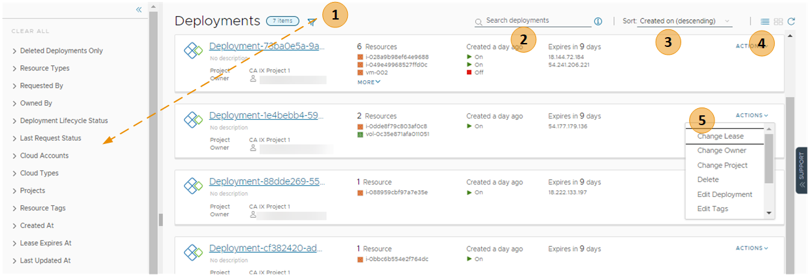
- Filter your requests based on attributes.
For example, you can filter based on owner, projects, lease expiration date, or other filtering options. Or you might want to find all the deployments for two projects with a particular tag. When you construct the filter for the projects and tag example, the results conform to the following criteria: (Project1 OR Project2) AND Tag1.
The values that you see in the filter pane depend on the current deployments that you have permission to view or manage.
Most of the filters and how to use them are relatively obvious. Additional information about some of these filters is provided below.
- Search for deployments based on keywords or requester.
- Sort the list to order by time or name.
- Switch between the deployment card and the deployment grid views.
- Run deployment-level actions on the deployment, including deleting unused deployments to reclaim resources.
You can also see deployment costs, expiration dates, scheduled deletion dates, and status.
To adjust what information you see for your deployments, click Manage Columns in the bottom left of the deployment grid and select your preferred columns.
You can switch between the card and grid view in the upper right of the page, to the right of the Sort text box. You can use the grid view to manage a large number of deployments on fewer pages.
Figure 1-2. Deployment page grid view
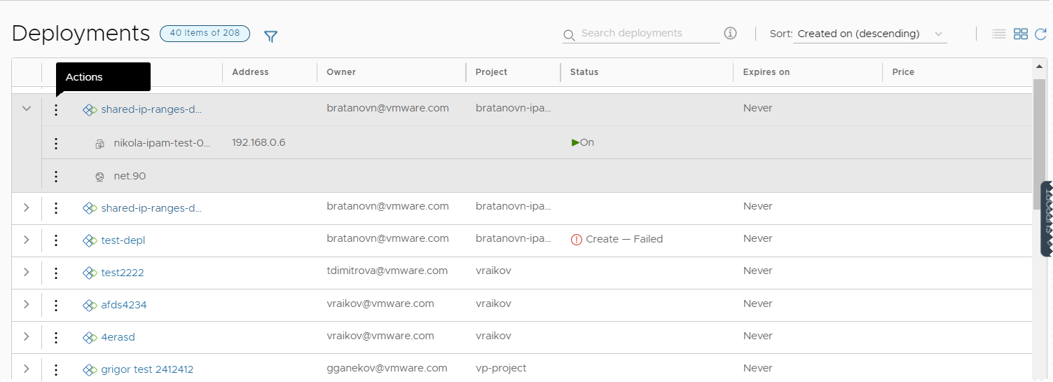

Working with selected deployment filters
The following table is a not a definitive list of filter options. Most of them are self-evident. However, some of the filters require a little extra knowledge.
Table 1-1. Selected filter information
Filter name | Description
Optimizable Resources Only | If you integrated VCF Operations and are using the integration to identify reclaimable resources, you can toggle on the filter to limit the list of qualifying deployments.
Deployment Lifecycle Status | The Deployment Lifecycle Status and Last Request Status filters can be used individually or in combination, particularly if you manage a large number of deployments. Examples are included at the end of the Last Request Status section below.  Deployment Lifecycle Status filters on the current state of the deployment based on the management operations.  This filter is not available for deleted deployments.  The values that you see in the filter pane depend on the current state of the listed deployments. You might not see all possible values. The following list includes all the possible values. Day 2 actions are included in the Update status.  - Create - Successful  - Create - In Progress  - Create - Failed  - Update - Successful  - Update - In Progress  - Update - Failed  - Delete - In Progress  - Delete - Failed
Last Request Status filters | Last Request Status filters on the last operation or action that ran on the deployment.  This filter is not available for deleted deployments.  The values that you see in the filter pane depend on the last operations that ran on the listed deployments. You might not see all possible values. The following list is all of the possible values.  - Pending. The first stage of a request where the action is submitted but the deployment process has not yet started.  - Failed. The request experienced a failure during any stage of the deployment process.  - Cancelled. The request was cancelled by a user while the deployment process was processing and not yet completed.  - Successful. The request successfully created, updated, or deleted a deployment.  - In Progress. The deployment process is currently running. Additional deployment states, for example, Initialization and Completion that you see in the deployment History tab are not provided as filters, but you can use the In Progress filter to locate deployments in those states.  - Approval Pending. The request triggered one or more approval policies. The process is waiting for a response to the approval request.  - Approval Rejected. The request was denied by the approvers in the triggered approval policies. The request does not continue.  The following examples illustrate how the how to use the Deployment Lifecycle Status and Last Request Status filters individually or together.  - To find all delete requests that failed, select Delete - Failed in the Deployment Lifecycle Status filter.  - To find all the requests waiting for approval, select Approval Pending in the Last Request Status filter.  - To find the delete requests where the approval request is still pending, select Delete - In Progress in the Deployment Lifecycle Status filter and Approval Pending in the Last Request Status filter.

Working with deployment details
You use the deployment details to understand how the resources are deployed and what changes have been made. You can also see pricing information, the current health of the deployment, if the deployment expires and when it's scheduled for deletion, and if you have any resources that need to be modified.
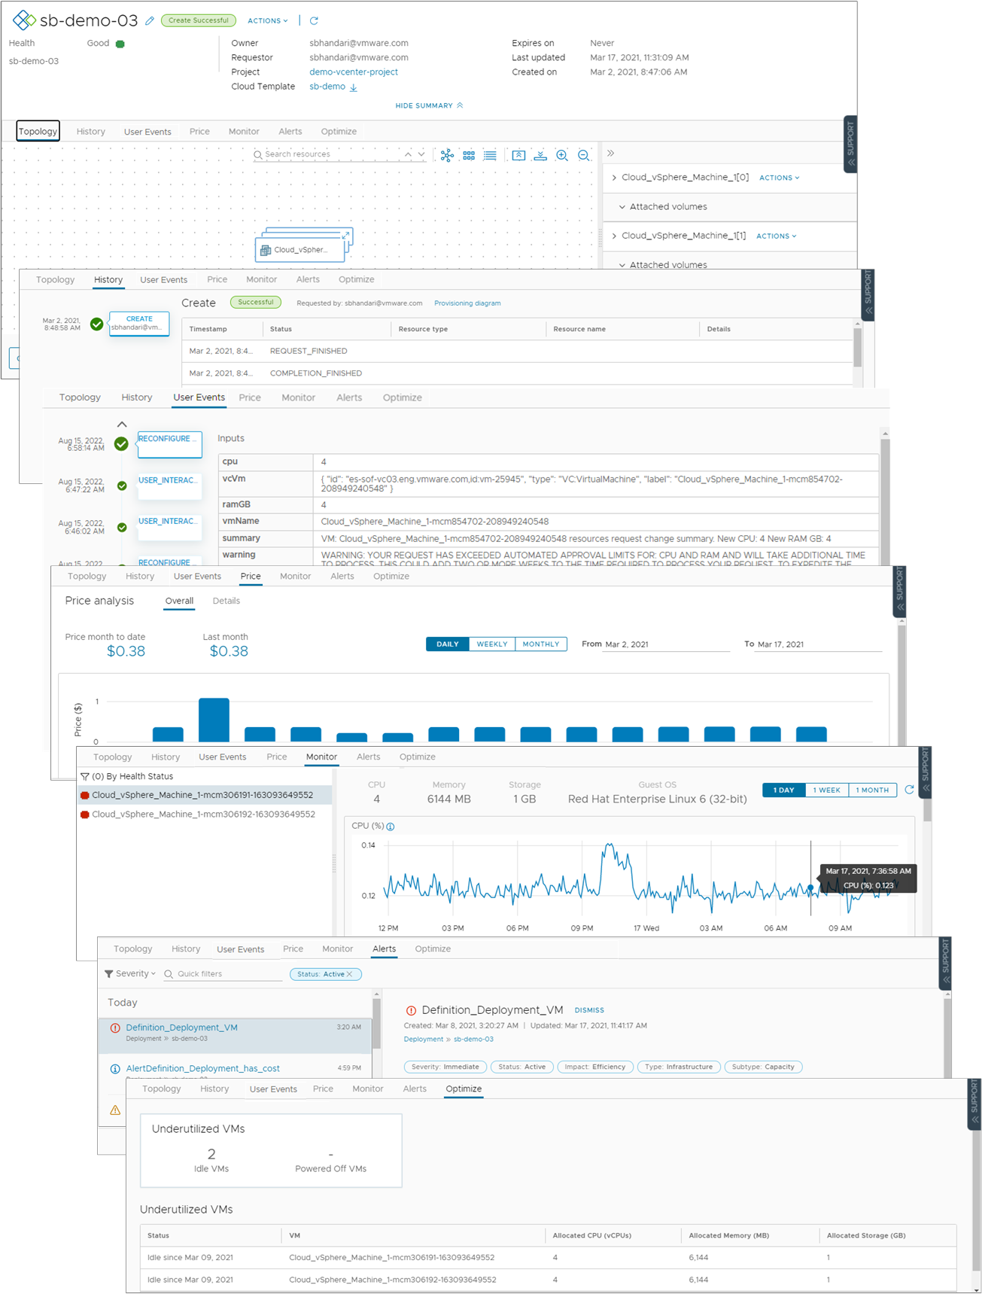
- Topology tab. You can use the Topology tab to understand the deployment structure and resources.
- History tab. The History tab includes all the provisioning events and any events related to actions that you run after deploying the requested item. If there are any problems with the provisioning process, the History tab events helps you with troubleshoot the failures.
- User Events tab. You can use the User Events tab to provide and track the user interactions for your deployment. The events include any initial input values, any required approvals, input values for day 2 changes, and any values that you must provide as part of a deployment or for a day 2 action workflow. Where the request requires input values, you can also enter the values on the Inputs tab in VCF Automation.
For deployments that include VCF Operations orchestrator workflow user events, where you enter values during the deployment process, there are some situations where the tab does not display the form or where the workflow is canceled. If you have multiple VCF Operations orchestrator instances that do not have tags or where they all have the same tag, the form does not load. Ensure that you correctly tag the instances so that the form displays on the tab. If there are not assignees in the workflow form, the workflow is canceled and the deployment or action fails. Ensure that you workflow form includes assignees.
- Price tab. You can use the pricing tab for insights about how much your deployment is costing your organization. Pricing information is provided by your VCF Operations or CloudHealth integrations.
- Monitor tab. The Monitor tab data provides information about the health of your deployment based on data from VCF Operations.
- Alerts tab. The Alerts tab provides active alerts on the deployment resources. You can dismiss the alert or add reference notes. The alerts are based on data from VCF Operations.
- Optimize tab. The Optimize tab provides utilization information about your deployment and offers suggestions for reclaiming or otherwise modifying the resources to optimize resource consumption. The optimization information is based on data from VCF Operations.

How do I monitor deployments in VCF Automation for VM Apps
You monitor deployment requests in VCF Automation for VM Apps to ensure that the resources are provisioned, that the provisioned resources are running, and to resize or destroy the resources as needed.
The Deployments page provides information about the current state of the deployment and where the resources are deployed in your provider clouds.

How do I know that my deployment request succeeded
The deployment cards that appear on the Deployments page show the state of the deployment, including in-progress (top) and completed (below). The card includes the number of deployed resources, how long it has been deployed, and the lease expiration date.
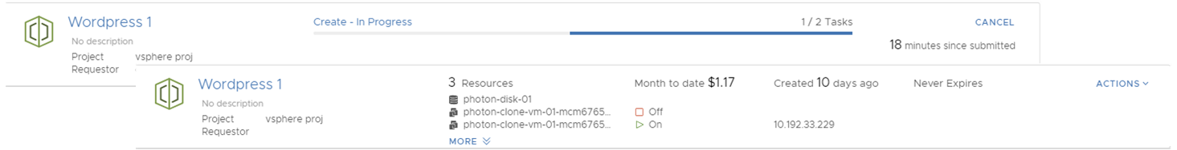
If an approval policy is triggered for your request, you might see the request in an in progress state with the name of at least one approver. Approval policies are defined in VCF Automation for VM Apps by your administrator. The approvers are defined in the policy. The approvers approve requests using an Approvals tab. You might also encounter approvals on day 2 actions.
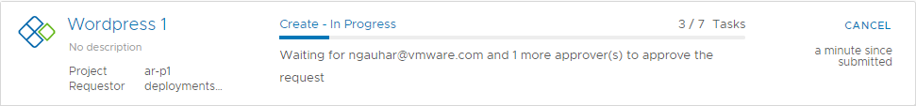
If a deployment fails, the cards show the error message for the point of failure and the process progress. To learn more about the failure, click the deployment name at review the History tab.
For more information about troubleshooting failed deployments, see What can I do if a VCF Automation for VM Apps deployment fails.
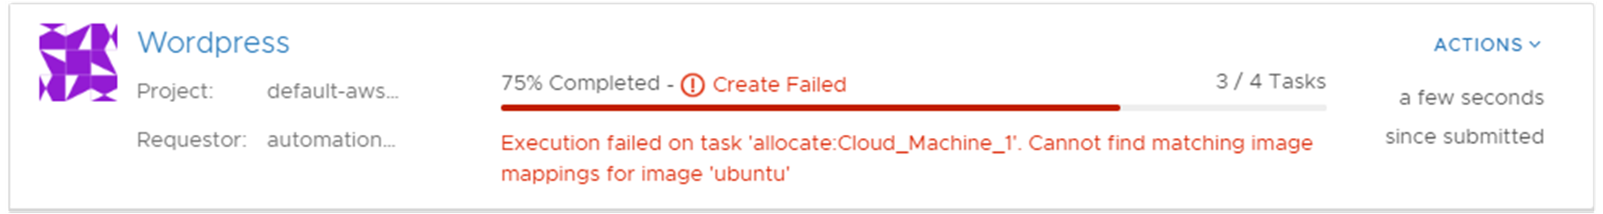

Where are my resources deployed
To access your successfully provisioned deployments, you might need more than the IP address provided on the card. Click the deployment name and review the deployment details on the Topology tab.
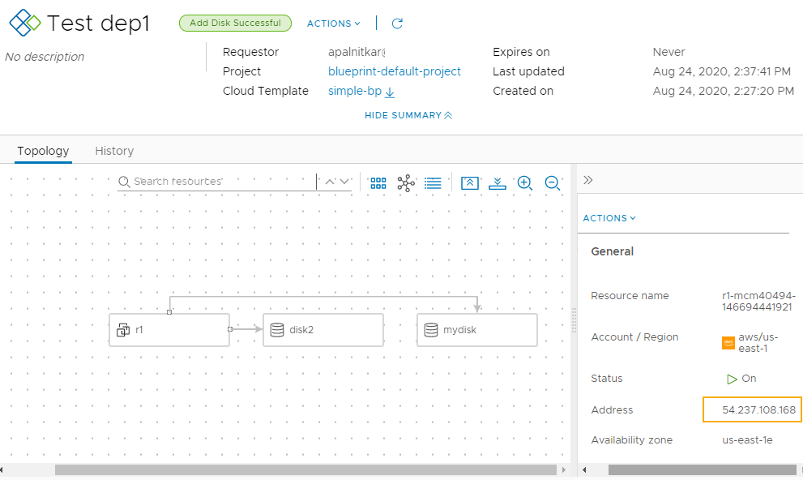
You most likely need the IP address for the primary component. As you click on each component, notice the information that is provided is specific to that component.
The availability of the external link depends on the cloud provider. Where it is available, you must have the credential on that provider to access the component.

How do I track deleted deployments
After you delete a deployment, you might want to see a list or review the history of a particular deployment.
To view your deleted deployments, click the filter on the Deployments page, and then turn on Deleted Deployments Only toggle. The list of deployments is now limited to those that are deleted.
If you need the name of delete machines, you can look at the history to retrieve the information.
The deleted deployments are available for 90 days.
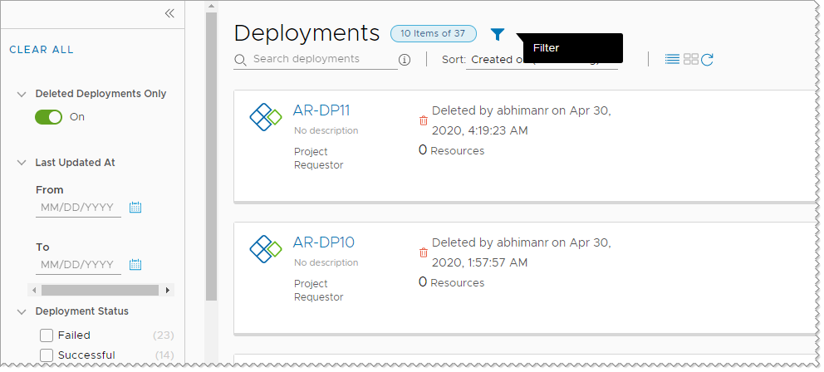

What can I do if a VCF Automation for VM Apps deployment fails
Your deployment request might fail for many reasons. It might be due to network traffic, a lack of resources on the target cloud provider, or a flawed deployment specification. Or, the deployment succeeded, but it does not appear to be working. You can examine your deployment, review any error messages, and determine whether the problem is the environment, the requested workload specification, or something else.
You use this workflow to begin your investigation. The process might reveal that the failure was due to a transient environmental problem. Redeploying the request after verifying the conditions have improved resolves this type of problem. In other cases, your investigation might require you to examine other areas in detail.
Procedure
- To determine if a request failed, select Deployments > Deployments and locate the deployment card.
Failed deployments are indicated on the card.
  - Review the error message.
  - For more information, click the deployment name for the deployment details.
- On the deployment details page, click the History tab.
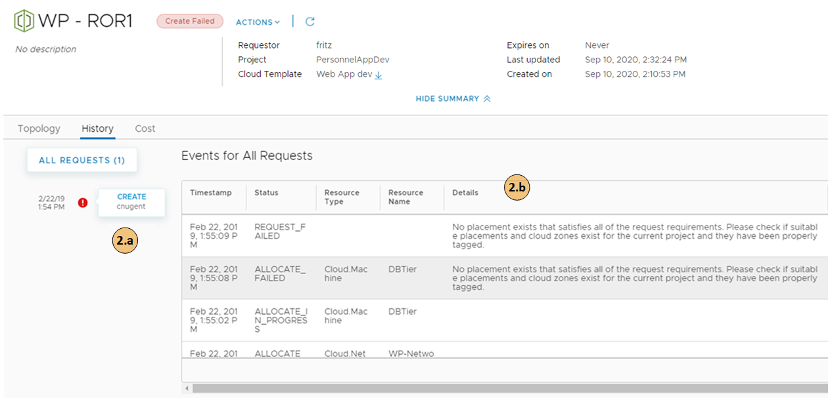
  - Review the event tree to see where the provisioning process failed. This tree is useful when you modify a deployment, but the change fails.
  - The Details provides a more verbose version of the error message.
What to do next
If you are unable to resolve your problem, contact your cloud administrator for additional assistance.

How do I track and respond to requests that require approval in VCF Automation for VM Apps
As a VCF Automation for VM Apps consumer, you received an email notification about a deployment or day 2 action request that you made. Your request must be approved by a designated approver before it proceeds. If you are an assigned approver, you received an email notification about a deployment request that someone made. In either case, you can use these procedures to understand the approval policy workflow related to deployment requests and how to respond to approval requests if are an assigned approver.

How do I track my requests that require approval in VCF Automation for VM Apps
This procedure assumes that you received an email notification about your deployment request is pending approval, or that you noticed that your deployment did not progress.
You receive an email with the name of your deployment and the name of the first approver on the list. The message includes a link to the deployment details where you can track the approvals in the deployment details.
If you received an email about the pending request, you can see the name of your deployment and the name of the first approver on the list. The message includes a link to the deployment details where you can track the approvals in the deployment details.
Procedure
- Select Consume > Deployments > Deployments.
- You requested a deployment or a day 2 action on an existing deployment, but you now see message on your deployment card.
For example, your card displays Create - Approval Pending and lists the names of the approvers.
Your request triggered one or more approval policies.
- For information that helps you track the progress of your request, click the deployment name, and then click the Details tab.
When the deployment is first awaiting approval, you only see APPROVAL_IN_PROGRESS. After a few minutes the list of approver names are added in the Details column. If the request requires multiple approvers, the approver list updates as an approver responds. With each update, only the pending approver names remain.
- When your request is approved or rejected, you receive another email message appropriate to the outcome.
If the request is rejected, the deployment details History tab displays REQUEST_FAILED and the details column provides the name of the approver and the reason for rejecting the request.

How do I respond to an approval request in VCF Automation for VM Apps
As a designated approver for deployment or day 2 action requests made in VCF Automation for VM Apps, you are tasked with approving requests. If you are an assigned approver in the policy, you received an email notification about a deployment request that someone made. If you are ? user with the Manage Approvals custom role who monitors and responds to approval requests, you do not receive a notification.
Some policies might require only your approval, while others require multiple people to approve a request.
If the policy that you are responding to has multiple approvers but only requires one approver, you might see an already approved request in the Approvals page. You do not need to take further action.
If you are managing many requests, you can limit the number of approval requests displayed by using the filter option. For example, rather than all the requests, you can use the Pending for me filter to see only pending approval requests from all levels where you are an assigned approver.
Procedure
- If you are an assigned approver, you receive an email that provides the name of the requesting user, the catalog item, and a link to the request in the Approvals page in VCF Automation for VM Apps.
If you are someone who manages approvals, you can select Inbox > Approvals and continue with the following steps.
- Locate the approval card for the notification.
- Review the deployment details and the approval details, and approve or reject the request.
Required approvals are grouped into sequential levels. For example, if you are an assigned approver for deployment requests where level 1 and level 4 policies apply, then the approval details page shows the required approvals from the level 1 policies grouped under the Level 1 category, and the level 4 policies grouped under the Level 2 category.
If you are a user with administrative rights, you have the following options.
  - Approve full request. You approve the request at all levels where you are an assigned approver. No other approvals are required so the request is approved.
  - Approve current level. You approve the request at all levels where you are an assigned approver. The request is routed to the next level that is pending approval.
  - Approve as an assigned approver. You approve the request at all levels where you are an assigned approver. If there are other approvers who have not responded, the request remains pending and is not routed to the next level until others approve the request.
If you reject the request, you must provide a reason that is included in the email message sent to the requester.
- The system sends an email to the requester indicating that the request was approved or rejected.

How do I track and respond to requests that require user input in VCF Automation for VM Apps
As a VCF Automation for VM Apps consumer, you received an email notification about a deployment request for a VCF Operations orchestrator workflow that requires user input before it proceeds. The deployment might request you or another user to provide input. You can use these procedures to understand how your request is processed and how to respond to user input requests.

How do I track my requests that require user input in VCF Automation for VM Apps
You receive an email with the name of your deployment and the name of the first assignee on the list. The message includes a link to the deployment details where you can track responses to your request on the User Events tab.
This procedure assumes that you received an email notification about the user input request, or that you noticed that your deployment did not progress.
Prerequisites
- A VCF Operations orchestrator workflow that contains a manual user interaction element is added to the catalog.
Procedure
- Select Consume > Deployments > Deployments.
- Locate your deployment request for the VCF Operations orchestrator workflow.
You notice a message on your deployment card. For example, your card displays User Interaction Pending.
- To view a summary of your request, click the deployment name.
- Click the User Events tab.
Until the user input request is answered, you see USER_INTERACTION_IN_PROGRESS and the list of users who must provide input.
- If you are one of the response assignees, you see an input form.
Provide the information required for the workflow to proceed, and click Submit.
- When your request is answered or rejected, you receive another email message.
If the user input request is rejected, your deployment request is canceled.
The deployment details History tab displays REQUEST_FAILED.

How do I respond to a user input request in VCF Automation for VM Apps
When a VCF Operations orchestrator workflow that contains a user interaction element is requested in the VCF Automation for VM Apps catalog, the deployment remains in progress until the assigned users provide the required input.
A VCF Operations orchestrator workflow can sometimes require additional input parameters while it runs. For example, if a certain event occurs while a workflow runs, the workflow can request user interaction to decide what course of action to take. The workflow waits before continuing, either until the assigned user responds to the request for information, or until the waiting time exceeds a possible timeout period.
If multiple users are listed as assignees that can respond to the input request, only one of them must answer or reject the request.
You can use the filter option to limit the number of the user input requests that you manage. For example, rather than all the requests that are waiting for input, you can use the Answered filter to see only requests that were answered by you or other assignees.
Prerequisites
- A VCF Operations orchestrator workflow that contains a manual user interaction element is added to the catalog.
Procedure
- If a workflow requires your input, you receive an email that provides the name of the requesting user, the name of the requested workflow, and a link to the request in the User Input Requests page in VCF Automation for VM Apps.
You can also select Inbox > User Input Requests in VCF Automation continue with the following steps.
- Locate the card for the user input request.
- Review the request summary and input fields, and answer or reject the request.
  - Answer. Provide the required input, and click Submit.
  - Reject. If you reject a user input request, the deployment request for the workflow is canceled.
- The system sends an email to the requester indicating that the user input request was answered or rejected.

How do I manage resources in VCF Automation for VM Apps
As a VCF Automation for VM Apps cloud administrator or catalog consumer, you can use the Deployments node on the Consume tab to manage your cloud resources.
You can locate and manage your resources using the different views. You can filter the lists, view resource details, and then run actions on the individual items. The available actions depend on the resource origin, for example, discovered compared to deployed, and the state of the resources.
If you are a VCF Automation for VM Apps administrator, you can also view and manage discovered machines.
To view your resources, select Consume > Deployments > Resources.
You can use the Projects drop-down on the Consume tab to view only the resources that are available for a specific project.

Viewing billable objects
As an VCF Automation or an VCF Automation administrator, you can monitor what billable objects are used in your organization. Counted objects include billable virtual machines, CPUs, and cores that are in use at view time. It might take up to ten minutes for the object count data to refresh.
When viewing resource lists, you can use the Billable Resources Only filter in combination with other available filters.
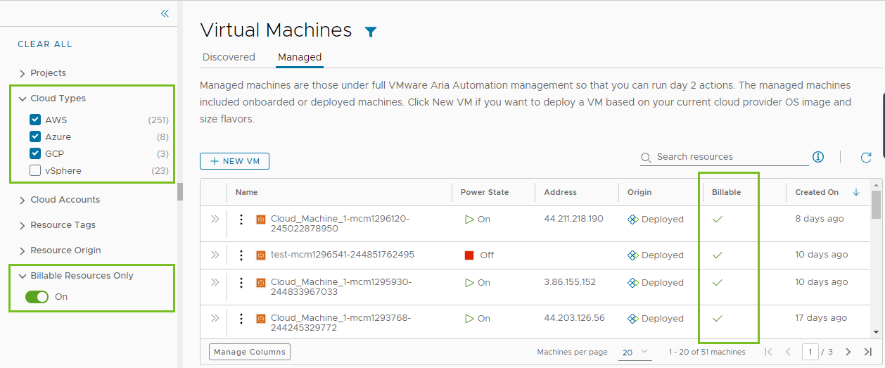
If you force delete a deployment, the resource count might not match what is displayed in the resource list. You must delete the virtual machine from the corresponding IaaS layer, such as vCenter.
What is actually counted towards the bill depends on your VCF Automation subscription commit contract and entitlement type.

Working with the resource lists
You can use the resource list to manage the machines, storage volumes, and networks that make up your deployments. In the resource list you can manage them in resource type groups rather than by deployments.
Similar to the deployment list view, you can filter the list, select a resource type, search, sort, and run actions.
If you click the resource name, you can work with the resource in the context of the deployment details.
If your administrator turned on the Create new resource setting, VCF Automation viewers and administrators, and project members have the option to Create New VM. Administrators can turn on the setting by selecting Infrastructure > Administration > Settings. To control the amount of resources that VCF Automation users might deploy, it is likely that your administrator added approval policies to reject or approve any deployment requests based on the image used or the flavor or size requested.
Figure 1-3. Resources page list
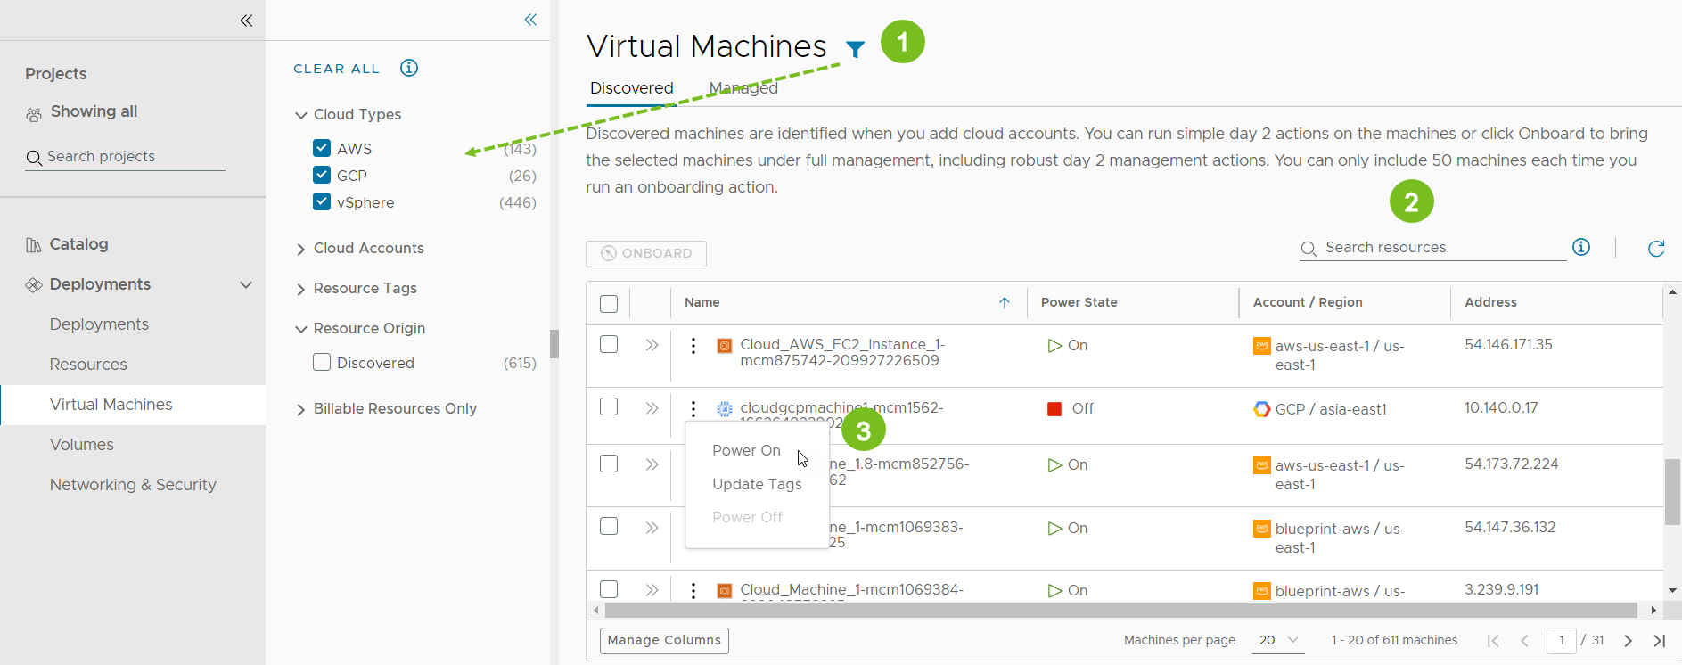
- Filter your list based on resource attributes.
For example, you can filter based on project, cloud types, origin, or other attributes.
- Search for resources based on name, account regions, or other values.
- Run available day 2 actions that are specific to the resources type and the resource state.
For example, you might power on a discovered machine if it is off. Or you might resize an onboarded machine.

List of managed resources by origin
You can use the Resources tab to manage the following types of resources.
Table 1-2. Resource origins
Managed Resource | Description
Deployed | Deployments are fully manage workloads that are deployed cloud templates or onboarded resources. The workload resources can include machines, storage volumes, networks, load balancers, and security groups.  You can manage your deployments in the Deployments section.
Discovered | Discovered resources are the machines, storage volumes, networks, load balancers, and security groups that the discovery process identified for each cloud account region that you added.  Only VCF Automation Administrators can see and manage discovered resources in the Resources section.
Migrated | Migrated resources are the 7.x deployments that your migrated to VCF Automation. The migrated resources can include machines, storage volumes, networks, load balancers, and security groups. Migrated resources are managed like deployments.  You can manage migrated resources in the Deployments section.
Onboarded | Onboarded resources are discovered resources that you bring under more robust VCF Automation management. Onboarded resources are managed like deployments.  You can manage onboarded resources in the Deployments section.

What is the resource details view
You can use the resource details view to get a deeper look at the selected resource. Depending on the resource, the details can include networks, ports, and other information collected about the machine. The depth of the information varies depending on cloud account type and origin.
To open the details pane, click the resource name or the double arrows.
Figure 1-4. Resources details pane
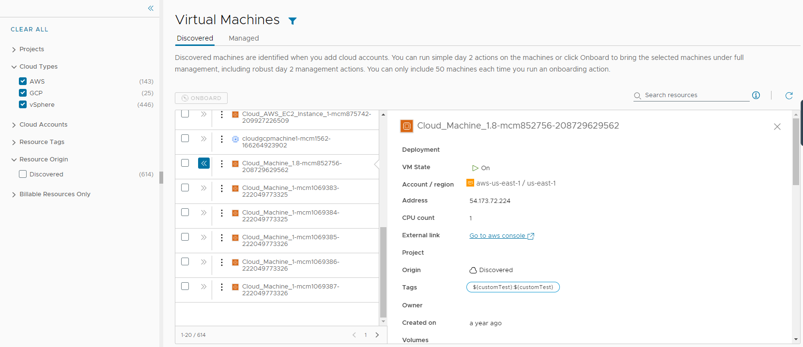

What day 2 actions can I run on resources
The available day 2 actions depend on the resource origin, cloud account, resource type, and state.
Table 1-3. List of actions by origin
Resource Origin | Day 2 Actions
Deployed | The actions that are available to run on the resources depend on the resource type, cloud account, and state. For a detailed list, see What actions can I run on deployments or supported resources in VCF Automation for VM Apps.
Discovered | The available actions for discovered resources are limited to virtual machines. Depending on the status, you can perform the following actions.  - Power Off  - Power On  Additional vSphere virtual machine action.  - Connect to Remote Console
Migrated | Migrated resources have the same day 2 action management options as deployments. The actions that are available to run on the migrated resources depend on the resource type, cloud account, status, and day 2 policies. For a detailed list, see What actions can I run on deployments or supported resources in VCF Automation for VM Apps.
Onboarded | Onboarded resources have the same day 2 action management options as deployments. The actions that are available to run on the onboarded resources depend on the resource type, cloud account, and state. For a detailed list, see What actions can I run on deployments or supported resources in VCF Automation for VM Apps.

How do I manage resources in VCF Automation for VM Apps
As a VCF Automation for VM Apps cloud administrator or catalog consumer, you can use the Deployments node on the Consume tab to manage your cloud resources.
You can locate and manage your resources using the different views. You can filter the lists, view resource details, and then run actions on the individual items. The available actions depend on the resource origin, for example, discovered compared to deployed, and the state of the resources.
If you are a VCF Automation for VM Apps administrator, you can also view and manage discovered machines.
To view your resources, select Consume > Deployments > Resources.
You can use the Projects drop-down on the Consume tab to view only the resources that are available for a specific project.

Viewing billable objects
As an VCF Automation or an VCF Automation administrator, you can monitor what billable objects are used in your organization. Counted objects include billable virtual machines, CPUs, and cores that are in use at view time. It might take up to ten minutes for the object count data to refresh.
When viewing resource lists, you can use the Billable Resources Only filter in combination with other available filters.

If you force delete a deployment, the resource count might not match what is displayed in the resource list. You must delete the virtual machine from the corresponding IaaS layer, such as vCenter.
What is actually counted towards the bill depends on your VCF Automation subscription commit contract and entitlement type.

Working with the resource lists
You can use the resource list to manage the machines, storage volumes, and networks that make up your deployments. In the resource list you can manage them in resource type groups rather than by deployments.
Similar to the deployment list view, you can filter the list, select a resource type, search, sort, and run actions.
If you click the resource name, you can work with the resource in the context of the deployment details.
If your administrator turned on the Create new resource setting, VCF Automation viewers and administrators, and project members have the option to Create New VM. Administrators can turn on the setting by selecting Infrastructure > Administration > Settings. To control the amount of resources that VCF Automation users might deploy, it is likely that your administrator added approval policies to reject or approve any deployment requests based on the image used or the flavor or size requested.
Figure 1-5. Resources page list

- Filter your list based on resource attributes.
For example, you can filter based on project, cloud types, origin, or other attributes.
- Search for resources based on name, account regions, or other values.
- Run available day 2 actions that are specific to the resources type and the resource state.
For example, you might power on a discovered machine if it is off. Or you might resize an onboarded machine.

List of managed resources by origin
You can use the Resources tab to manage the following types of resources.
Table 1-4. Resource origins
Managed Resource | Description
Deployed | Deployments are fully manage workloads that are deployed cloud templates or onboarded resources. The workload resources can include machines, storage volumes, networks, load balancers, and security groups.  You can manage your deployments in the Deployments section.
Discovered | Discovered resources are the machines, storage volumes, networks, load balancers, and security groups that the discovery process identified for each cloud account region that you added.  Only VCF Automation Administrators can see and manage discovered resources in the Resources section.
Migrated | Migrated resources are the 7.x deployments that your migrated to VCF Automation. The migrated resources can include machines, storage volumes, networks, load balancers, and security groups. Migrated resources are managed like deployments.  You can manage migrated resources in the Deployments section.
Onboarded | Onboarded resources are discovered resources that you bring under more robust VCF Automation management. Onboarded resources are managed like deployments.  You can manage onboarded resources in the Deployments section.

What is the resource details view
You can use the resource details view to get a deeper look at the selected resource. Depending on the resource, the details can include networks, ports, and other information collected about the machine. The depth of the information varies depending on cloud account type and origin.
To open the details pane, click the resource name or the double arrows.
Figure 1-6. Resources details pane


What day 2 actions can I run on resources
The available day 2 actions depend on the resource origin, cloud account, resource type, and state.
Table 1-5. List of actions by origin
Resource Origin | Day 2 Actions
Deployed | The actions that are available to run on the resources depend on the resource type, cloud account, and state. For a detailed list, see What actions can I run on deployments or supported resources in VCF Automation for VM Apps.
Discovered | The available actions for discovered resources are limited to virtual machines. Depending on the status, you can perform the following actions.  - Power Off  - Power On  Additional vSphere virtual machine action.  - Connect to Remote Console
Migrated | Migrated resources have the same day 2 action management options as deployments. The actions that are available to run on the migrated resources depend on the resource type, cloud account, status, and day 2 policies. For a detailed list, see What actions can I run on deployments or supported resources in VCF Automation for VM Apps.
Onboarded | Onboarded resources have the same day 2 action management options as deployments. The actions that are available to run on the onboarded resources depend on the resource type, cloud account, and state. For a detailed list, see What actions can I run on deployments or supported resources in VCF Automation for VM Apps.

How do I work with discovered resources in VCF Automation for VM Apps
If you are a VCF Automation for VM Apps administrator, you use the Resources page on the Consume tab to manage your discovered machines. Only administrators will see discovered resources on the various pages.
This workflow focuses on managing discovered virtual machines.

Locate discovered virtual machines
Discovered resources are collected from the cloud account region and added to the resources on the Deployments node on the Consume tab. This example focuses on virtual machines, but other resource types are collected, including storage and network information.
- Select Consume > Deployments > Virtual Machines > Discovered.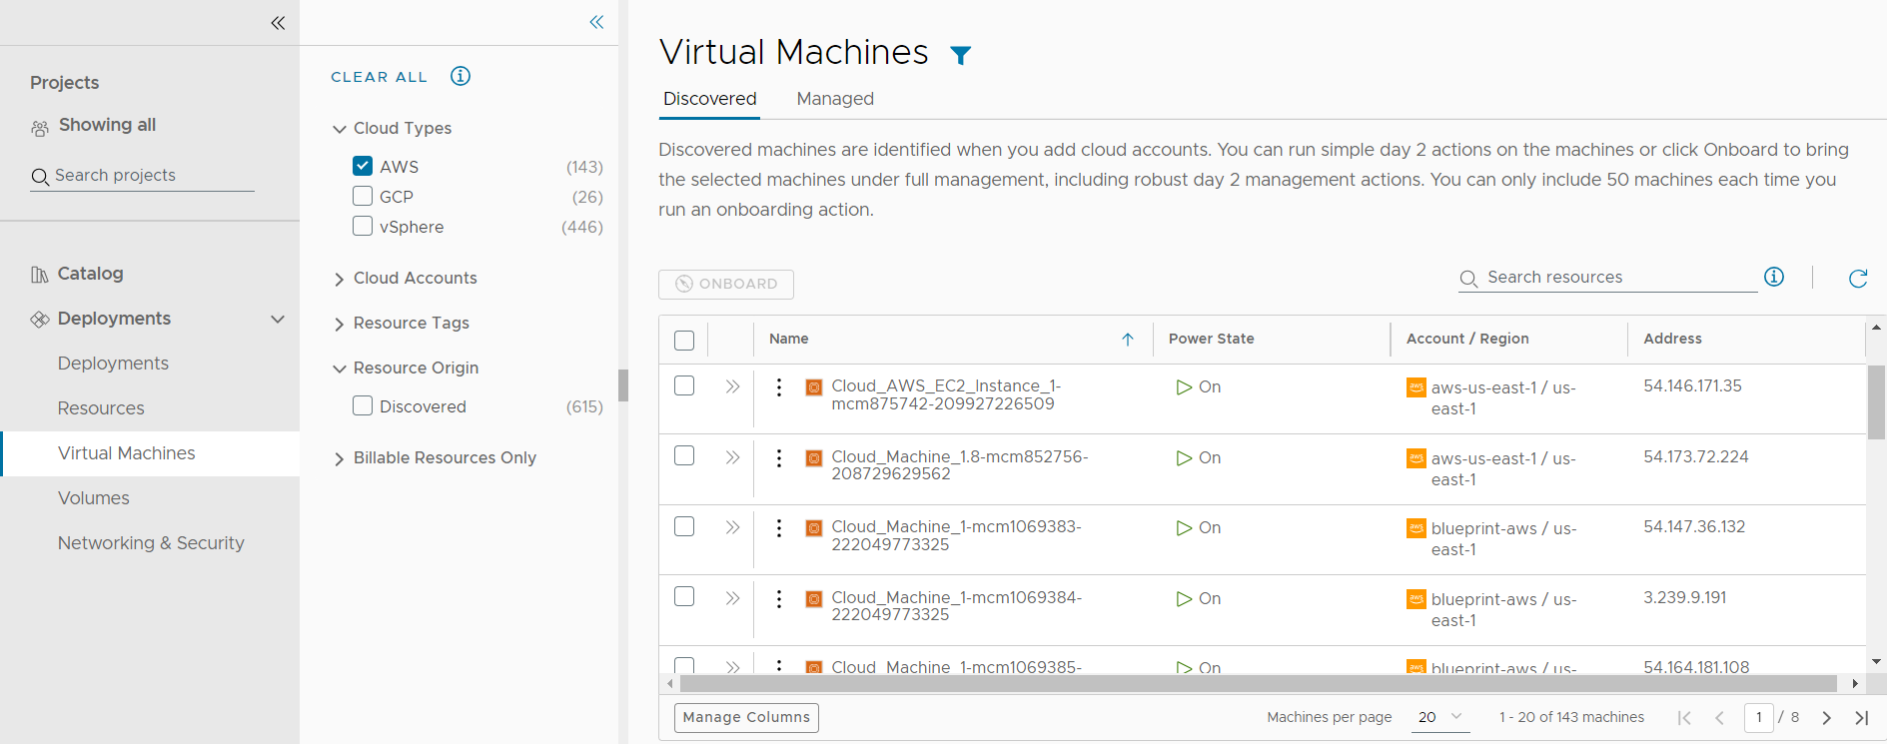
- To locate the AWS virtual machines, click the Filter icon near the page label.
- In the filter list, expand Cloud Types and select AWS.
The list is now limited to discovered AWS virtual machines. You can see deployed, discovered, and other origin types on the Managed tab.
- To locate a particular machine, you can use the Search resources option to search by name, IP address, tags, or values.
In this example, mysql is the search term.

Review virtual machine details
The resource details include all the collected information for the resource. You can use this information to understand the resource and any associations with other resources.
- Locate the virtual machine in the Virtual Machine list.
- To view the resource details, click the machine name or click the double arrows in the left column.
The details pane opens on the right side of the list.
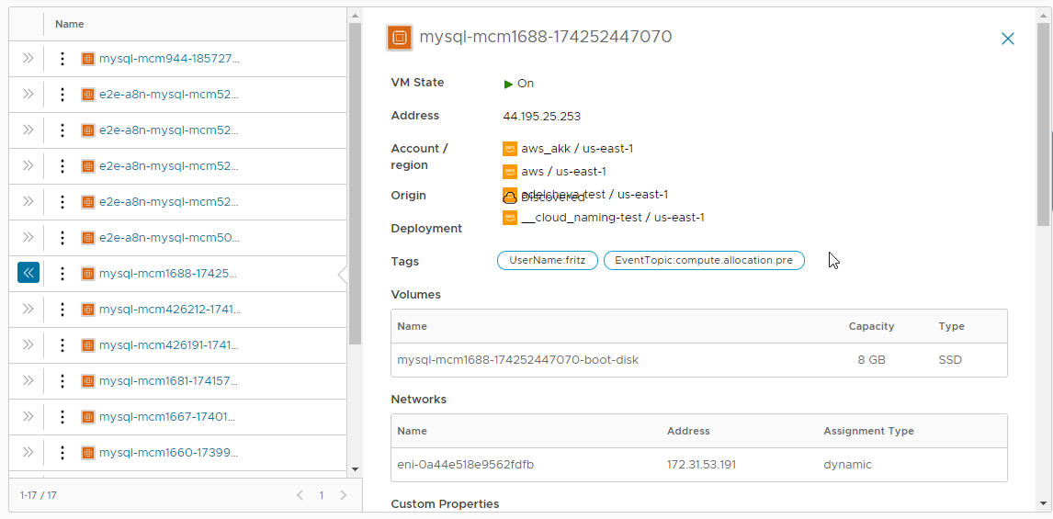
- Review the details, including storage, networks, custom properties, and other collected information.
- To close the pane, click the double arrows or click the resource name.

Run day 2 actions on the virtual machine
You use the day 2 actions to manage the resources. The current actions for discovered virtual machines includes Power On and Power Off. If you are managing a vSphere virtual machine, you can also run Connect with Remote Console.
- Locate the machine in the Virtual Machines list.
- Click the vertical ellipsis to see the available actions.
The possible actions for an AWS virtual machine are Power Off and Power On. Power On is not active because the machine is already on.
- Click Power Off and submit the request.
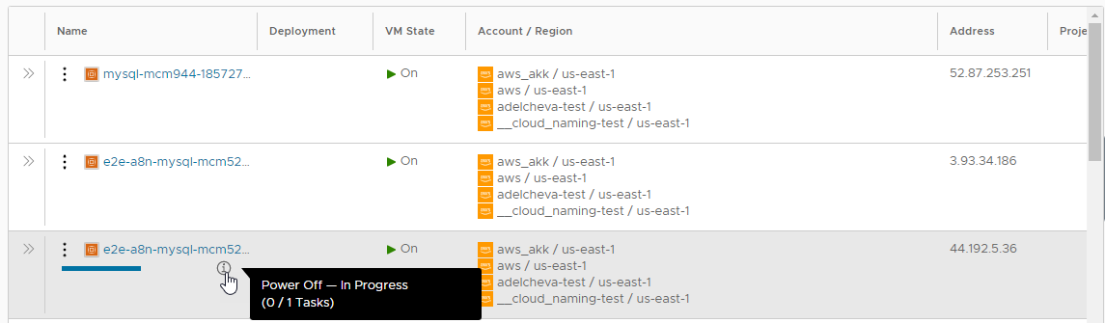
When the process is completed, the machine is powered off. You can now power it back on.

Onboarding virtual machines
You can quickly onboard discovered machines from the Virtual Machines page. Onboarding gets you full day 2 management capabilities for the onboarded resources. See What actions can I run on deployments or supported resources in VCF Automation for VM Apps.
- On the Discovered tab, select the machines that you want to onboard and then click Onboard.
You can onboard up to 50 virtual machines at a time.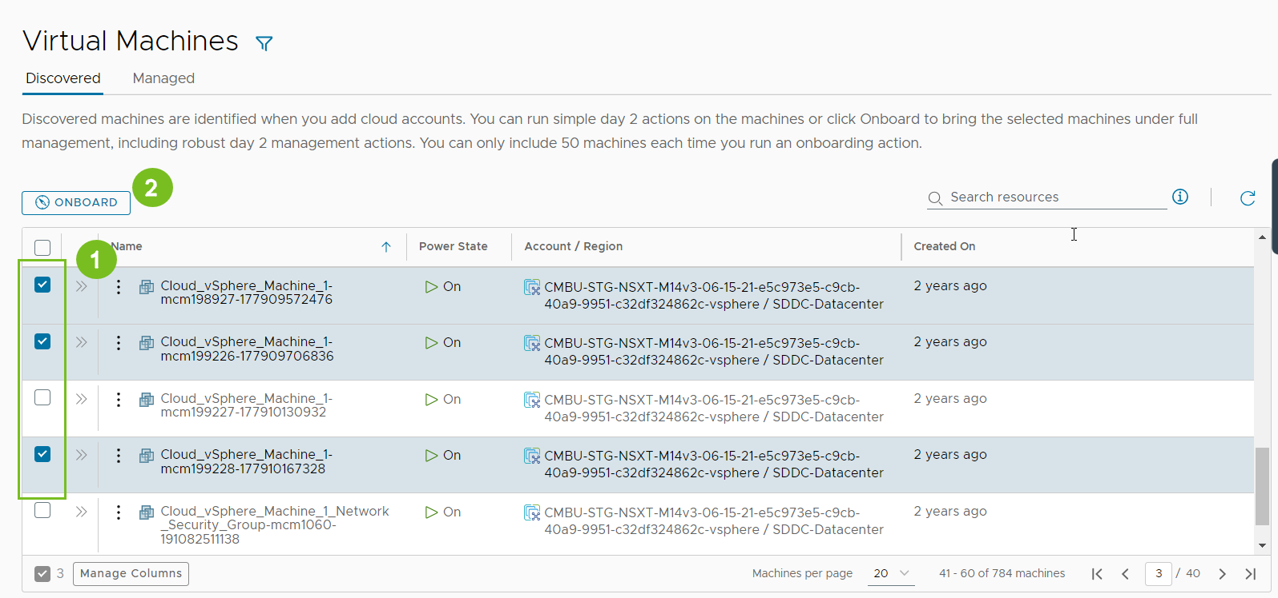
- Follow the prompts in the onboarding wizard.
  - Select a project for the machines.
  - Select if you want to group the machines into a single deployment or if you want to create a separate deployment for each machine.
  - Click Next.
  - Review the deployment summary. You can update the deployment name and owner by clicking the deployment name.
  - When you're done, click Onboard.
The selected machines are onboarded.
- To view the deployment, go to Resources > Deployments and then click the deployment name.
- You manage your onboarded machines, go to Virtual Machines > Managed.

What actions can I run on deployments or supported resources in VCF Automation for VM Apps
After you deploy catalog items, you can run actions in VCF Automation for VM Apps to modify and manage the resources. The available actions depend on the resource type and whether the action is supported on a particular cloud account or integrated platform.
The available actions also depend on what your administrator entitled you to run.
As an administrator or project administrator, you can set up Day 2 Actions policies. See How do I entitle deployment users to day 2 actions using policies in for VM Apps.
You might also see actions that are not included in the list. These are likely custom actions that your administrator configured in VCF Automation for VM Apps.
Caution To change a deployment, you can edit its cloud template and reapply it, or you can use day 2 actions. However, in most cases you should avoid mixing the two approaches.
Lifecycle day 2 changes such as power on/off are usually safe, but others require caution, such as when adding disks.
For example, if you add disks with a day 2 action, and then take a mixed approach by reapplying the cloud template, the cloud template could overwrite the day 2 change, which might remove disks and cause data loss.
Table 1-6. List of possible actions
Action | Applies to these resource types | Available for these cloud types | Resource origin | Description
Add Disk | Machines | - Amazon Web Service  - Google Cloud Platform  - Microsoft Azure  - VMware vSphere | - Deployed  - Onboarded | Add additional disks to existing virtual machines.  If you add a disk to an Azure machine, the persistent disk or non-persistent disk is deployed in the resource group that includes the machine.  When you add a disk to an Azure machines, you can also encrypt the new disk using the Azure disk encryption set configured in the storage profile.  You cannot add a disk to an Azure machine with an unmanaged disk.  When you add a disk to vSphere machines, you can select the SCSI controller, the order of which was set in the cloud template and deployed. You can also specify the unit number for the new disk. You cannot specify a unit number without a selected controller. If you do not select a controller or provide a unit number, the new disk is deployed to first available controller and assigned then next available unit number on that controller.  Note Any virtual device that VCF Automation processes must be configured with the SCSI controller.  If you add a disk to a vSphere machine for a project with defined storage limits, the added disk must not exceed the storage limits. Storage limits consider the actual capacity for thick and thin resource provisioning so that you cannot over-provision using thin provisioning.  If you use VMware Storage DRS (SDRS) and the datastore cluster is configured in the storage profile, you can add disks on SDRS to vSphere machines.
Attach SaltStack Resource | Machines | - Amazon Web Services  - Google Cloud Platform  - Microsoft Azure  - VMware vSphere | - Deployed  - Onboarded | Attach a SaltStack Resource to a deployment resource so that you can install a Salt minion and update the Salt configuration on the virtual machine. You can use this action to update a configuration on a resource or attach the resource and install the minion on another resource in the deployment.  The Attach Salt Resource action is available if you configured the SaltStack Config integration.  To apply a configuration, you must select an authentication method. The Remote access with existing credentials uses the remote access credentials that are included in the deployment. If you changed the credentials on the machine after deployment, the action can fail. If you know the new credentials, use the Password authentication method.  The Password and Private key use the user name and the password or key to validate your credentials and then connect to the virtual machine using SSH.  If you do not provide a value for the Master ID and Minion ID, Salt creates the values for you.
Cancel | - Deployments  - Various resource types in deployments | - Amazon Web Service  - Google Cloud Platform  - Microsoft Azure  - VMware vSphere | - Deployed  - Onboarded | Cancel a deployment or a day 2 action on a deployment or a resource while the request is being processed.  You can cancel the request on the deployment card or in the deployment details. After you cancel the request, it appears as a failed request on the Deployments page. Use the Delete action to release any deployed resources and clean up your deployment list.  Canceling a request that you think has been running too long is one method for managing deployment time. However, it is more efficient to set the Request Timeout in the projects. The default timeout is two hours. You can set if for a longer period of time if the workload deployment for a project requires more time.
Change Display Name | Disk | - Amazon Web Service  - Microsoft Azure  - VMware vSphere | - Deployed  - Onboarded | Change the name of a disk to a meaningful display name.  This action changes the display name in:  - Topology (Node view)  - Topology (Tree view)  - Side panel  - Resource name is day 2 actions, such as "Resize Disk"  - All Resources grid view  - Volumes gride view
Change Lease | Deployments | - Amazon Web Service  - Microsoft Azure  - VMware vSphere | - Deployed  - Onboarded | Change the lease expiration date and time.  When a lease expires, the deployment is destroyed and the resources are reclaimed.  Lease policies are set in VCF Automation.
Change Owner | Deployments | - Amazon Web Service  - Google Cloud Platform  - Microsoft Azure  - VMware vSphere | - Deployed  - Onboarded | Changes the deployment owner to the selected user or Active Directory group. The selected user or AD group must be an administrator or a member of the same project that deployed the request. Only users or AD groups defined in the project are available to become the owner. Custom groups are not eligible to be the target owner.  When a cloud template designer deploys a template, the designer is both the requester and the owner. However, a requester can make another project member the owner.  You can use policies to control what an owner can do with a deployment, giving them permissions that are more restrictive or less restrictive.
Change Project | Deployments | - Amazon Web Service  - Google Cloud Platform  - Microsoft Azure  - NSX-T  - NSX-V  - VMware Cloud Director  - VMware Cloud Foundation  - VMware Cloud on AWS  - VMware vSphere | - Deployed  - Migrated  - Onboarded | You use the change project action to move a deployment from one project to another project.  The change project action is available for deployments with deployed resources, migrated resources, onboarded resources, and deployments with a mixture of deployed, migrated, and onboarded resources.  Supported resources include the following resource types and constraints:  - Deployments with deployed resources can contain virtual machines, disks, load balancers, networks, security groups, Azure groups, NATs, gateways, custom resources, Terraform configurations, and Ansible and Ansible Tower resources.  - Deployments with migrated resources can contain virtual machines, disks, load balancers, networks, security groups, NATs, gateways, and custom resources.  - Deployments with onboarded resources can contain virtual machines, disks, and networks.  - If you add an unsupported resource type in any deployment type, deployed, migrated, or onboarded resources, you cannot run the change project action.  Roles, considerations, and constraints for deployments with deployed, migrated, onboarded, and hybrid/mixed resources:  - To change the project of a deployment with deployed or migrated resources, the initiating user must have the following role:  - Cloud administrator.  - You can only change the project when the target project contains all the cloud zones where the deployment's machines and disks are deployed. The moved deployment is then subject to the configured limits of the target project, including instance count, memory, CPU, and storage. After the move, the current usage is released from the source project.  - After you move a deployment to the target project, it is subject to the policies of target project. For example, lease, day 2 actions, resource quota, and other polices. To move a deployment, the deployment lease defined by the lease policy of the target project cannot expire in the next 24 hours.  - The Change Project action is available for deployments where the custom resources are scoped to be available to any project. The lifecycle and day 2 actions for each custom resource in the deployment must be shared with all projects to ensure that you can continue to manage the custom resource using lifecycle actions or day 2 actions after you move the deployment to the new project.  - The extensibility constraints of the target project must match the vRO integration or the same ABX FaaS provider as the source project. The integrations and providers must match so that you can manage the custom resource using lifecycle actions or day 2 actions after you move the deployment to the new project.  - The Change Project action is available for deployments with Terraform configurations where all the content sources are shared. If any content sources used in the deployment are not shared, the Change Project action fails validation and does not run.  - If a Change Project action fails because a Terraform GitHub repository content source was not shared, you can note the corresponding ID that you must share and then share the source. To share the source repository, select Infrastructure > Integrations and select the GitHub integration. In the open integration page, click the Projects tab, expand the project that contains the repository for the failed action and turn on the sharing for that repository. You can also use the API to share the content source repositories.  - The Change Project action might not be available if you migrated a deployment that contains a custom resource, where the custom resource includes an update action, and you have performed an iterative update of the deployment by redeploying the cloud template.  Roles, considerations, and constraints for deployments with onboarded resources:  - To move a deployment with onboarded resources, the initiating user must have at least one of the following roles:  - Cloud administrator.  - Manage Deployments permission. This permission can be defined as a custom role.  - Project administrator of the target project.  - Project member of the target project and the deployments are shared between all users in the target project.  - While you can move onboarded resources to a project that does not contain the same cloud zones, if the target project does not have the same cloud zones, any future day 2 actions involving cloud account / region resources that you run might not work.  General considerations:  - If you are an administrator who is moving the deployment, you might move the deployment to a project where the owner is not a member and therefore loses access. To resolve the problem, you can add the owner to the target project, move the deployment to a project where they are a member, or use the Change Owner action.
Change Security Groups | Machines | - VMware vSphere | - Deployed  - Onboarded | You can associate and dissociate security groups with machine networks in a deployment. The change action applies to existing and on-demand security groups for NSX-V and NSX-T. This action is available only for single machines, not machine clusters.  To associate a security group with the machine network, the security group must be present in the deployment.  Dissociating a security group from all networks of all machines in a deployment does not remove the security group from the deployment.  These changes do not affect security groups applied as part of the network profiles.  This action changes the machine's security group configuration without recreating the machine. This is a non-destructive change.  - To change the machine's security group configuration, select the machine in the topology pane, then click the Action menu in the right pane and select Change Security Groups. You can now add or remove the association on the security groups with the machine networks.
Connect to Remote Console | Machines | - VMware vSphere | - Deployed  - Discovered  - Onboarded | Open a remote session on the selected machine.  Review the following requirements for a successful connection.  - As a deployment consumer, verify that the provisioned machine is powered on.
Create Disk Snapshot | Machines and disks | - Microsoft Azure | - Deployed  - Onboarded | Create a snapshot of a virtual machine disk or a storage disk.  - For machines, you create snapshots for individual machine disks, including boot disk, image disks, and storage disks.  - For storage disks, you create snapshots of independent managed disks, not unmanaged disks.  In addition to providing a snapshot name, you can also provide the following information for the snapshot:  - Incremental Snapshot. Select the check box to create a snapshot of the changes since the last snapshot rather full snapshot.  - Resource Group. Enter the name of the target resource group where you want to create the snapshot. By default, the snapshot is created in the same resource group that is used by the parent disk.  - Encryption Set Id. Select the encryption key for the snapshot. By default, the snapshot is encrypted with the same key that is used by the parent disk.  - Tags. Enter any tags that will help you manage the snapshots in Microsoft Azure.
Create Snapshot | Machines | - Google Cloud Platform  - VMware vSphere | - Deployed  - Onboarded | Create a snapshot of the virtual machine.  If you are allowed only two snapshots in vSphere and you already have them, this command is not available until you delete a snapshot.  When creating a snapshot for a Google Cloud Platform machine, you can also create a disk snapshot of the attached disks. The combined snapshot allows you to manage the machine as the attached disks as a single entity.
Delete | Deployments | - Amazon Web Service  - Google Cloud Platform  - Microsoft Azure  - VMware vSphere | - Deployed  - Onboarded | Destroy a deployment.  All the resources are deleted and the reclaimed.  If a delete fails, you can run the delete action on a deployment a second time. During the second attempt, you can select Ignore Delete Failures. If you select this option, the deployment is deleted, but the resources might not be reclaimed. You should check the systems on which the deployment was provisioned to ensure that all resources are removed. If they are not, you must manually delete the residual resources on those systems.
 | NSX Gateway | - NSX | - Deployed  - Onboarded | Delete the NAT port forwarding rules from an NSX-T or NSX-V gateway.
 | Machines and load balancers | - Amazon Web Service  - Microsoft Azure  - VMware vSphere  - VMware NSX | - Deployed  - Onboarded | Remove a machine or load balancer from a deployment. This action might result in an unusable deployment.
 | Security groups | - NSX-T  - NSX-V | - Deployed  - Onboarded | If the security is not associated with any machine in the deployment, the process removes the security group from the deployment.  - If the security group is on-demand, then it is destroyed on the endpoint.  - If the security group is shared, the action fails.
 | Tanzu Kubernetes clusters | - VMware vSphere | - Deployed  - Onboarded | Remove a Tanzu Kubernetes cluster from a deployment.
Delete Disk Snapshot | Machines and disks | - Microsoft Azure | - Deployed  - Onboarded | Delete an Azure virtual machine disk or managed disk snapshot.  This action is available when there is at least one snapshot.
Delete Snapshot | Machines | - VMware vSphere  - Google Cloud Platform | - Deployed  - Onboarded | Delete a snapshot of the virtual machine.
Disable Boot Diagnostics | Machines | - Microsoft Azure | - Deployed  - Onboarded | Turn off the Azure virtual machine debugging feature.  This option is only available if the feature is turned on.
Disable Log Analytics | Machines | - Microsoft Azure | - Deployed  - Onboarded | Turn off the ability to run log queries on Azure virtual machine logs.  Select the name of the extension that you want to deactivate. If there is no extension name to select, then the log analytics are not currently enabled on this machine.  To work with the log analytics, Azure Monitor and the cloud template must be configure to support the workspace. See Log Analytics.
Edit Tags | Deployments | - Amazon Web Service  - Microsoft Azure  - VMware vSphere | - Deployed  - Onboarded | Add or modify resource tags that are applied to individual deployment resources.
Enable Boot Diagnostics | Machines | - Microsoft Azure | - Deployed  - Onboarded | Turn on the Azure virtual machine debugging feature to diagnose virtual machine boot failures. The boot diagnostics information is available in your Azure console.  The Enable option is only available if the feature is not currently turned on.
Enable Log Analytics | Machines | - Microsoft Azure | - Deployed  - Onboarded | Turn on the Azure virtual machine to edit and run log queries on data collected by Azure Monitor logs.  You provide the extension name. The workspace ID and key must be the values that are configured in Azure.  To work with the log analytics, Azure Monitor and the cloud template must be configure to support the workspace. See Log Analytics.
Get Terraform State | Terraform Configuration | - Amazon Web Service  - Google Cloud Platform  - Microsoft Azure  - VMware vSphere | - Deployed  - Onboarded | Display the Terraform state file.  To view any changes that were made to the Terraform machines on the cloud platforms that they were deployed on and update the deployment, you first run the Refresh Terraform State action, and then run this Get Terraform State action.  When the file is displayed in a dialog box. The file is available for approximately 1 hour before you need to run a new refresh action. You can copy it if you need it for later.  You can also view the file on the deployment History tab. Select the Get Terraform State event on the Events tab, and then click Request Details. If the file is not expired, click View content. If the file is expired, run the Refresh and Get actions again.  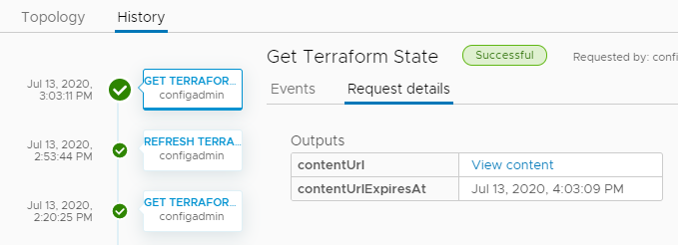  You can run other day 2 action on the Terraform resources that are embedded in the configuration. The available actions depend on the resource type, the cloud platform that they are deployed on, and whether you are entitled to run the actions based on a day 2 policy.
Power Off | Deployments | - Amazon Web Service  - Microsoft Azure  - VMware vSphere | - Deployed  - Discovered  - Onboarded | Power off the deployment after first attempting to shutdown the guest operating systems. If the soft power off fails, a hard power off still runs.
 | Machines | - Amazon Web Service  - Google Cloud Platform  - Microsoft Azure  - VMware vSphere | - Deployed  - Onboarded | Power off the machine after first attempting to shut down the guest operating systems. If the soft power off fails, the hard power off still runs.
Power On | Deployments | - Amazon Web Service  - Microsoft Azure  - VMware vSphere | - Deployed  - Onboarded | Power on the deployment. If the resources were suspended, normal operation resumes from the point at which they were suspended.
 | Machines | - Amazon Web Service  - Google Cloud Platform  - Microsoft Azure  - VMware vSphere | - Deployed  - Discovered  - Onboarded | Power on the machine. If the machine was suspended, normal operation resumes from the point at which the machine was suspended.
Reboot | Machines | - Amazon Web Service  - VMware vSphere | - Deployed  - Onboarded | Reboot the guest operating system on a virtual machine.  For a vSphere machine, VMware Tools must be installed on the machine to use this action.
Rebuild | Deployments | - VMware vSphere | - Deployed  - Migrated  - Onboarded | Rebuild several or all virtual machines in the deployment where the deployment failed or not all requested VMs are provisioned successfully.  The rebuild process keeps the same configuration, such as name, ID, IP address, machine data store, and custom properties for each selected machine.  A non-persistent disk that is attached to a virtual machine is wiped clean and then recreated as part of the build action. Any attached first class disks are detached and the contents is retained. After you rebuild the machine, you can re-attach the disk.  For machines with a missing image, you must select a valid image to rebuild.
 | Machines | - VMware vSphere | - Deployed  - Migrated  - Onboarded | Rebuild a virtual machine where the deployment resulted in a partial deployment, the virtual machine is not usable, or to reprovision a problematic virtual machine after a successful deployment.  The rebuild process keeps the same configuration, such as name, ID, IP address, machine data store, and custom properties.  A non-persistent disk that is attached to a virtual machine is wiped clean and then recreated as part of the build action. Any attached first class disks are detached and the contents is retained. After you rebuild the machine, you can re-attach the disk.
Reconfigure | Load Balancers | - Amazon Web Service  - Microsoft Azure  - VMware NSX | - Deployed  - Onboarded | Change the load balancer size and logging level.  You can also add or remove routes, and change the protocol, port, health configuration, and member pool settings.  For NSX load balancers, you can enable or deactivate the health check and modify the health options. For NSX-T, you can set the check to active or passive. NSX-V does not support passive health checks.
 | NSX Gateway port forwarding | - NSX-T  - NSX-V | - Deployed  - Onboarded | Add, edit, or delete the NAT port forwarding rules from an NSX-T or NSX-V gateway.
 | Security Groups | - NSX-T  - NSX-V  - VMware Cloud  - VMware vSphere | - Deployed  - Onboarded | Add, edit, or remove firewall rules or constraints based on whether the security group is an on-demand or an existing security group.  - On-demand security group  Add, edit, or remove firewall rules for NSX-T and VMware Cloud on-demand security groups.  - To add or remove a rule, select the security group in the topology pane, click the Action menu in the right pane, and select Reconfigure. You can now add, edit, or remove the rules.  - Existing security group  Add, edit, or remove constraints for existing NSX-V, NSX-T, and VMware Cloud security groups.  - To add or remove a constraint, select the security group in the topology pane, click the Action menu in the right pane, and select Reconfigure. You can now add, edit, or remove the constraints.
Refresh Terraform State | Terraform Configuration | - Amazon Web Service  - Google Cloud Platform  - Microsoft Azure  - VMware vSphere | - Deployed  - Onboarded | Retrieve the latest iteration of the Terraform state file.  To retrieve any changes that were made to the Terraform machines on the cloud platforms that they were deployed on and update the deployment, you first run this Refresh Terraform State action.  To view the file, run the Get Terraform State action on the configuration.  Use the deployment history tab to monitor the refresh process.
Remove Disk | Machines | - Amazon Web Service  - Google Cloud Platform  - Microsoft Azure  - VMware vSphere | - Deployed  - Onboarded | Remove disks from existing virtual machines.  If you run the day 2 action on a deployment that is deployed as vSphere machines and disks, the disk count is reclaimed as it applies to project storage limits. Storage limits consider the actual capacity for thick and thin resource provisioning so that you cannot over-provision using thin provisioning. The project storage limits do not apply to additional disks that you added after deployment as a day 2 action.
Reset | Machines | - Amazon Web Service  - Google Cloud Platform  - VMware vSphere | - Deployed  - Onboarded | Force a virtual machine restart without shutting down the guest operating system.
Resize | Machines | - Amazon Web Service  - Microsoft Azure  - Google Cloud Platform  - VMware vSphere | - Deployed  - Onboarded | Increase or decrease the CPU and memory of a virtual machine.
Resize Boot Disk | Machines | - Amazon Web Service  - Google Cloud Platform  - Microsoft Azure  - VMware vSphere | - Deployed  - Onboarded | Increase or decrease the size of your boot disk medium.  If you run the day 2 action on a deployment that is deployed as vSphere machines and disks, and the action fails with a message similar to “The requested storage is more than the available storage placement,” it is likely due to the defined storage limits on your vSphere VM templates and the content library that are defined in the project. Storage limits consider the actual capacity for thick and thin resource provisioning so that you cannot over-provision using thin provisioning. The project storage limits do not apply to additional disks that you added after deployment as a day 2 action.
Resize Disk | Storage disk | - Amazon Web Service  - Google Cloud Platform | - Deployed  - Onboarded | Increase the capacity of a storage disk.  If you run the day 2 action on a deployment that is deployed as vSphere machines and disks, and the action fails with a message similar to “The requested storage is more than the available storage placement,” it is likely due to the defined storage limits on your vSphere VM templates and the content library that are defined in the project. Storage limits consider the actual capacity for thick and thin resource provisioning so that you cannot over-provision using thin provisioning. The project storage limits do not apply to additional disks that you added after deployment as a day 2 action.  For the vSphere Storage DRS, you can relocate the virtual machine within the cluster of the current LUN lacks sufficient space.
 | Machines | - Amazon Web Service  - Google Cloud Platform  - Microsoft Azure  - VMware vSphere | - Deployed  - Onboarded | Increase or decrease the size of disks included in the machine image template and any attached disks.
Restart | Machines | - Microsoft Azure | - Deployed  - Onboarded | Shut down and restart a running machine.
Revert to Snapshot | Machines | - Google Cloud Platform  - VMware vSphere | - Deployed  - Onboarded | Revert to a previous snapshot of the machine.  You must have an existing snapshot to use this action.  If you created a snapshot for a Google Cloud Platform machine that included the attached disks, the full snapshot is reverted.
Run Puppet Task | Managed resources | - Puppet Enterprise | - Deployed  - Onboarded | Run the selected task on machines in your deployment.  The tasks are defined in your Puppet instance. You must be able to identify the task and provide the input parameters.
Scale Worker Nodes | Tanzu Kubernetes clusters | - VMware vSphere | - Deployed  - Onboarded | Increase or decrease the number of Tanzu Kubernetes worker node virtual machines in your deployment.
Shutdown | Machines | - VMware vSphere | - Deployed | Shut down the guest operating system and power off the machine. VMware Tools must be installed on the machine to use this action.
Suspend | Machines | - Microsoft Azure  - VMware vSphere | - Deployed  - Onboarded | Pause the machine so that it cannot be used and does not consume any system resources other than the storage it is using.
Update | Deployments | - Amazon Web Service  - Microsoft Azure  - VMware vSphere | - Deployed  - Onboarded | Change the deployment based on the input parameters.  For an example, see How to move a deployed machine to another network in VCF Automation for VM Apps.  If the deployment is based on vSphere resources, and the machine and disks include the count option, storage limits defined in the project might apply when you increase the count. If the action fails with a message similar to “The requested storage is more than the available storage placement,” it is likely due to the defined storage limits on your vSphere VM templates that are defined in the project. The project storage limits do not apply to additional disks that you added after deployment as a day 2 action.  There are some properties that cannot be updated using this action. See Deployment properties that you cannot update using day 2 actions in VCF Automation for VM Apps.
Update Salt Configuration | SaltStack Config resource | - Amazon Web Service  - VMware vSphere | - Deployed  - Onboarded | Add or change the Salt environment, apply state files, or provide variables for the selected Salt resource.
Update Tags | Machines and disks | - Amazon Web Service  - Microsoft Azure  - VMware vSphere | - Deployed  - Onboarded | Add, modify, or delete a tag that is applied to an individual resource.
Update Tanzu Version | Tanzu Kubernetes clusters | - VMware vSphere | - Deployed  - Onboarded | Update the current Kubernetes version to a later version.
Unregister | Machines | - Amazon Web Service  - Google Cloud Platform  - Microsoft Azure  - VMware vSphere | - Deployed (vSphere only)  - Onboarded | Unregister machines and machine clusters to remove them from VCF Automation management and inventory. The machines are not removed from the cloud platform.  Unregistered machines are available for onboarding. You can run the onboarding workflow to bring them back under management. For example, you might want to onboard a machine into a new project or a different VCF Automation instance.  - Deployed vSphere machines considerations.  - The unregistered machine, along with any attached disks, is removed from VCF Automation management. If you must continue to manage the disk, you can use the IaaS API to detach the disk before you unregister the machine.  - If a deployment has only one machine and you unregister the machine, the deployment remains in VCF Automation.  - An unregistered machine can still be a discovered machine that you can onboarded, if needed.  - The machine is removed from VCF Automation licensing and metering.  - The reservation quota and the storage limit are adjusted when the machine is no longer managed.  - When you unregister a machine, the IP address changes from ALLOCATED to UNREGISTERED in AUTOMATION. If the machine is re-onboarded, the IP address changes back to ALLOCATED. If an unregistered machine is deleted in vCenter, the IP address remains UNREGISTERED in VCF Automation.  To manually release the IP address, select Infrastructure > Resources > Networks. Select the IP Addresses tab and search for IP addresses where the status is Unregistered. Release the IP address as needed.  - All NAT rules that target the unregistered machine's NIC are removed from the NAT rules list in VCF Automation when the machine is unregistered. If all the NAT rules target only the NICs on the machine that you want to unregister, the unregister fails. NAT needs at least one rule in the list. You can reconfigure the NAT rules or delete the NAT before you unregister the machine.  No changes are made to the NSX DNAT or router configurations.  - Unregister extensibility events topics exist and pre and post unregister events are generated by the Event Broker Service.  - Onboarded machines considerations.  - The unregistered machine, along with the any attached disks, is removed from VCF Automation management.  - After you remove the machine, you can then re-run the onboarding workflow for the unregistered machine. For example, you might want to onboard the resource again, this time to a new project.  - Missing machines considerations.  - The machine is listed as missing after migration or a backup and restore operation on the vCenter. Missing commonly means that the database record is unusable.  - You can unregister the missing machine to remove it from the database. The unregistered missing machine is not available for onboarding.

How to move a deployed machine to another network in VCF Automation for VM Apps
While maintaining deployments and networks, you might need the ability to relocate machines that you deployed with VCF Automation for VM Apps.
For example, you might deploy to a test network first, then move to a production network. The technique described here lets you design a cloud template in advance to prepare for such day 2 actions. Note that the machine is moved. It isn't deleted and redeployed.
This procedure only applies to Cloud.vSphere.Machine resources. It won't work for cloud agnostic machines deployed to VCF Automation.
Prerequisites
- The VCF Automation network profile must include all subnets that the machine will connect to. In VCF Automation, you can check networks by going to Infrastructure > Configure > Network Profiles.
The network profile must be in an account and region that are part of the appropriate VCF Automation project for your users.
- Tag the two subnets with different tags. The example that follows assumes that test and prod are the tag names.
- The deployed machine must keep the same IP assignment type. It can't change from static to DHCP, or vice versa, while moving to another network.
Procedure
- In VCF Automation for VM Apps, go to Design, and create a cloud template for the deployment.
- In the inputs section of the code, add an entry that lets the user select a network.
inputs:
net-tagging:
type: string
enum:
- test
- prod
title: Select a network
- In the resources section of the code, add the Cloud.Network and connect the machine to it.
- Under the Cloud.Network, create a constraint that references the selection from the inputs.
resources:
ABCServer:
type: Cloud.vSphere.Machine
properties:
name: abc-server
. . .
networks:
- network: '${resource["ABCNet"].id}'
ABCNet:
type: Cloud.Network
properties:
name: abc-network
. . .
constraints:
- tag: '${input.net-tagging}'
- Continue with your design, and deploy it as you normally would. At deployment, the interface prompts you to select the test or prod network.
- When you need to make a day 2 change, go to Resources > Deployments > Deployments, and locate the deployment associated with the cloud template.
- To the right of the deployment, click Actions > Update.
- In the Update panel, the interface prompts you the same way, to select the test or prod network.
- To change networks, make your selection, click Next, and click Submit.

Deployment properties that you cannot update using day 2 actions in VCF Automation for VM Apps
Day 2 actions are changes that you can make to deployed resources. There are limits to the changes that you can make using the actions. There are some properties that you cannot change using certain actions. Review the list of excluded properties if you expected a change but nothing was modified.

Storage Properties
The following storage properties cannot be modified using the Update deployment action.
Table 1-7. List of excluded properties
Deployment Component | Property
Cloud.Machine | storage - bootDiskCapacityInGB
Cloud.Machine | storage - maxDiskCapacityInGB
Cloud.Machine | storage - constraints
Cloud.Volume | encrypted
Cloud.Volume | name
Cloud.Volume | constraints
Cloud.Volume | maxDiskCapacityInGB
Cloud.Volume | persistent
Cloud.Volume | tags
Cloud.Vsphere.Disk | datastore
Cloud.Vsphere.Disk | storagePolicy
Cloud.Vsphere.Disk | provisioningType
Cloud.Vsphere.Disk | SCSIController
Cloud.Vsphere.Disk | UnitNumber
Cloud.AWS.Volume | volumeType
Cloud.AWS.Volume | iops
Cloud.Azure.Disk | resourceGroup
Cloud.Azure.Disk | storageAccountName
Cloud.Azure.Disk | managedDiskType
Cloud.Azure.Disk | diskCaching
Cloud.GCP.Disk | persistentDiskType

Deployments - Troubleshooting workflow - Cloud Assembly, Service Broker, vRA
THE FOLLOWING IS USED IN CLOUD ASSEMBLY AND CATALOG BROKER
You use this workflow to begin your investigation. The process might reveal that the failure was due to a transient environmental problem. Redeploying the request after verifying the conditions have improved resolves this type of problem. In other cases, your investigation might require you to examine other areas in detail.
As a project member, you can review the request details in VCF Automation.
Prerequisites
Procedure
- To determine if a request failed, select Deployments > Deployments and locate the deployment card.
Failed deployments are indicated on the card.
  - Review the error message.
  - For more information, click the deployment name for the deployment details.
- On the deployment details page, click the History tab.
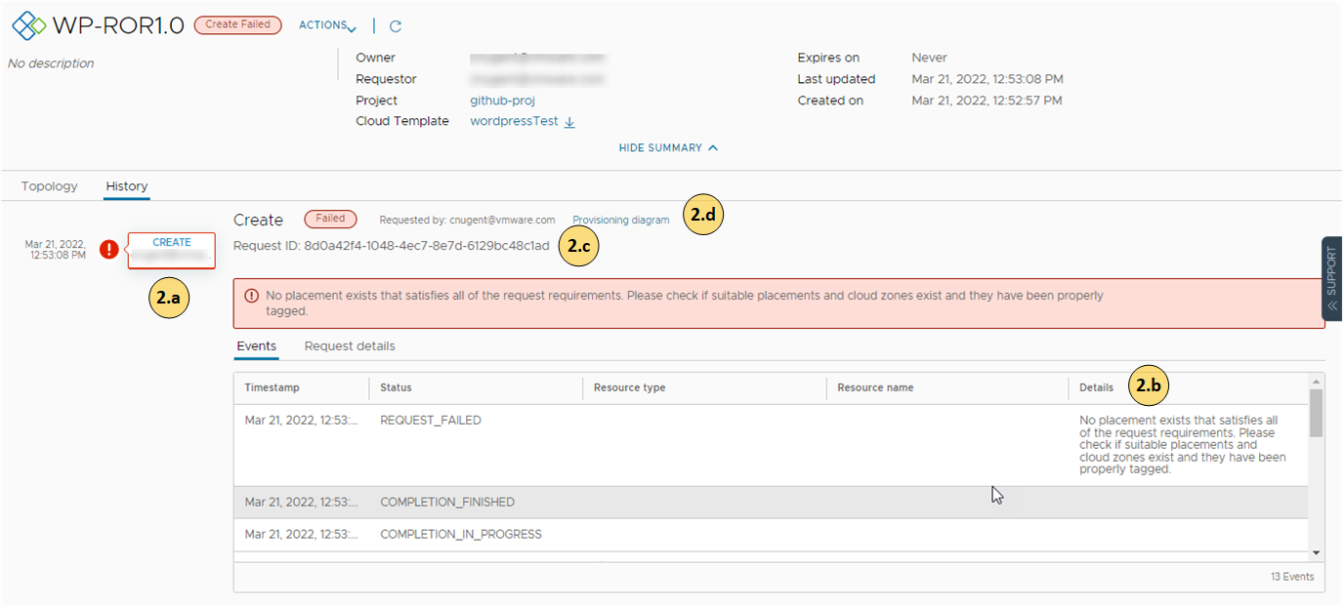
  - Review the event tree to see where the provisioning process failed. This tree is useful when you modify a deployment, but the change fails.
The tree also shows when you run deployment actions. You can use the tree troubleshoot failed changes.
  - The Details provides a more verbose version of the error message.
  - The request ID specifically identifies each request in the tree. You can use the ID to locate a request in the Infrastructure > Activity > Requests page. You might also use it for billing purposes.
  - If the requested item was an VCF Automation cloud template, the link to the right of the message opens VCF Automation so that you can see the Request Details.
- The Request Details provides the provisioning workflow for failed components so that you can research the problem.
The request history is retained for 48 hours.
View and filter deleted deployment history for up to 90 days after deletion
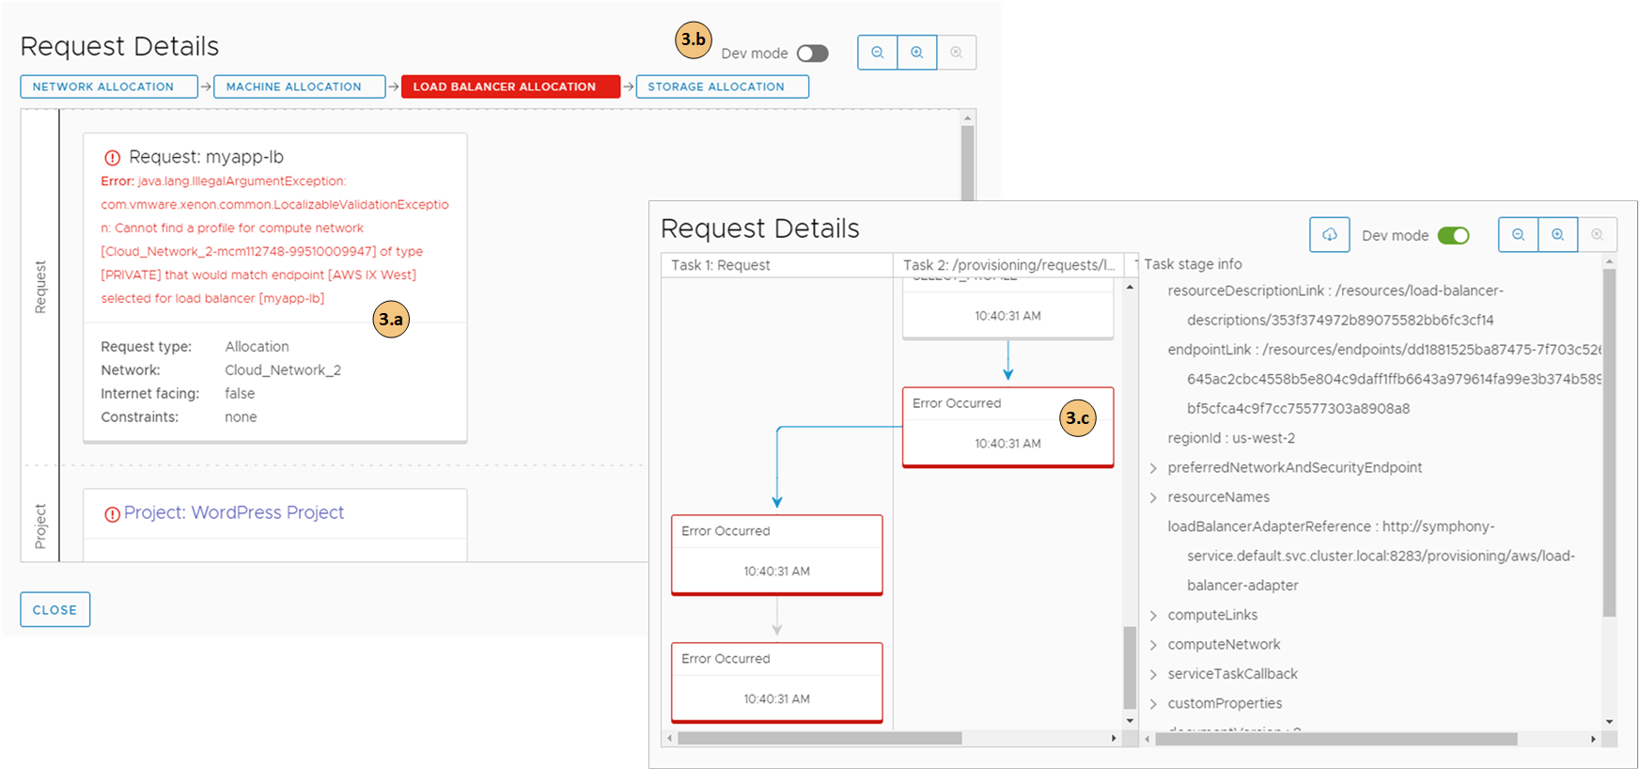
  - Review the error message.
  - You can turn on the Dev mode to switch between the simple provisioning workflow and a more detailed flowchart.
  - Click the card to review the deployment script.
- Resolve the errors and redeploy the cloud template.
The errors might be in the template construction or they might be related to how your infrastructure is configured.
What to do next
When the errors are resolved and the cloud template is deployed, you can see information similar to the following example in the Request Details. To see the request details, select Infrastructure > Activity > Requests.
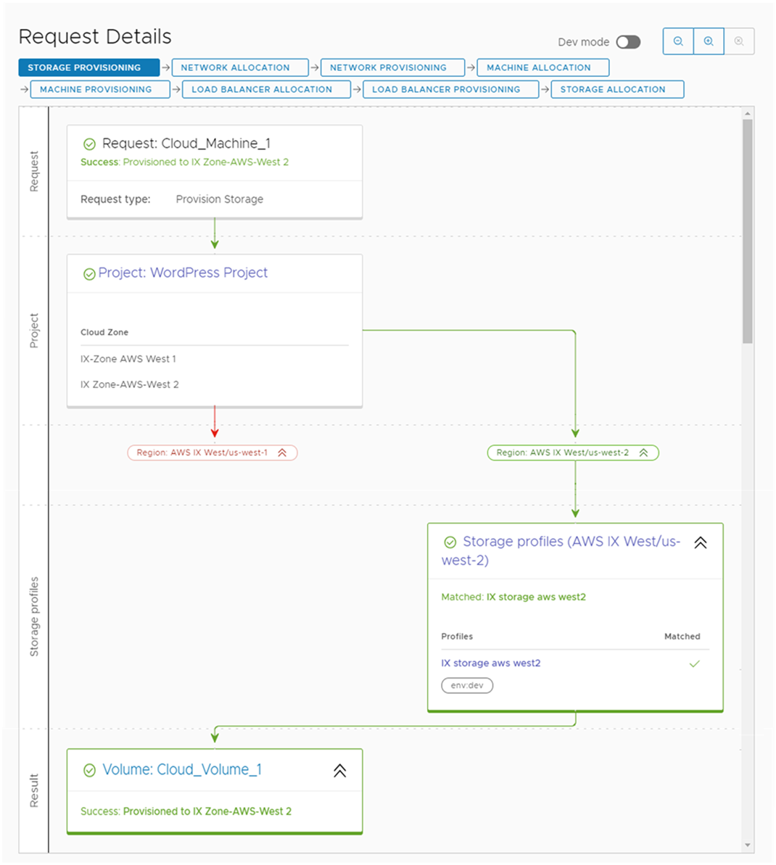

Deployments and Resources share content - Assembler, Consumption, vRA 7.5
This is shared content verify the targets before and after making any changes.

Working with deployment cards and the deployment list
You can locate and manage your deployments using the card list. You can filter or search for specific deployments, and then run actions on those deployments.
Figure 1-7. Deployments page card view

- Filter your requests based on attributes.
For example, you can filter based on owner, projects, lease expiration date, or other filtering options. Or you might want to find all the deployments for two projects with a particular tag. When you construct the filter for the projects and tag example, the results conform to the following criteria: (Project1 OR Project2) AND Tag1.
The values that you see in the filter pane depend on the current deployments that you have permission to view or manage.
Most of the filters and how to use them are relatively obvious. Additional information about some of these filters is provided below.
- Search for deployments based on keywords or requester.
- Sort the list to order by time or name.
- Switch between the deployment card and the deployment grid views.
- Run deployment-level actions on the deployment, including deleting unused deployments to reclaim resources.
You can also see deployment costs, expiration dates, scheduled deletion dates, and status.
To adjust what information you see for your deployments, click Manage Columns in the bottom left of the deployment grid and select your preferred columns.
You can switch between the card and grid view in the upper right of the page, to the right of the Sort text box. You can use the grid view to manage a large number of deployments on fewer pages.
Figure 1-8. Deployment page grid view


Working with the resource lists
You can use the resource lists to manage the following resource types: machines, storage volumes, networks, load balancers, and security groups that make up your deployments. In the resource list you can manage them in resource type groups rather than by deployments.
- All Resources
Includes all the discovered, deployed, migrated, and onboarded resources described in the following sections.
- Virtual Machines
Individual virtual machines. The machines might be part of larger deployments.
Only administrators have permission to use the Create New VM option. Administrators can turn the option on in VCF Automation by selecting Infrastructure > Administration > Settings and turning on Create new resource. To control the amount of resources that VCF Automation users might deploy, it is likely that your administrator added approval policies to reject or approve any deployment requests based on the image used or the flavor or size requested.
- Volumes
Administrators should know that by activating the option, VCF Automation users can create VMs based on any image and any flavor even through they are not administrators themselves. To avoid the potential overconsumption of resources, administrators can create approval policies to reject or approve any deployment requests based on the image used or the flavor or size requested.
Storage volumes that were discovered or associated with deployments.
- Networking and Security
Includes networks, load balancers, and security groups.
Similar to the deployment list view, you can filter the list, select a resource type, search , sort, and run actions.
If you click the resource name, you can work with the resource in the context of the resource details.
Figure 1-9. Virtual Machines page list
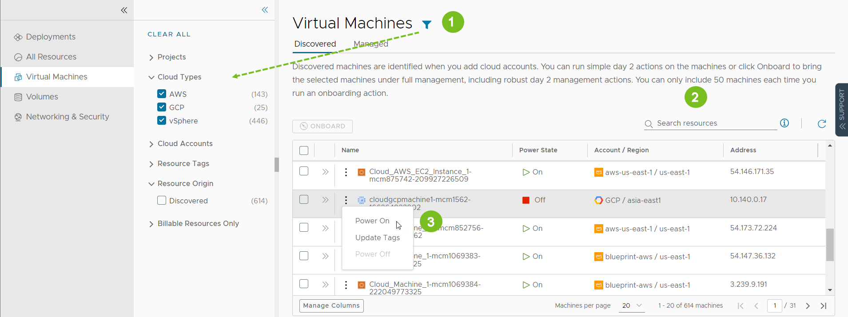
- Filter your list based on resource attributes.
For example, you can filter based on project, cloud types, origin, or other attributes.
- Search for resources based on name, account regions, or other values.
- Run available day 2 actions that are specific to the resources type and the resource state.
For example, you might power on a discovered machine if it is off. Or you might resize an onboarded machine.
In addition to the search and filter options on each page, the All Resource page includes a Resource Type selector where you can construct a filter for all the resources.
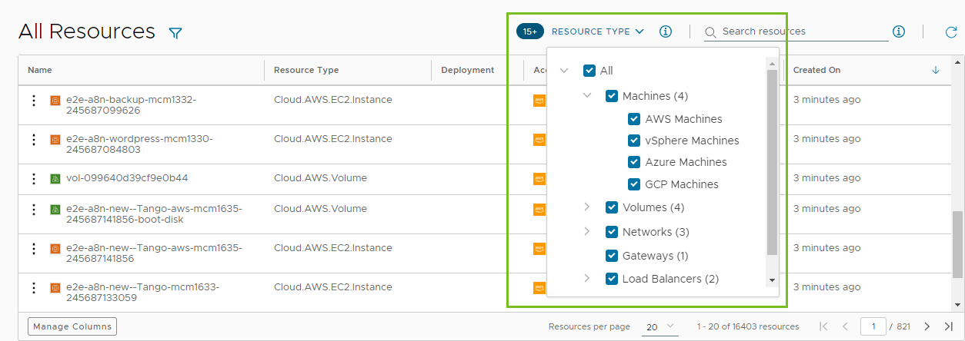

Working with the resource details view
You can use the resource details view to get a deeper look at the selected resource. Depending on the resource, the details can include networks, ports, and other information collected about the machine. The depth of the information varies depending on cloud account type and origin.
To open the details pane, click the resource name or the double arrows.
Figure 1-10. Resources details pane


Working with selected deployment filters
The following table is a not a definitive list of filter options. Most of them are self-evident. However, some of the filters require a little extra knowledge.
Table 1-8. Selected filter information
Filter name | Description
Optimizable Resources Only | If you integrated VCF Operations and are using the integration to identify reclaimable resources, you can toggle on the filter to limit the list of qualifying deployments.
Deployment Lifecycle Status | The Deployment Lifecycle Status and Last Request Status filters can be used individually or in combination, particularly if you manage a large number of deployments. Examples are included at the end of the Last Request Status section below.  Deployment Lifecycle Status filters on the current state of the deployment based on the management operations.  This filter is not available for deleted deployments.  The values that you see in the filter pane depend on the current state of the listed deployments. You might not see all possible values. The following list includes all the possible values. Day 2 actions are included in the Update status.  - Create - Successful  - Create - In Progress  - Create - Failed  - Update - Successful  - Update - In Progress  - Update - Failed  - Delete - In Progress  - Delete - Failed
Last Request Status filters | Last Request Status filters on the last operation or action that ran on the deployment.  This filter is not available for deleted deployments.  The values that you see in the filter pane depend on the last operations that ran on the listed deployments. You might not see all possible values. The following list is all of the possible values.  - Pending. The first stage of a request where the action is submitted but the deployment process has not yet started.  - Failed. The request experienced a failure during any stage of the deployment process.  - Cancelled. The request was cancelled by a user while the deployment process was processing and not yet completed.  - Successful. The request successfully created, updated, or deleted a deployment.  - In Progress. The deployment process is currently running. Additional deployment states, for example, Initialization and Completion that you see in the deployment History tab are not provided as filters, but you can use the In Progress filter to locate deployments in those states.  - Approval Pending. The request triggered one or more approval policies. The process is waiting for a response to the approval request.  - Approval Rejected. The request was denied by the approvers in the triggered approval policies. The request does not continue.  The following examples illustrate how the how to use the Deployment Lifecycle Status and Last Request Status filters individually or together.  - To find all delete requests that failed, select Delete - Failed in the Deployment Lifecycle Status filter.  - To find all the requests waiting for approval, select Approval Pending in the Last Request Status filter.  - To find the delete requests where the approval request is still pending, select Delete - In Progress in the Deployment Lifecycle Status filter and Approval Pending in the Last Request Status filter.

Working with the deployment resources

Working with deployment details
You use the deployment details to understand how the resources are deployed and what changes have been made. You can also see pricing information, the current health of the deployment, if the deployment expires and when it's scheduled for deletion, and if you have any resources that need to be modified.

- Topology tab. You can use the Topology tab to understand the deployment structure and resources.
- History tab. The History tab includes all the provisioning events and any events related to actions that you run after deploying the requested item. If there are any problems with the provisioning process, the History tab events helps you with troubleshoot the failures.
- User Events tab. You can use the User Events tab to provide and track the user interactions for your deployment. The events include any initial input values, any required approvals, input values for day 2 changes, and any values that you must provide as part of a deployment or for a day 2 action workflow. Where the request requires input values, you can also enter the values on the Inputs tab in VCF Automation.
For deployments that include VCF Operations Orchestrator workflow user events, where you enter values during the deployment process, there are some situations where the tab does not display the form or where the workflow is canceled. If you have multiple VCF Operations Orchestrator instances that do not have tags or where they all have the same tag, the form does not load. Ensure that you correctly tag the instances so that the form displays on the tab. If there are not assignees in the workflow form, the workflow is canceled and the deployment or action fails. Ensure that you workflow form includes assignees.
- Price tab. You can use the pricing tab for insights about how much your deployment is costing your organization. Pricing information is provided by your VCF Operations or CloudHealth integrations.
- Monitor tab. The Monitor tab data provides information about the health of your deployment based on data from VCF Operations.
- Alerts tab. The Alerts tab provides active alerts on the deployment resources. You can dismiss the alert or add reference notes. The alerts are based on data from VCF Operations.
- Optimize tab. The Optimize tab provides utilization information about your deployment and offers suggestions for reclaiming or otherwise modifying the resources to optimize resource consumption. The optimization information is based on data from VCF Operations.

How do I know that my deployment request succeeded
The deployment cards that appear on the Deployments page show the state of the deployment, including in-progress (top) and completed (below). The card includes the number of deployed resources, how long it has been deployed, and the lease expiration date.
The cards also provide the IP addresses and the actions that you can run on the deployment.

If a deployment fails, the cards show the error message for the point of failure and the process progress. To learn more about the failure, click the deployment name at review the History tab.
For more information about troubleshooting failed deployments, see


Where are my resources deployed
To access your successfully provisioned deployments, you might need more than the IP address provided on the card. Click the deployment name and review the deployment details on the Topology tab.

You most likely need the IP address for the primary component. As you click on each component, notice the information that is provided is specific to that component.
The availability of the external link depends on the cloud provider. Where it is available, you must have the credential on that provider to access the component.

Troubleshooting workflow
Each deployment failure can have different causes. You use the workflow to begin your investigation. Your investigation might reveal that the failure was due to a transient environmental problem. Redeploying the request after verifying the conditions have improved resolves this type of problem. In other cases, your investigation might require you to examine other areas in detail.
As a project member, you can review the request details in VCF Automation.
Table 1-9. Start Troubleshooting Errors
Workflow | Troubleshooting Application | Example
 | On the Deployments page, failed deployments are indicated on the status bar. The card includes the last failure message. For more information, click the deployment name.
 | On the deployment details History tab, you can use the event tree to see where the provisioning process failed. This tree is useful when you modify a deployment, but the change fails. | 
 | The Status Reason provides a more verbose version of the error message.
 | If the requested item was a VCF Automation cloud template, the link in the Details column opens VCF Automation so that you can see the related information. It might be cloud account details or Request Details.
 | The default Request Details provides a simple provisioning workflow that you can use to research the failure. | 
 | You can turn on the Dev mode to switch between the simple provisioning workflow and a more detailed flowchart.  Click the card. The details appear on the right.
 | The swimlane flowchart provides more detailed information that you can use to identify the problem.

List of managed resources by origin
You can use the Resources tab to manage the following types of resources.
Table 1-10. Resource origins
Managed Resource | Description
Deployed | Deployments are fully manage workloads that are deployed cloud templates or onboarded resources. The workload resources can include machines, storage volumes, networks, load balancers, and security groups.  You can manage your deployments in the Deployments section.
Discovered | Discovered resources are the machines, storage volumes, networks, load balancers, and security groups that the discovery process identified for each cloud account region that you added.  Only VCF Automation Administrators can see and manage discovered resources in the Resources section.
Migrated | Migrated resources are the 7.x deployments that your migrated to VCF Automation. The migrated resources can include machines, storage volumes, networks, load balancers, and security groups. Migrated resources are managed like deployments.  You can manage migrated resources in the Deployments section.
Onboarded | Onboarded resources are discovered resources that you bring under more robust VCF Automation management. Onboarded resources are managed like deployments.  You can manage onboarded resources in the Deployments section.

Working with the resource lists
You can use the resource list to manage the machines, storage volumes, and networks that make up your deployments. In the resource list you can manage them in resource type groups rather than by deployments.
Similar to the deployment list view, you can filter the list, select a resource type, search, sort, and run actions.
If you click the resource name, you can work with the resource in the context of the deployment details.
If your administrator turned on the Create new resource setting, VCF Automation viewers and administrators, and project members have the option to Create New VM. Administrators can turn on the setting by selecting Infrastructure > Administration > Settings. To control the amount of resources that VCF Automation users might deploy, it is likely that your administrator added approval policies to reject or approve any deployment requests based on the image used or the flavor or size requested.
Figure 1-11. Resources page list

- Filter your list based on resource attributes.
For example, you can filter based on project, cloud types, origin, or other attributes.
- Search for resources based on name, account regions, or other values.
- Run available day 2 actions that are specific to the resources type and the resource state.
For example, you might power on a discovered machine if it is off. Or you might resize an onboarded machine.

What is the resource details view
You can use the resource details view to get a deeper look at the selected resource. Depending on the resource, the details can include networks, ports, and other information collected about the machine. The depth of the information varies depending on cloud account type and origin.
To open the details pane, click the resource name or the double arrows.
Figure 1-12. Resources details pane


What day 2 actions can I run on resources
The available day 2 actions depend on the resource origin, cloud account, resource type, and state.
Table 1-11. List of actions by origin
Resource Origin | Day 2 Actions
Deployed | The actions that are available to run on the resources depend on the resource type, cloud account, and status. For a detailed list, see XREF TO CA OR SB DEPLOYMENT ACTION TOPIC.
Discovered | The available actions for discovered resources are limited to virtual machines. Depending on the status, you can perform the following actions.  - Power Off  - Power On  Additional vSphere virtual machine action.  - Connect to Remote Console
Migrated | Migrated resources have the same day 2 action management options as deployments. The actions that are available to run on the migrated resources depend on the resource type, cloud account, status, and day 2 policies. For a detailed list, see XREF TO CA OR SB DEPLOYMENT ACTION TOPIC.
Onboarded | Onboarded resources have the same day 2 action management options as deployments. The actions that are available to run on the onboarded resources depend on the resource type, cloud account, status, and day 2 policies. For a detailed list, see XREF TO CA OR SB DEPLOYMENT ACTION TOPIC.

Locate discovered virtual machines
Discovered resources are collected from the cloud account region and added to the resources on the Resource tab. This example focuses on virtual machines, but other resource types are collected, including storage and network information.
- Select Resources > Virtual Machines > Discovered.
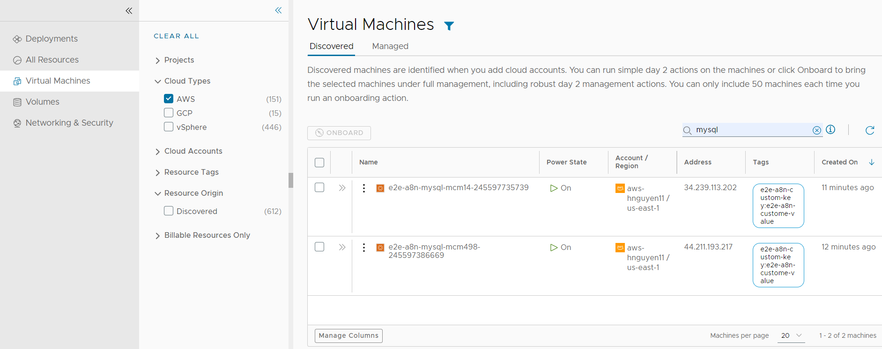
- To locate the AWS virtual machines, click the Filter icon near the page label.
- In the filter list, expand Cloud Types and select AWS.
The list is now limited to discovered AWS virtual machines. You can see deployed, discovered, and other origin types on the Managed tab.
- To locate a particular machine, you can use the Search resources option to search by name, IP address, tags, or values.
In this example, mysql is the search term.

Locate discovered virtual machines
Discovered resources are collected from the cloud account region and added to the resources on the Deployments node on the Consume tab. This example focuses on virtual machines, but other resource types are collected, including storage and network information.
- Select Consume > Deployments > Virtual Machines > Discovered.
- To locate the AWS virtual machines, click the Filter icon near the page label.
- In the filter list, expand Cloud Types and select AWS.
The list is now limited to discovered AWS virtual machines. You can see deployed, discovered, and other origin types on the Managed tab.
- To locate a particular machine, you can use the Search resources option to search by name, IP address, tags, or values.
In this example, mysql is the search term.

Review virtual machine details
The resource details include all the collected information for the resource. You can use this information to understand the resource and any associations with other resources.
- Locate the virtual machine in the Virtual Machine list.
- To view the resource details, click the machine name or click the double arrows in the left column.
The details pane opens on the right side of the list.

- Review the details, including storage, networks, custom properties, and other collected information.
- To close the pane, click the double arrows or click the resource name.

Run day 2 actions on the virtual machine
You use the day 2 actions to manage the resources. The current actions for discovered virtual machines includes Power On and Power Off. If you are managing a vSphere virtual machine, you can also run Connect with Remote Console.
- Locate the machine in the Virtual Machines list.
- Click the vertical ellipsis to see the available actions.
The possible actions for an AWS virtual machine are Power Off and Power On. Power On is not active because the machine is already on.
- Click Power Off and submit the request.

When the process is completed, the machine is powered off. You can now power it back on.

Locate virtual machine resources
Deployed, onboarded, and migrated virtual machines are available on the All Resources page and the Managed tab on the Virtual Machines page. This example focuses on virtual machines, but you can apply the same workflow to the other resource types.
- Select Resources > Virtual Machines > Managed.
- Locate your virtual machine.
You can use the filters or the search to locate particular resources.
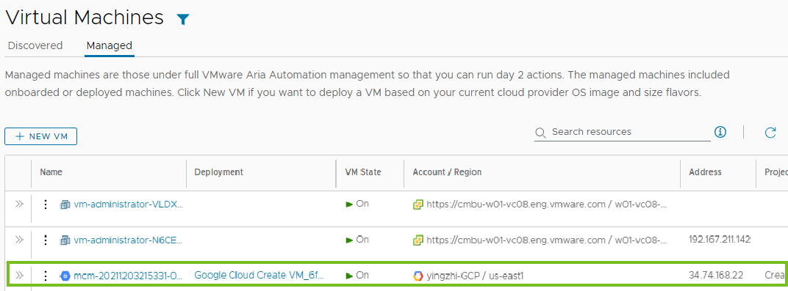

Locate virtual machine resources
Deployed, onboarded, and migrated virtual machines are available on the Resources page and the Managed tab on the Virtual Machines page. This example focuses on virtual machines, but you can apply the same workflow to the other resource types.
- Select Consume > Deployments > Virtual Machines > Managed.
- Locate your virtual machine.
You can use the filters or the search to locate particular resources.


Review the virtual machine details
The resource details provide a quick view of the machine information, including networks, custom properties, and other collected information.
- Locate the machine in the Virtual Machines list.
- Click the double arrows next to the resource name in the left column of the table.
The details pane opens on the right side of the list.
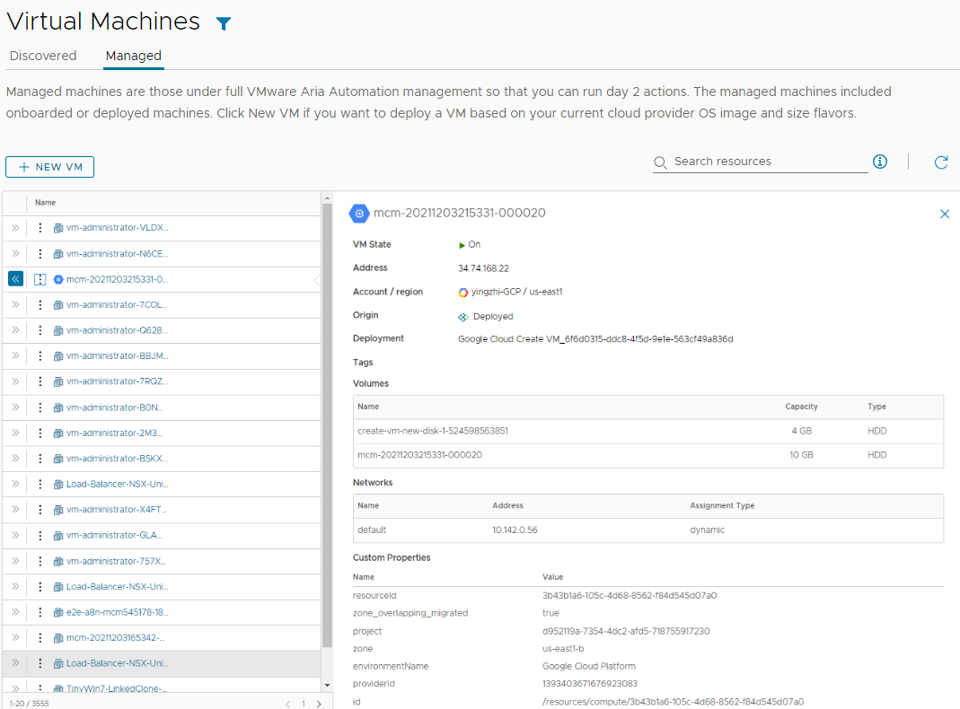
- To close the pane, click the double arrows or the resource name.

Run day 2 actions on the virtual machine
You use the day 2 actions to manage your resources. The available actions depend on the resource type, the state of the resource, and the day 2 action policies that are enforced.
- Locate the machine in the Virtual Machines list.
- Click the vertical ellipsis to see the available actions.
- Click the action.
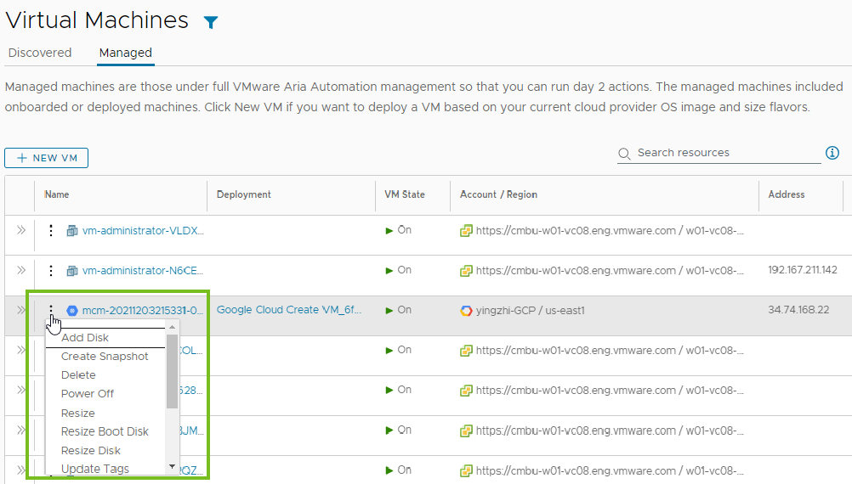

Viewing billable objects
As an VCF Automation or an VCF Automation administrator, you can monitor what billable objects are used in your organization. Counted objects include billable virtual machines, CPUs, and cores that are in use at view time. It might take up to ten minutes for the object count data to refresh.
When viewing resource lists, you can use the Billable Resources Only filter in combination with other available filters.

If you force delete a deployment, the resource count might not match what is displayed in the resource list. You must delete the virtual machine from the corresponding IaaS layer, such as vCenter.
What is actually counted towards the bill depends on your VCF Automation subscription commit contract and entitlement type.
To learn more about billing in VCF Automation, see this article.

Onboarding virtual machines
You can quickly onboard discovered machines from the Virtual Machines page. Onboarding gets you full day 2 management capabilities for the onboarded resources. See What actions can I run on deployments or supported resources in VCF Automation for VM Apps.
- On the Discovered tab, select the machines that you want to onboard and then click Onboard.
You can onboard up to 50 virtual machines at a time.
- Follow the prompts in the onboarding wizard.
  - Select a project for the machines.
  - Select if you want to group the machines into a single deployment or if you want to create a separate deployment for each machine.
  - Click Next.
  - Review the deployment summary. You can update the deployment name and owner by clicking the deployment name.
  - When you're done, click Onboard.
The selected machines are onboarded.
- To view the deployment, go to Resources > Deployments and then click the deployment name.
- You manage your onboarded machines, go to Virtual Machines > Managed.
If you need to onboard more than 50 machines, you create an onboarding plan. See What are onboarding plans.

Provision and Manage Virtual Machines
You can use a variety of methods to provision VMs with the VM Service in vSphere Supervisor.
If you have access to VCF Automation for All Apps, the Iaas Services Console provides a graphical user interface for provisioning VMs using the VM Service.
If the Supervisor Admin has deployed the Local Consumption Interface, the Local Consumption Interface also provides a graphical user interface for provisioning VMs.
In addition, the VCF CLI and kubectl provide command-line interfaces for provisioning VMs. If you have the access to VCF Automation for All Apps, use VCF CLI and kubectl in the namespace of your organization, provided to by your organization administrator.

What to Read Next
- Provision a VM Using Self-Service
- Deploying and Managing Virtual Machines in vSphere Supervisor

Provision a VM Using Self-Service
You can provision VMs using the the VM Service in vSphere Supervisor.
If you have access to VCF Automation for All Apps, the Iaas Services Console provides a graphical user interface for provisioning VMs using the VM Service. As you go through the configuration procedure, the Kubernetes resource YAML manifest is generated in real time on the right.
If the Supervisor Admin has deployed the Local Consumption Interface, the Local Consumption Interface also provides a graphical user interface for provisioning VMs.
Prerequisites
- Verify that you have access to a namespace.
- The namespace must have access to the content library that contains the VM image.
Procedure
- Log in to the interface you are using by following the steps in Access the IaaS Services Console or Local Consumption Interface.
- On the Virtual Machine Service card, click Create VM.
Alternatively, click Go to Service, then, on the Virtual Machines tab, click Create VM.
- Select the source for the VM.
The configuration options depend on what file type you choose. This procedure uses the OVF file type.
- Click Next.
- Configure VM class and storage class.
Zone | You have the following options:  - Automatic. A zone is automatically selected based on the VM requirements. You cannot add storage volume later.  - Select a specific zone, in which case you can add storage later.
VM Image | Select the image you want to provision. The VM images available for selection are pulled from the content library associated with the namespace.
VM Class | best-effort-xsmall
Storage Class | global-storage-profile  The options that are available to you depend on what destinations your organization administrator defined.
Power State | Select if you want the VM to be initially powered on or off.
- Click Next to configure an advanced VM.
If you are provisioning a basic VM, you can skip steps 7 and 8 and click Review and Confirm to finalize your configuration.
- Configure advanced settings.
Persistent Volume | Click Attach Volume.  The volumes have their own life cycle and are managed independently from the VM. For example, if you provisioned a MySQL database and then you delete the VM, you can reattach the database to another VM.  If you selected automatic zone selection in step 8, you cannot attach additional volumes.
Load Balancer | Click Add and select New or Existing.
Guest Customization | - Cloud-init. Recommended for Linux.  - Sysprep. Recommended for Windows.  - Linuxprep. Focused on VMware VM.  - vAppConfig. OVA and OVF formats.
- Configure networking for the VM.
Add Network Interface | Subnet set available for the VM.
- On the Review and Confirm tab, click Deploy VM.
Consider copying the Kubernetes resource YAML manifest to clipboard or downloading it as a .zip file. You can reuse the manifest to provision VMs with the same or modified configuration from the command line. You can also store the manifest in a source control repository like GitHub.
Results
The provisioning process begins and the Virtual Machines tab on the Virtual Machine Service page opens with your current request at the top.
What to do next
Review your provisioned VM.
- Click the VM name to open the VM Details page, where you can perform day 2 operations on the VM like powering it off or on, attaching additional disk volumes, increasing volume capacity, or detaching volumes from the VM.
- Click the double arrows next to the VM name to expand the details view.
- Click View YAML to view the active configuration of the VM Kubernetes object. You can edit certain fields in the manifest directly. For example, if the VM was Powered On in the original configuration, you can change the powerState to PoweredOff.
- Click the vertical ellipsis next to the VM name to view your options, such as opening the remote or web console or deleting the VM.

Deploying and Managing Virtual Machines in vSphere Supervisor
With the VM Service functionality, DevOps engineers can deploy and run VMs, in addition to containers, in a common, shared Kubernetes environment. You can use the VM Service to manage the lifecycle of virtual machines in a namespace. VM Service manages stand-alone VMs and VMs that make up VKS clusters.
The VM Service addresses the needs of DevOps teams that use Kubernetes, but have existing VM-based workloads that cannot be easily containerized. It also helps users reduce the overhead of managing a non-Kubernetes platform alongside a container platform. When running containers and VMs on a Kubernetes platform, DevOps teams can consolidate their workload footprint to just one platform.
Note In addition to stand-alone VMs, the VM Service manages the VMs that make up VKS clusters. For information about the clusters, Managing vSphere Kubernetes Service Clusters and Workloads.
Figure 2-13. VM Service Architecture
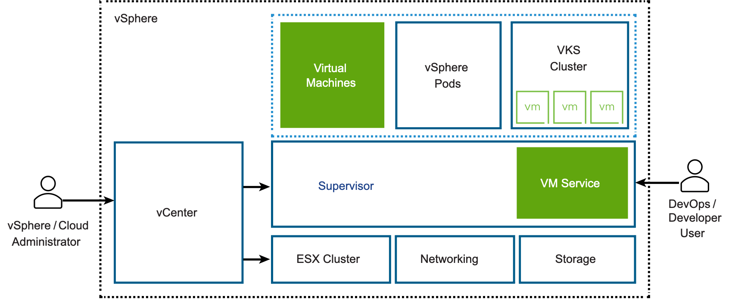
Each VM deployed through the VM Service functions as a complete machine running all the components, including its own operating system, on top of the Supervisor infrastructure. The VM has access to networking and storage that the Supervisor provides, and is managed using the standard Kubernetes kubectl command. The VM runs as a fully isolated system that is immune to interference from other VMs or workloads in the Kubernetes environment.

When to Use Virtual Machines on a Kubernetes Platform?
Generally, a decision to run workloads in a container or in a VM depends on your business needs and goals. Among the reasons to use VMs appear the following:
- Your applications cannot be containerized.
- You have specific hardware requirements for your project.
- Applications are designed for a custom kernel or custom operating system.
- Applications are better suited to running in a VM.
- You want to have a consistent Kubernetes experience and avoid overhead. Rather than running separate sets of infrastructure for your non-Kubernetes and container platforms, you can consolidate these stacks and manage them with a familiar kubectl command.

Concepts of VM Service
To describe the state of a VM to be deployed in a vSphere Namespace, you use such parameters as a VM class, a VM image, and a storage class. The VM Service then brings together these specifications to create stand-alone VMs or VMs that support VKS clusters.
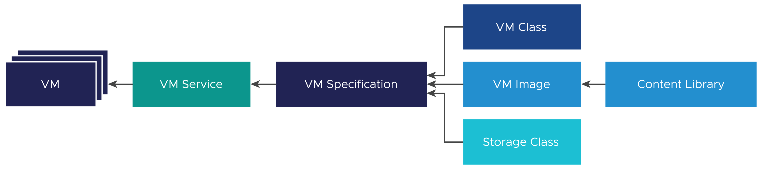
VM Service
VM Class
VM Image
Content Library
Storage Class
VM Specification
VM Operator for Kubernetes
Networking

VM Service and Supervisor with vSphere Zones
When you create VMs on a three-zone Supervisor, the VM instance is replicated across all available zones. To control the VMs placement through the YAML file, the DevOps team can use the Kubernetes label topology.kubernetes.io/zone. For example, topology.kubernetes.io/zone: zone-a02.

Workflow for Provisioning and Monitoring a VM
As a vSphere administrator, you set guardrails for the policy and governance of the VMs, and deliver VM resources, such as VM classes and VM templates to DevOps engineers. After a VM is deployed, you can monitor it using the .
Step | Performed by | Description
1 | vSphere administrator | Creating and Managing Content Libraries for Stand-Alone VMs in vSphere Supervisor
2 | vSphere administrator | Working with VM Classes in vSphere Supervisor  To use NVIDIA vGPU, configure a PCI device in the VM class. See Deploying a VM with vGPU and Other PCI Devices in a Supervisor.
3 | DevOp engineer | Deploying a Stand-Alone VM in vSphere Supervisor  For VKS cluster VMs, see the VKS cluster documentation.
4 | vSphere administrator | Monitor Virtual Machines Available in vSphere Supervisor
5 | DevOps engineer | Manage and Publish Content Library Images in vSphere Supervisor

Creating and Managing Content Libraries for Stand-Alone VMs in vSphere Supervisor
To deploy virtual machines in the Supervisor environment, DevOps users must have access to VM images, or templates, that contain software configurations, including operating systems, applications, and data. To provide access to images, a vSphere administrator configures a VM content library, and then associates it with the namespace where the VMs are deployed. Starting with vSphere 8.0 Update 2, the vSphere administrator can also assign the content library at a Supervisor level, so that it becomes available to all namespaces.

Create a Content Library for Stand-Alone VMs in the Supervisor Environment
As a vSphere administrator, create a content library to store and manage VM templates.

Create a Content Library for Stand-Alone VMs
You can create a local content library and populate it with templates and other types of files. You can also create a subscribed library to use the contents of an already existing published local library.
To protect the items of a content library, you can apply an OVF security policy. The OVF security policy enforces strict validation when you deploy or update a content library, import items to a content library, or synchronize templates. To make sure that the templates are signed by a trusted certificate, you can add the OVF signing certificate from a trusted CA to a content library.
For more information about content libraries and VM templates in vSphere, see Using Content Libraries in vSphere Virtual Machine Administration.
Prerequisites
Required privileges:
- Content library > Create local library orContent library > Create subscribed library on the vCenter instance where you want to create the library.
- Datastore > Allocate space on the destination datastore.
Procedure
- Navigate to the VM Service page.
  - From the home menu, select Supervisor Management.
  - Click the Services tab and click Manage on the VM Service card.
- On the VM Service page, click Content Libraries > Create a content library.
This action takes you to the content library section in the vSphere Client.
- Click Create.
The New Content Library wizard opens.
- On the Name and location page, enter a name, select a vCenter instance for the content library and click Next.
Make sure to use an informative name for the content library, so that your DevOps team can easily find and access the library items.
- On the Configure content library page, select the type of content library that you want to create and click Next.
Option | Description
Local content library | A local content library is accessible only in the vCenter instance where you create it by default.(Optional)  - To make the content of the library available to other vCenter instances, select Enable publishing.  - If you want to require a password for accessing the content library, select Enable authentication and set a password.
Subscribed content library | A subscribed content library originates from a published content library. Use this option to take advantage of existing content libraries.  You can synchronize the subscribed library with the published library to see up-to-date content, but you cannot add or remove content from the subscribed library. Only an administrator of the published library can add, modify, and remove contents from the published library.  Provide the following information to subscribe to a library:  - In the Subscription URL text box, enter the URL address of the published library.  - If authentication is enabled on the published library, select Enable authentication and enter the publisher password.  - Select a download method for the contents of the subscribed library.  - If you want to download a local copy of all the items in the published library immediately after subscribing to it, select immediately.  - If you want to save storage space, select when needed. You download only the metadata for the items in the published library.  If you need to use an item, synchronize the item or the entire library to download its content.  - If prompted, accept the SSL certificate thumbprint.  The SSL certificate thumbprint is stored on your system until you delete the subscribed content library from the inventory.
- (Optional) On the Apply security policy page, select Apply Security Policy and select OVF default policy.
For the subscribed library, this option appears only if the library supports security policies.
If you select this option, the system performs a strict OVF certificate verification when importing an OVF item to the library from the local host or synchronizing an item. The OVF items that do not pass the certificate validation cannot be imported.
If the item does not pass the validation during synchronization, it is marked with the Verification Failed tag. Only the item and metadata will be kept, but not the files in the item.
- On the Add storage page, select datastore as a storage location for the content library contents and click Next.
- On the Ready to complete page, review the details and click Finish.

Populate a Content Library with VM Images for Stand-Alone VMs
After you create the content library, populate it with VM templates in OVA or OVF format. Your DevOps engineers can use the templates to provision new stand-alone virtual machines.
You can use several methods to populate the library. This topic describes how to add items to a local content library by importing files from your local machine or from a Web server. For other ways to populate the content library, see Populating Libraries with Content in vSphere Virtual Machine Administration.
Note There are no restrictions on the VM images that you use. If you want to test ready-to-use OVA images, you can download them from the Recommended Images page. Keep in mind that these images are for POC use only. In the production environment, create images with latest patches and required security settings that follow corporate security policies.
Prerequisites
- Create VM images that are compatible with the vSphere Supervisor environment.
The image specification requires that all VM images include VMware Tools or an equivalent open source package. The images must use one of the following to bootstrap the guest OS and its networking stack. For more information, see Bootstrap Providers.
  - Linux + Cloud-Init version 17.9-21.2 with DataSourceVMwareGuestInfo.
  - Linux + Cloud-Init version 21.3+
  - Windows + Cloudbase-Init version 1.1.0+
  - Windows + Sysprep (System Preparation)
For information about Cloud-Init, see the official documentation at The standard for customising cloud instances.
For information about Sysprep, see the official documentation at Sysprep overview.
- If your library is protected by a security policy, make sure that all library items are complaint. If a protected library includes a mix of compliant and non-compliant items, the kubectl get virtualmachineimages fails to present VM images to the DevOps engineers.
- Required privilege:Content library > Add library item andContent library > Update files on the library.
Procedure
- From the home menu, select Content Libraries.
- Right-click a local content library and select Import Item.
The Import Library Item dialog box opens.
- In the Source section, select the source of the item.
Option | Description
URL | Enter the path to the Web server where the item is.  Note You can import either an .ovf or .ova file. The resulting content library item is of the OVF Template type.
Local File | Click Upload File to navigate to the file that you want to import from your local system. You can use the drop-down menu to filter files in your local system.  Note You can import either an .ovf or .ova file. When you import an OVF template, first select the OVF descriptor file (.ovf). Next, you are prompted to select the other files in the OVF template, for example the .vmdk file. The resulting content library item is of the OVF Template type.
vCenter reads and validates the manifest and certificate files in the OVF package during importing. A warning is displayed in the Import Library Item wizard, if certificate issues exist, for example if vCenter detects an expired certificate.
Note vCenter does not read signed content, if the OVF package is imported from an .ovf file from your local machine.
- In the Destination section, enter a name and a description for the item.
- Click Import.
Results
The item appears on the Templates tab or on the Other Types tab.
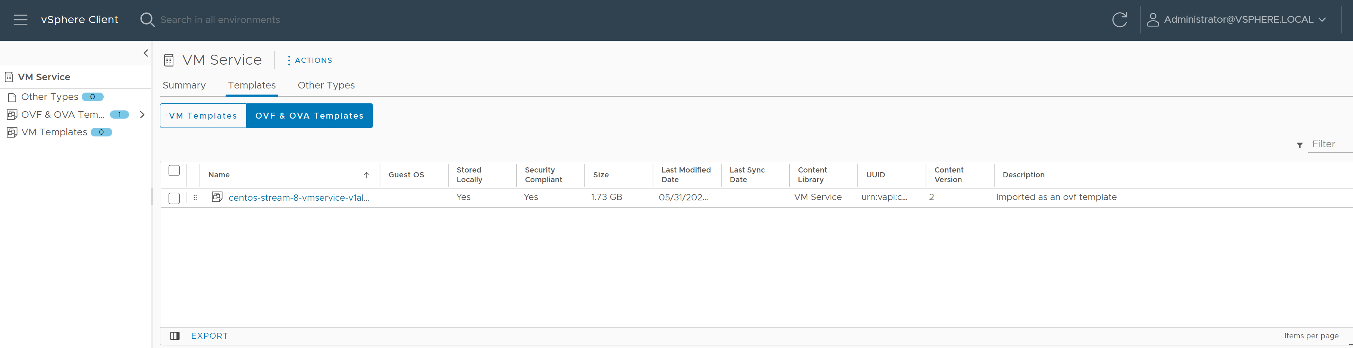

Add and Manage VM Content Libraries in vSphere Supervisor
After you create the content library and populate it with VM templates, use the to add the library to the namespace. By adding the library to the namespace, you give your DevOps users access to the library. In addition, you can use the Data Center CLI (DCLI) commands to add a writable or read-only content library to the namespace, or assign a read-only library at a cluster level.

Add a VM Content Library to a Namespace Using the vSphere Client
The content library that you add with the is read-only. The DevOps users can access images from this content library, but cannot publish VM images to this library.
You can add multiple content libraries to a single namespace. You can add the same content library to different namespaces.
Note This procedure applies only to content libraries for VM Service. A content library for VKS must be managed from the VKS card.
Prerequisites
Required privileges:
- Namespaces > Modify cluster-wide configuration
- Namespaces > Modify namespace configuration
Procedure
- In the , go to the namespace.
  - From the home menu, select Supervisor Management.
  - Click the Namespaces tab and click the namespace.
- Add a content library.
  - On the VM Service card, click Add Content Library.
  - Select one or several content libraries and click OK.

Manage VM Content Libraries on a Namespace Using the
After you associate the library with the namespace, you can use the to remove it from the namespace. You can also add more libraries.
Removing a content library from a namespace does not affect VMs that were previously deployed with the library images.
Note This procedure applies only to content libraries for VM Service. VKS content libraries must be managed from the VKS card.
Prerequisites
Required privileges:
- Namespaces > Modify cluster-wide configuration
- Namespaces > Modify namespace configuration
Procedure
- In the , go to the namespace.
  - From the home menu, select Supervisor Management.
  - Click the Namespaces tab and click the namespace.
- Add or remove a content library.
  - On the VM Service card, click Manage Content Library.
  - Perform one of the following operations.
Remove a content library | Deselect the content library and click OK.
Add a content library | Select one or several content libraries and click OK.
What to do next
OVF templates from the library become available in the Kubernetes namespace as VM images and can be used by DevOps to self-service VMs. See Deploy a Virtual Machine on a Namespace in a Supervisor.
Note Only OVF templates from the library show up in the namespaces. Other types of content do not show up in the namespace.

Add a VM Content Library to a Namespace Using Data Center CLI
As a vSphere administrator, you can use the Data Center CLI (DCLI) command to assign the content library to a namespace. When assigning the library, you can make the library associated with the namespace writable. When the library is writable, in addition to viewing the library and the images in the library, DevOps users can publish new VM images to it.
With the DCLI commands, you can add any type of the library, including local, published, and subscribed, to the namespace. However, only local and published can be linked as writable libraries.? Content libraries and library items are available only in the associated namespace?.
Procedure
- Log in to vCenter using the root user account.
- Type dcli +i to use the DCLI in interactive mode.
- Obtain the ID of the content library to be associated with the namespace.
dcli > namespacemanagement content library list
- Run the following command to associate the content library with the namespace.
The update operation is not incremental. Only libraries specified in the list will be associated with the namespace and the libraries that were added previously will be removed, unless their IDs are specified. For example, if you update '[{"content_library": "CLA", "writable": "true"}]' and then later update '[{"content_library": "CLB", "writable": "true"}]', CLA will be removed and only CLB will be added. If you want both CLA and CLB to be associated, you have to specify both libraries: '[{"content_library": "CLA", "writable": "true"}, {"content_library": "CLB", "writable": "true"}]'.
dcli > namespaces instances update --namespace namespace_name --content-libraries '[{"content_library": "content_library_ID", "writable": "true | false"}]'
Use the following arguments:
  - --namespace namespace_name – Name of the namespace.
  - --content_libraries content_library_ID writable: true | false – ID of the content library to be associated with the namespace and whether the library is writable or not.
For example,
dcli > namespaces instances update --namespace lb-edit-ns --content-libraries '[{"content_library": "cl-b585915ddxxxxxxxx", "writable": "true"}]'
- To delete the content library from the namespace, repeat the namespaces instances update command removing the content library entry from the array list.
For example,
dcli > namespaces instances update --namespace lb-edit-ns --content-libraries '[]'
Results
The added content library becomes available in the DevOps namespace view.
The DevOps user can run the following commands to verify that the content library has been added or deleted.
kubectl get cl -n lb-edit-ns
NAMESPACE NAME VSPHERENAME TYPE WRITABLE STORAGETYPE AGE
lb-edit-ns cl-b585915ddxxxxxxxx Test-ns-cl Local true Datastore 3m9s
kubectl describe cl cl-b585915ddxxxxxxxx -n lb-edit-ns
kubectl get clitem -n lb-edit-ns

Add a VM Content Library to Supervisor Using Data Center CLI
In addition to assigning the content library at a namespace level, the vSphere administrator can use the Data Center CLI (DCLI) command to associate the library with a Supervisor cluster. The content library becomes available to all namespaces in the Supervisor.
You can associate all types of libraries, including local, published, and subscribed.
Note The content library associated with the Supervisor is read-only. The DevOps users can only access VM images from this content library, but cannot publish VM images to this library.
Prerequisites
For more information about the DCLI commands, see VMware Data Center CLI.
Procedure
- Log in to vCenter using the root user account.
- Type dcli +i to use the DCLI in interactive mode.
- Obtain the name of the Supervisor and the ID of the content library to connect to the Supervisor.
  - Get the name of the Supervisor from the list of clusters.
The command lists all clusters available on vCenter.
dcli > namespacemanagement clusters list
  - List IDs of all content libraries of any type available on vCenter.
dcli > library list
  - Verify details for the specific library.
dcli > library get --library-id content_library_ID
- Associate one or more content libraries with the Supervisor.
The update operation is not incremental. Only libraries specified in the list will be associated with the namespace and the libraries that were added previously will be removed, unless their IDs are specified. For example, if you update '[{"content_library": "CLA", "writable": "true"}]' and then later update '[{"content_library": "CLB", "writable": "true"}]', CLA will be removed and only CLB will be added. If you want both CLA and CLB to be associated, you have to specify both libraries: '[{"content_library": "CLA", "writable": "true"}, {"content_library": "CLB", "writable": "true"}]'.
dcli > namespacemanagement clusters update --cluster cluster_name --content-libraries '[{"content_library": content_library_ID_1}, {"content-library": content_library_ID_2}]'
Use the following arguments:
  - --cluster cluster_name – Identifier for the Supervisor cluster.
  - --content-libraries content_library_ID – An ID of a content library to be associated with the Supervisor. You can list several IDs.
For example,
dcli > namespacemanagement clusters update --cluster cluster_name --content-libraries '[{"content_library": 535d4b3d-xxxx-xxxx-xxxx-xxxxxxxxxxxx}, {"content-library": b5aa7f68-xxxx-xxxx-xxxx-xxxxxxxxxxxx}]'
- Verity that the content libraries are connected to the cluster.
dcli > namespacemanagement clusters get --cluster cluster_name
The output must include the IDs of the connected content libraries.
- To delete the associated content library from the cluster, repeat the namespacemanagement clusters update command removing the content library entry from the content library array list.
For example,
dcli > namespacemanagement clusters update --cluster cluster_name --content-libraries '[]'
Results
The newly added content libraries become available in the DevOps cluster view. Any changes that the vSphere administrator makes to the content libraries are reflected in the DevOps view. The DevOps user can run the following commands to list the content libraries and describe their contents:
- kubectl get ccl – List of all content libraries available at the cluster level. The output can look similar to the following.
NAME VSPHERENAME TYPE STORAGETYPE AGE
cl-f28af8153fb849bd7 Kubernetes Service Content Library Subscribed Datastore 6d5h
cl-knounwp7xxxxxxxxx Image Registry Content Library Local Datastore 6d4h
- kubectl get cclitem – List of all items in the content libraries at the cluster level.
- kubectl describe ccl NAME – Detailed information for a specific content library at the cluster level.

Manage and Publish Content Library Images in vSphere Supervisor
After a vSphere administrator assigns content libraries to a namespace or cluster, DevOps users can access the library and use its items to deploy VMs from VM images in the library. If the library assigned to the namespace is writable, the DevOps users with Edit permissions can also manage the library items and publish new VM images.
Note There are no restrictions on the VM images that you use. If you want to test ready-to-use OVA images, you can download them from the Recommended Images page. Keep in mind that these images are for POC use only. In the production environment, create images with latest patches and required security settings that follow corporate security policies.
Prerequisites
As a DevOps user, make sure that you follow these requirements:
- You have Edit permissions on the vSphere Namespace.
- The vSphere administrator has assigned a writable content library to the namespace. See Add a VM Content Library to Supervisor Using Data Center CLI.
- The content library is local or published. Subscribed libraries cannot be edited.
Procedure
- Manage the library items.
  - Verify that the content libraries are available in the namespace.
Note If you want to manage library items in the library or publish VM images to the library, make sure that its writable status is true.
kubectl get cl -n <namespace-name>
NAME VSPHERENAME TYPE WRITABLE STORAGETYPE AGE
cl-b585915ddxxxxxxxx Test-ns-cl-1 Local true Datastore 3m9s
cl-535d4b3dnxxxyyyyy Test-ns-cl-1 Local false Datastore 3m9s
  - Check the contents of the library.
kubectl get clitem -n <namespace-name>
NAME VSPHERENAME CONTENTLIBRAYREF TYPE READY AGE
clitem-d2wnmq..... item 1 cl-b585915ddxxxxxxxx Ovf True 26c
clitem-55088d..... item 2 cl-b585915ddxxxxxxxx Ovf True 26c
clitem-xyzxyz..... xyzxyz cl-535d4b3dnxxxyyyyy Ovf True 26c
  - Delete an image from the content library.
Note You can delete an item only from the library that is writable and if you have Edit permissions or permissions of a higher level.
Once you delete the clitem, the corresponding vmi resource is also deleted.
kubectl delete clitem clitem-55088d.....
NAME VSPHERENAME CONTENTLIBRAYREF TYPE READY AGE
clitem-d2wnmq..... item 1 cl-b585915ddxxxxxxxx Ovf True 26c
clitem-xyzxyz..... xyzxyz cl-535d4b3dnxxxyyyyy Ovf True 26c
  - Get image details.
kubectl get vmi -n <namespace-name>
NAME PROVIDER-NAME CONTENT-LIBRAY-NAME IMAGE-NAME VERSION OS-TYPE FORMAT AGE
vmi-d2wnmq..... clitem-d2wnmq..... cl-b585915ddxxxxxxxx item 1 ubuntu64guest ovf 26c
vmi-55088d..... clitem-55088d..... cl-b585915ddxxxxxxxx item 2 otherguest ovf 26c
- Publish an image to the content library.
  - Create a yaml file to deploy a source VM.
Make sure that the imageName in the VirtualMachine spec references one of the VM images from the content library.
For example, source-vm.yaml.
apiVersion: vmoperator.vmware.com/v1alpha2
kind: VirtualMachine
metadata:
name: source-vm
namespace: test-publish-ns
spec:
className: best-effort-small
storageClass: wcpglobal-storage-profile
imageName: vmi-d2wnmq.....
powerState: poweredOn
vmMetadata:
transport: CloudInit
  - Obtain information about the deployed VM and connect to the VM to make sure it's running.
You see the output similar to the following.
kubectl get vm -n <namespace-name>
NAME POWER-STATE CLASS IMAGE PRIMARY-IP AGE
source-vm poweredOn best-effort-small vmi-d2wnmq..... 192.168.000.00 9m32s
  - Create a publish request for a new target image.
For example, vmpub.yaml. In the request, indicate the name of the source VM and target content library where you want to publish your image. Make sure that the library is writable.
apiVersion: vmoperator.vmware.com/v1alpha2
kind: VirtualMachinePublishRequest
metadata:
name: vmpub-1
namespace: test-publish-ns
spec:
source:
apiVersion: vmoperator.vmware.com/v1alpha2
kind: VirtualMachine
name: source-vm # If empty, the name of this VirtualMachinePublishRequest will be used as the source VM name ("vmpub-1" in this example).
target:
item:
name: publish-image-1 # If empty, the target item name is <source-vm-name>-image by default
location:
apiVersion: imageregistry.vmware.com/v1alpha2
kind: ContentLibrary
name: cl-b585915ddxxxxxxxx
  - Describe the publish request.
Make sure that the publish request in a Ready status with the ImageName set.
kubectl describe vmpub vmpub-1 -n <namespace-name>
==================
Status:
imageName: vmi-12980cddd...
ready: true
==================
  - Verify that the new image is added to the content library after the publish request is complete.
kubectl get vmi
NAME PROVIDER-NAME CONTENT-LIBRAY-NAME IMAGE-NAME VERSION OS-TYPE FORMAT AGE
vmi-12980cddd.. clitem-12980cddd.. cl-b585915ddxxxxxxxx publish-image-1 ubuntu64guest ovf 7m12s
vmi-d2wnmq..... clitem-d2wnmq..... cl-b585915ddxxxxxxxx item 1 ubuntu64guest ovf 26m
vmi-55088d..... clitem-55088d..... cl-b585915ddxxxxxxxx item 2 otherguest ovf 26m
You can use this new image to deploy a new VM.

Working with VM Classes in vSphere Supervisor
To be able to self-service VMs in a Supervisor, DevOps users must have access to VM classes. A VM class is a template that defines CPU, memory, and reservations for VMs. The VM class helps to set guardrails for the policy and governance of VMs by anticipating development needs and accounting for resource availability and constraints.
The platform offers several default VM classes. A vSphere administrator can use them as is or create custom VM classes. To make the classes available to the DevOps users, the vSphere administrator adds them to a namespace. The VM classes assigned to the namespace can be used by stand-alone VMs and by the VMs that make up VKS clusters.

Create a Custom VM Class Using the
As a vSphere administrator, you can use available default classes. You can also create custom VM classes instead of the default and use them for VM deployment in a namespace.
When you create new classes, keep in mind the following considerations.
- VM classes that you create in a vCenter instance are available to all vCenter clusters and all namespaces in these clusters.
- VM classes are available to all namespaces in vCenter. However, DevOps engineers can use only those VM classes that you associate with a particular namespace.
Note You can also create VM classes using the DCLI command. See Create and Manage VM Classes Using the Data Center CLI.
Prerequisites
Required privileges:
- Namespaces > Modify cluster-wide configuration
- Namespaces > Modify namespace configuration
- Virtual Machine Classes > Manage Virtual Machine Classes
Procedure
- Go to the VM Service page.
  - From the home menu, select Supervisor Management.
  - Click the Services tab and click Manage on the VM Service pane.
- On the VM Service page, click VM Classes and click Create VM Class.
- On the Name page, specify the VM class name and click Next.
The VM class name Identifies the VM class. Enter a unique DNS compliant name that follows these requirements:
  - Use a unique name that does not duplicate the names of default or custom VM classes in your environment.
  - Use alphanumeric string with maximum length of 63 characters.
  - Do not use uppercase letters or spaces.
  - Use a dash anywhere except as a first or last character. For example, vm-class1.
After you create the VM class, you cannot change its name.
- On the Compatibility page, select the VM class hardware compatibility and click Next.
For more information, see Virtual Machine Compatibility in the vSphere documentation.
Note You can only set the hardware compability of a VM class during its creaiton and you cannot change it later.
- On the Configuration page, leave the defaults.
- On the Review and Confirm page, review the details and click Finish.
What to do next
Edit the VM class configuration such as VM hardware and VM options.

Edit a VM Class Using the
Checkout how to edit a VM class after its creation. You can configure hardware resources such as CPU, memory, and devices as well as edit VM options and advanced parameters. You can also edit default VM classes that Supervisors offer.
Editing a VM class does not result in automatic reconfiguring of the VMs that were previously deployed from this class. For example, if a DevOps user created a VKS cluster with the VM class and you later change the VM class definition, existing VKS VMs remain unaffected. New VKS VMs will use the modified class definition.
Caution If you scale out a VKS cluster after editing a VM class used by that cluster, new cluster nodes use the updated class definition, but existing cluster nodes continue to use the initial class definition, resulting in a mismatch. Both control plane and worker nodes can be scaled. For information about scaling, see Scale a Workload Cluster in the vSphere Supervisor Services and Standalone Components documentation.
When you delete a VM class, it is removed from all associated namespaces. DevOps users can no longer self-service VMs using this VM class. VMs that have already been created with this VM class are not affected.
Prerequisites
Required privileges:
- Namespaces > Modify cluster-wide configuration
- Namespaces > Modify namespace configuration
- Virtual Machine Classes > Manage Virtual Machine Classes
Procedure
- In the , display available VM classes.
  - From the home menu, select Supervisor Management.
  - Click the Services tab and click the VM Service pane.
  - On the VM Service page, click VM Classes.
All default or user-created VM classes appear under Available VM Classes.
- In the selected VM class pane, click Manage and click Edit.
- In the Virtual Hardware page, configure the hardware resources of the VM class, such as memory, CPU, and different devices.
All the VM hardware settings are applied when a DevOps user assigns the VM class to a VM. For example, the CPU configuration values become the CPU resources dedicated to all the VMs that DevOps user creates by using the VM class.
Note Starting from vSphere 8.0 Update 2b, the wizard for creating and editing VM classes changes from setting CPU and memory resources in percentages to numeric values in MB, GB, TB, and HMz. For all previously created VM classes you will see the CPU and memory in percentages, but now you can edit these values in the new numeric formats.
VM Configuration Option | Description
CPU | Define the CPU resources dedicated to the VM. For more information on configuring CPU resources, see Virtual CPU Configuration and Limitations and Configure CPU Resources of a Virtual Machine in vSphere Virtual Machine Administration.
Memory | Define the memory configured for a VM in MB, GB, or TB. For more information on VM memory resources, see Virtual Memory Configuration in vSphere Virtual Machine Administration.
Video Card | Configure 3D graphics to take advantage of Windows AERO, CAD, Google Earth, and other 3D design, modeling, and multimedia applications. For more information on the video card setting, see How do I Configure 3D Graphics in vSphere Virtual Machine Administration.
Security Devices | Provide additional security to the VM class by configuring ® Software Guard Extensions (vSGX). See Securing Virtual Machines with Intel Software Guard Extensions in vSphere Virtual Machine Administration.
- In the Virtual Hardwareoption, click Add New Device to add and configure devices to the VM class.
You configure different devices to the VM class, such as storage controllers, network adapters, USB, and PCI devices.
For more information about the VM configuration options, see the vSphere Virtual Machine Administration documentation.
VM Configuration Option | Description
RDM Disk | Add a raw device mapping (RDM) to store virtual machine data directly on a SAN LUN, instead of storing it in a virtual disk file. See Add an RDM Disk to a Virtual Machine in vSphere Virtual Machine Administration.
Host USB Device | Add one or more USB passthrough devices from an ESXi host to a virtual machine if the physical devices are connected to the host on which the virtual machine runs. See Add USB Devices from an ESXi Host to a Virtual Machine in vSphere Virtual Machine Administration.
NVDIMM | Configure a virtual NVDIMM device to the VM class to enable it to use non-volatile, or persistent, computer memory. See Add an NVDIMM Device to a Virtual Machine in vSphere Virtual Machine Administration.
CD/DVD Drive | Configure a CD/DVD device to the VM class. See How do I Add or Modify a Virtual Machine CD or DVD Drive in vSphere Virtual Machine Administration.
NVMe Controller, SATA Controller, SCSI Controller | Configure storage controllers to the VM class. See SCSI, SATA, and NVMe Storage Controller Conditions, Limitations, and Compatibility in vSphere Virtual Machine Administration .
USB Controller | Add a USB controller to the VM class to support USB passthrough from an ESXi host or from a client compute. See Add a USB Controller to a Virtual Machine in vSphere Virtual Machine Administration.
PCI Device | Configure VMs to use the NVIDIA GRID virtual GPU (vGPU) technology, if ESXi hosts in your Supervisor environment have one or more NVIDIA GRID GPU graphics devices. You can also configure other PCI devices on an ESXi host to make them available to a VM in a passthrough mode.  If you select this option, the memory resource reservation value automatically changes to 100%.  For more information and additional requirements, see Deploying a VM with PCI Devices in Supervisor Environment.
Watchdog Timer | Add a virtual Watchdog Timer (VWDT) device to ensure self-reliance related to the system performance within a virtual machine. See How do I Add a Virtual Watchdog Timer Device to a Virtual Machine in vSphere Virtual Machine Administration.
Precision Clock | Add a precision clock device to the VM. A precision clock is a virtual clock device that provides a virtual machine with access to the system time of the primary ESXi host. See How do I Add a Precision Clock Device to a Virtual Machine in vSphere Virtual Machine Administration.
Serial Port | Configure a connection of the virtual serial port to a physical serial port or to a file on the host computer. See Change the Serial Port Configuration in vSphere Virtual Machine Administration.
Instance Storage | Configure instance storage to the VM. Along with persistent storage volumes, a VM can use instance storage. Unlike persistent volumes that exist separately from the VM, instance storage volumes depend on the lifecycle of a VM instance.  Using the Instance Storage option, you can add appropriate storage policies and configure volumes to be used with the VM.  For additional requirements, see Deploying a VM with Instance Storage in vSphere Supervisor.
Network Adapter | Configure a network adapter to the VM class. When the DevOps user deploys a VM by using the VM class, she can specify a workload network to the adapter. The workload network must be configured to the vSphere Namespace where the VM runs. For more information on the supported adapter types, see Network Adapter Basics in vSphere Virtual Machine Administration.
- On the VM Options page, set or change VM options to run VMware Tools scripts, control user access to the remote console, configure startup behavior, and more.
For more information the VM options that you can configure to the VM class, see Configuring Virtual Machine Options in vSphere Virtual Machine Administration.
- On the Advanced Parameters page, change or add VM configuration parameters when instructed by a VMware technical support representative, or if you see VMware documentation that instructs you to add or change a parameter to fix a problem with your system.
For more information the VM advanced parameters, see Configure Virtual Machine Advanced File Parameters in vSphere Virtual Machine Administration.
- Once you are ready with editing the VM class, review and confirm your changes and click Finish.

Associate a VM Class with a Namespace Using the
As a vSphere administrator, add a default or custom VM class to one or more namespaces on a Supervisor. When you add a VM class to a namespace, you make the class available to DevOps users, so that they can start self-servicing VMs in the Kubernetes namespace environment. The VM classes you assign to the namespace are also used by the VMs that make up VKS clusters.
You can add multiple VM classes to a single namespace. Different VM classes serve as indicators of different levels of service. If you publish multiple VM classes, DevOps users can select between all custom and default classes when creating and managing virtual machines in the namespace.
Note To be able to deploy a VKS cluster in a newly created namespace, DevOps engineers need to have access to VM classes. As a vSphere administrator, you must explicitly associate default or custom VM classes to any new namespace where the VKS cluster is deployed.
Prerequisites
Required privileges:
- Namespaces > Modify cluster-wide configuration
- Namespaces > Modify namespace configuration
- Virtual Machine Classes > Manage Virtual Machine Classes
Procedure
- In the , go to the namespace.
  - From the home menu, select Supervisor Management.
  - Click the Namespaces tab and click the namespace.
- Add a VM class.
  - On the VM Service pane, click Add VM Class.
  - Select one or several VM classes and click OK.
Results
The VM classes you added become available in the namespace for the DevOps to self-service VMs. These classes can also be used by the VMs that make up VKS clusters.

Manage VM Classes on a Namespace Using the
After you associate a VM class with a namespace, you can add more VM classes or remove the class to unpublish it from the Kubernetes namespace.
Prerequisites
- If you want to remove a VM class from a namespace, verify that it is not used by VKS. Removing it can affect operations VKS.
- Required privileges:
  - Namespaces > Modify cluster-wide configuration
  - Namespaces > Modify namespace configuration
  - Virtual Machine Classes > Manage Virtual Machine Classes
Procedure
- In the , go to the namespace.
  - From the home menu, select Supervisor Management.
  - Click the Namespaces tab and click the namespace.
- Add or remove a VM class.
  - On the VM Service pane, click Manage VM Class.
  - Perform one of the following operations.
Remove a VM class | Deselect the VM class and click OK.
Add a VM class | Select one or several VM classes and click OK.

Create and Manage VM Classes Using the Data Center CLI
In addition the, you can use the Data Center CLI (DCLI) commands to create and manage the VM classes. The DCLI commands give you more flexibility and access to VM configuration options not available in the.

Prerequisites
Log in tovCenter using the root user account and type dcli +i to use the DCLI in interactive mode.
For information about DCLI commands, see Overview of Running DCLI Commands.

Available DCLI Commands
Command | Description
namespacemanagement virtualmachineclasses create | Create a VM class object.
namespacemanagement virtualmachineclasses delete | Delete the VM class object.
namespacemanagement virtualmachineclasses get | Return information about a VM class.
namespacemanagement virtualmachineclasses list | Return information about all VM classes.
namespacemanagement virtualmachineclasses update | Update configuration of the VM class object.

Create a VM Class Using Data Center CLI
As a vSphere administrator, use the DCLI com vmware vcenter namespacemanagement virtualmachineclasses create command to create a VM class. You can configure such VM properties as CPU, memory, memory reservations, network adapters, and so on.
The command takes the following arguments.
Argument | Description
-h, --help | Show this help message and exit.
--config-spec CONFIG_SPEC | A VirtualMachineConfigSpec associated with the VM class (json input).
--cpu-count CPU_COUNT | Required. The number of CPUs configured for virtual machine of this class (integer).
--cpu-reservation CPU_RESERVATION | The percentage of total available CPUs reserved for a virtual machine (integer).
--description DESCRIPTION | Description for the VM class (string).
--devices-dynamic-direct-path-io-devices DEVICES_DYNAMIC_DIRECT_PATH_IO_DEVICES | List of Dynamic DirectPath I/O devices (json input).
--devices-vgpu-devices DEVICES_VGPU_DEVICES | List of vGPU devices (json input).
--id ID | Required. Identifier of the virtual machine class (string).
--instance-storage-policy INSTANCE_STORAGE_POLICY | Storage policy corresponding to the instance storage (string).
--instance-storage-volumes INSTANCE_STORAGE_VOLUMES | List of instance storage volumes (json input).
--memory-mb MEMORY_MB | Required. The amount of memory in MB configured for virtual machine of this class (integer).
--memory-reservation MEMORY_RESERVATION | The percentage of available memory reserved for a virtual machine of this class.
Use the following examples to create VM classes with different properties.

CPU and Memory
com vmware vcenter namespacemanagement virtualmachineclasses create --id cpu-mem-class --cpu-count 2 --memory-mb 2048 --config-spec '{"_typeName":"VirtualMachineConfigSpec","numCPUs":2,"memoryMB":2048}'
Setting numCPUs and memoryMB in the Config Spec is optional. If you chose to set them, they must have the same values as the mandatory --cpu-count and --memory-mb vAPI fields.

CPU and Memory Reservations
When you create a VM Class by using a Config Spec having CPU and memory reservation, the memory reservation or limit is in MB for memoryAllocation, MHz for cpuAllocation.
com vmware vcenter namespacemanagement virtualmachineclasses create --id cpu-res-class-1 --config-spec '{"_typeName":"VirtualMachineConfigSpec","numCPUs":2,"memoryMB":2048,"cpuAllocation":{"_typeName":"ResourceAllocationInfo","reservation":200,"limit":200},"memoryAllocation":{"_typeName":"ResourceAllocationInfo","reservation":200,"limit":200}}' --cpu-count 2 --memory-mb 2048

Network Adapter
The following command creates a network adapter of type E1000.
com vmware vcenter namespacemanagement virtualmachineclasses create --id class-w-e1000 --cpu-count 2 --memory-mb 2048 --config-spec '{"_typeName":"VirtualMachineConfigSpec","deviceChange":[{"_typeName":"VirtualDeviceConfigSpec","operation":"add","device":{"_typeName":"VirtualE1000","key":-100}}]}'

vGPUs
In these examples, the first command creates a VM class with a vGPU by using the field --devices-vgpu-devices. The second command creates a VM class with a vGPU by using a configSpec.
com vmware vcenter namespacemanagement virtualmachineclasses create --id vmclass-1 --devices-vgpu-devices '[{"profile_name": "mockup-vmiop-8c"}]' --memory-reservation 100 --cpu-count 2 --memory-mb 4096
com vmware vcenter namespacemanagement virtualmachineclasses create --id vmclass-2 --cpu-count 2 --memory-mb 4096 --config-spec '{"_typeName":"VirtualMachineConfigSpec","deviceChange":[{"_typeName":"VirtualDeviceConfigSpec","operation":"add","device":{"_typeName":"VirtualPCIPassthrough","key":20,"backing":{"_typeName":"VirtualPCIPassthroughVmiopBackingInfo","vgpu":"mockup-vmiop-8c"}}}]}' --memory-reservation 100

Instance Storage
The following examples create VM classes that use instance storage by using the --instance-storage-volumes and --instance-storage-policy fields.
com vmware vcenter namespacemanagement virtualmachineclasses create --id vmclass-ist-1 --instance-storage-volumes '[{"size":47}]' --instance-storage-policy "e28d4352-1d1e-431b-b3f7-528bef5838a0" --cpu-count 2 --memory-mb 4096
The ID field in this example is a well-known virtualDisk ID that represents an instance storage device in the VM Service VMs.
com vmware vcenter namespacemanagement virtualmachineclasses create --id vmclass-ist-2 --cpu-count 2 --memory-mb 2048 --config-spec '{"_typeName":"VirtualMachineConfigSpec","deviceChange":[{"_typeName":"VirtualDeviceConfigSpec","operation":"add","fileOperation":"create","device":{"_typeName":"VirtualDisk","key":0,"backing":{"_typeName":"VirtualDiskFlatVer2BackingInfo","fileName":"","diskMode":"","thinProvisioned":false},"capacityInKB":0,"capacityInBytes":49283072,"vDiskId":{"_typeName":"ID","id":"e28d4352-1d1e-431b-b3f7-528bef5838a0"}},"profile":[{"_typeName":"VirtualMachineDefinedProfileSpec","profileId":"e28d4352-1d1e-431b-b3f7-528bef5838a0","profileData":{"_typeName":"VirtualMachineProfileRawData","extensionKey":"com.vmware.vim.sps"}}]}]}'

Update a VM Class Using Data Center CLI
As a vSphere administrator, use the DCLI com vmware vcenter namespacemanagement virtualmachineclasses update command to modify a VM class.
Use the following as examples.

Modify CPU and Memory
com vmware vcenter namespacemanagement virtualmachineclasses get --vm-class cpu-mem-class
com vmware vcenter namespacemanagement virtualmachineclasses update --vm-class cpu-mem-class --cpu-count 4 --memory-mb 4096

Modify CPU and Memory Reservations
When you create a VM Class by using a Config Spec having CPU and memory reservation, the memory reservation or limit is in MB for memoryAllocation, MHz for cpuAllocation.
com vmware vcenter namespacemanagement virtualmachineclasses get --vm-class cpu-res-class-1
com vmware vcenter namespacemanagement virtualmachineclasses update --vm-class cpu-res-class-1 --cpu-reservation 100 --memory-reservation 100
com vmware vcenter namespacemanagement virtualmachineclasses get --vm-class cpu-res-class-1
You can also use Config Spec to update the CPU and memory reservations. Any existing CPU or memory reservations will be overwritten. Use the following as an example:
com vmware vcenter namespacemanagement virtualmachineclasses update --vm-class cpu-res-class-1 --config-spec '{"_typeName":"VirtualMachineConfigSpec","cpuAllocation":{"_typeName":"ResourceAllocationInfo","reservation":200,"limit":200},"memoryAllocation":{"_typeName":"ResourceAllocationInfo","reservation":200,"limit":200}}'

Add vGPUs
com vmware vcenter namespacemanagement virtualmachineclasses get --vm-class class-w-e1000
com vmware vcenter namespacemanagement virtualmachineclasses update --vm-class class-w-e1000 --devices-vgpu-devices '[{"profile_name": "mockup-vmiop-8c"}]'
com vmware vcenter namespacemanagement virtualmachineclasses get --vm-class class-w-e1000
com vmware vcenter namespacemanagement virtualmachineclasses get --vm-class vmclass-1
com vmware vcenter namespacemanagement virtualmachineclasses update --vm-class vmclass-1 --config-spec '{"_typeName":"VirtualMachineConfigSpec","deviceChange":[{"_typeName":"VirtualDeviceConfigSpec","operation":"add","device":{"_typeName":"VirtualPCIPassthrough","key":20,"backing":{"_typeName":"VirtualPCIPassthroughVmiopBackingInfo","vgpu":"mockup-vmiop-8c"}}},{"_typeName":"VirtualDeviceConfigSpec","operation":"add","device":{"_typeName":"VirtualPCIPassthrough","key":20,"backing":{"_typeName":"VirtualPCIPassthroughVmiopBackingInfo","vgpu":"mockup-vmiop"}}}]}'
com vmware vcenter namespacemanagement virtualmachineclasses get --vm-class vmclass-1

Remove vGPU
com vmware vcenter namespacemanagement virtualmachineclasses update --vm-class vmclass-1 --devices-vgpu-devices '[]'
com vmware vcenter namespacemanagement virtualmachineclasses get --vm-class vmclass-1

Add Instance Storage
com vmware vcenter namespacemanagement virtualmachineclasses update --vm-class vmclass-1 --instance-storage-volumes '[{"size":47}]' --instance-storage-policy "e28d4352-1d1e-431b-b3f7-528bef5838a0"
com vmware vcenter namespacemanagement virtualmachineclasses get --vm-class vmclass-1
com vmware vcenter namespacemanagement virtualmachineclasses get --vm-class vmclass-ist-2
com vmware vcenter namespacemanagement virtualmachineclasses update --vm-class vmclass-ist-2 --instance-storage-volumes '[{"size":51},{"size":50}]' --instance-storage-policy "e28d4352-1d1e-431b-b3f7-528bef5838a0"
com vmware vcenter namespacemanagement virtualmachineclasses get --vm-class vmclass-ist-2
com vmware vcenter namespacemanagement virtualmachineclasses update --vm-class vmclass-ist-2 --config-spec '{"_typeName":"VirtualMachineConfigSpec","deviceChange":[{"_typeName":"VirtualDeviceConfigSpec","operation":"add","fileOperation":"create","device":{"_typeName":"VirtualDisk","key":0,"backing":{"_typeName":"VirtualDiskFlatVer2BackingInfo","fileName":"","diskMode":"","thinProvisioned":false},"capacityInKB":0,"capacityInBytes":52428800,"vDiskId":{"_typeName":"ID","id":"cc737f33-2aa3-4594-aa60-df7d6d4cb984"}},"profile":[{"_typeName":"VirtualMachineDefinedProfileSpec","profileId":"e28d4352-1d1e-431b-b3f7-528bef5838a0","profileData":{"_typeName":"VirtualMachineProfileRawData","extensionKey":"com.vmware.vim.sps"}}]}]}'
com vmware vcenter namespacemanagement virtualmachineclasses get --vm-class vmclass-ist-2

Remove Instance Storage
com vmware vcenter namespacemanagement virtualmachineclasses update --vm-class vmclass-ist-1 --instance-storage-volumes '[]' --instance-storage-policy ""
com vmware vcenter namespacemanagement virtualmachineclasses get --vm-class vmclass-ist-1

Add Network Adapters
This command adds both an instance storage and an e1000 NIC to the VM class.
com vmware vcenter namespacemanagement virtualmachineclasses update --vm-class vmclass-ist-2 --config-spec '{"_typeName":"VirtualMachineConfigSpec","deviceChange":[{"_typeName":"VirtualDeviceConfigSpec","operation":"add","fileOperation":"create","device":{"_typeName":"VirtualDisk","key":0,"backing":{"_typeName":"VirtualDiskFlatVer2BackingInfo","fileName":"","diskMode":"","thinProvisioned":false},"capacityInKB":0,"capacityInBytes":52428800,"vDiskId":{"_typeName":"ID","id":"cc737f33-2aa3-4594-aa60-df7d6d4cb984"}},"profile":[{"_typeName":"VirtualMachineDefinedProfileSpec","profileId":"e28d4352-1d1e-431b-b3f7-528bef5838a0","profileData":{"_typeName":"VirtualMachineProfileRawData","extensionKey":"com.vmware.vim.sps"}}]},{"_typeName":"VirtualDeviceConfigSpec","operation":"add","device":{"_typeName":"VirtualE1000","key":-100}}]}'
com vmware vcenter namespacemanagement virtualmachineclasses get --vm-class vmclass-ist-2

Empty Config Spec
com vmware vcenter namespacemanagement virtualmachineclasses update --vm-class class-w-e1000 --config-spec ''

What to do next
The VM classes that you create with the DCLI, become available in vCenter. You can use the to assign these VM classes to a namespace. See Associate a VM Class with a Namespace Using the.

Deploying a Stand-Alone VM in vSphere Supervisor
As a DevOps engineer, use the kubectl command to review available VM resources and provision a stand-alone Linux or Windows VM in a namespace on a Supervisor. If the VM includes a PCI device configured for vGPU, after you create and boot the VM in your a Supervisor environment, you can install the NVIDIA vGPU graphics driver to enable GPU operations.

Prerequisites
To be able to deploy a stand-alone VM, a DevOps engineer must have access to specific VM resources. Make sure that a vSphere administrator has performed these steps to make VM resources available:
- Create a namespace and assign storage policies to it. See the Supervisor documentation.
- Create a content library and associate it with the namespace. See Creating and Managing Content Libraries for Stand-Alone VMs in vSphere Supervisor.
  - If a content library is protected by a security policy, all library items must be complaint. If the protected library includes a mix of compliant and non-compliant items, the kubectl get virtualmachineimages command fails to present VM images to the DevOps engineers.
  - If you plan to deploy VMs with vGPU devices, you must have access to images with the boot mode set to EFI, such as CentOS.
- Associate default or custom VM classes with a namespace. See Working with VM Classes in vSphere Supervisor.
If you plan to use NVIDIA vGPU or other PCI devices for your VMs, you must follow additional requirements. For information, see Deploying a VM with PCI Devices in Supervisor Environment.
For information about VM operator and supported fields, see Concepts of VM Service and https://vm-operator.readthedocs.io/en/stable/ref/api/v1alpha2/.

View VM Resources Available on a Namespace in a Supervisor
As a DevOps engineer, verify that you can access VM resources on your namespace, and view VM classes and VM templates available in your environment. You can also list storage classes and other items you might need to self-service a VM.
This task covers commands you use to access resources available for a deployment of a stand-alone VM. For information about resources necessary to deploy VKS clusters and VMs that make up the clusters, see Using VM Classes with VKS Clusters in the vSphere Supervisor Services and Standalone Components documentation.
Procedure
- Access your namespace in the Kubernetes environment.
See Connecting to Supervisor and VKS Clusters.
- To view VM classes available in your namespace, run the following command.
kubectl get virtualmachineclass
You can see the following output.
Note Because the best effort VM class type allows resources to be overcommitted, you can run out of resources if you have set limits on the namespace where you are provisioning the VMs. For this reason, use the guaranteed VM class type in the production environment.
NAME VIRTUALMACHINECLASS AGE
best-effort-large best-effort-large 44m
best-effort-medium best-effort-medium 44m
best-effort-small best-effort-small 44m
best-effort-xsmall best-effort-xsmall 44m
custom custom 44m
- To view details of a specific VM class, run the following commands.
  - kubectl describe virtualmachineclassesname_vm_class
If a VM class includes a vGPU device, you can see its profile under spec: hardware: devices: vgpuDevices.
......
spec:
hardware:
cpus: 4
devices:
vgpuDevices:
- profileName: grid_v100-q4
......
  - kubectl get virtualmachineclasses -o wide
If the VM class includes a vGPU or a passthrough device, the output shows it in the VGPUDevicesProfileNames or PassthroughDeviceIDs column.
- View the VM images.
kubectl get virtualmachineimages
The output you see is similar to the following. The image name, such as vmi-xxxxxxxxxxxxx is auto-generated by the system.
NAME VERSION OSTYPE FORMAT IMAGESUPPORTED AGE
vmi-xxxxxxxxxxxxx centos8_64Guest ovf true 4d3h
- To describe a specific image, use the following command.
kubectl describe virtualmachineimage vmi-xxxxxxxxxxxxx
VMs with vGPU devices require images that have boot mode set to EFI, such as CentOS. Make sure to have access to these images.
- Verify that you can access storage classes.
kubectl get resourcequotas
For more information, see Display Storage Classes in a.
NAME AGE REQUEST LIMIT
my-ns-ubuntu-storagequota 24h wcpglobal-storage-profile.storageclass.storage.k8s.io/requests.storage: 0/9223372036854775807

Deploy a Virtual Machine on a Namespace in a Supervisor
As a DevOps engineer, provision a VM and its guest OS in a declarative manner by writing VM deployment specifications in a Kubernetes YAML file.
Note Starting with VCF 9.0, the v1alpha1 version of the VM Operator API is deprecated. Use v1alpha2 or v1alpha3 instead, as both are supported on Supervisor and are fully backward compatible. Support for v1alpha1 will be phased out. For information, see https://vm-operator.readthedocs.io/en/latest/ref/api/.
Prerequisites
If you use NVIDIA vGPU or other PCI devices for your VMs, see Deploying a VM with PCI Devices in Supervisor Environment.
Procedure
- Prepare a VM YAML file.
In the file, specify the following parameters:
apiVersion | Specifies the version of the VM Service API. Such as vmoperator.vmware.com/v1alpha2.
kind | Specifies the type of Kubernetes resource to create. The only available value is VirtualMachine.
spec.imageName | Specifies the virtual machine image resource name in Kubernetes cluster.
spec.storageClass? | Specifies the storage class to be used for storage of the persistent volumes.
spec.className | Specifies the name of the VM class that describes the virtual hardware settings to be used.
spec.networkInterfaces | Specifies network-related settings for the VM.  - networkType. Values for this key can be nsx-t or vsphere-distributed.  - networkName. If needed, specify the name or leave the default name.
spec.vmMetadata | Includes additional metadata to pass to the VM. You can use this key to customize the guest OS image and set such items as the hostname of the VM and user-data, including passwords, ssh keys, and so on.  For additional information, including details on how to bootstrap and customize Windows VMs using the Microsoft System Preparation tool (Sysprep), see Customizing a Guest.
topology.kubernetes.io/zone | Controls the VM placement on a three-zone Supervisor. For example, topology.kubernetes.io/zone: zone-a02.
The following example VM YAML file my-vm uses CloudInit as a bootstrapping method. The example shows a VirtualMachine resource that specifies user data in a Secret resource my-vm-bootstrap-data. The Secret will be used to bootstrap and customize the guest OS.
The data in the Secret includes the CloudInit cloud-config. For more information on the cloud-config format, see the Cloud config examples official documentation.
For examples with Sysprep as a bootstrapping method, see Sysprep.
apiVersion: vmoperator.vmware.com/v1alpha2
kind: VirtualMachine
metadata:
name: my-vm
namespace: my-namespace
spec:
className: small
imageName: vmi-xxxxxxxxxxxxx
storageClass: iscsi
vmMetadata:
transport: CloudInit
secretName: my-vm-bootstrap-data
apiVersion: v1
kind: Secret
metadata:
name: my-vm-bootstrap-data
namespace: my-namespace
stringData:
user-data: |
#cloud-config
users:
- default
- name: xyz..
primary_group: xyz..
groups: users
ssh_authorized_keys:
- ssh-rsa AAAAB3NzaC1yc2EAAAADAQABAAABAQDSL7uWGj...
runcmd:
- "ls /"
- [ "ls", "-a", "-l", "/" ]
write_files:
- path: /etc/my-plaintext
permissions: '0644'
owner: root:root
content: |
Hello, world.
Use the following example if you are deploying a VM in an environment with zones.
To get the values for ZONE_NAME, run the kubectl get vspherezones command.
apiVersion: vmoperator.vmware.com/v1alpha2
kind: VirtualMachine
metadata:
name: <vm-name>
namespace: <vm-ns>
labels:
topology.kubernetes.io/zone: ZONE_NAME
...
- Deploy the VM.
kubectl apply -f my-vm.yaml
- Verify that the VM has been created.
kubectl get vm
NAME AGE
my-vm 28s
- Check the VM details and its status.
kubectl describe virtualmachine my-vm
The output is similar to the following. From the output, you can also obtain the IP address of the VM, which appears in the Vm Ip field.
Name: my-vm
Namespace: my-namespace
API Version: vmoperator.vmware.com/v1alpha2
Kind: VirtualMachine
Metadata:
Creation Timestamp: 2021-03-23T19:07:36Z
Finalizers:
virtualmachine.vmoperator.vmware.com
Generation: 1
Managed Fields:
...
...
Status:
Bios UUID: 4218ec42-aeb3-9491-fe22-19b6f954ce38
Change Block Tracking: false
Conditions:
Last Transition Time: 2021-03-23T19:08:59Z
Status: True
Type: VirtualMachinePrereqReady
Host: 10.185.240.10
Instance UUID: 50180b3a-86ee-870a-c3da-90ddbaffc950
Phase: Created
Power State: poweredOn
Unique ID: vm-73
Vm Ip: 10.161.75.162
Events: <none>
...
- Verify that the VM IP is reachable.
ping 10.161.75.162
PING 10.161.75.162 (10.161.75.162): 56 data bytes
64 bytes from 10.161.75.162: icmp_seq=0 ttl=59 time=43.528 ms
64 bytes from 10.161.75.162: icmp_seq=1 ttl=59 time=53.885 ms
64 bytes from 10.161.75.162: icmp_seq=2 ttl=59 time=31.581 ms
Results
A VM created through the VM Service can be managed only by DevOps from the Kubernetes namespace. Its life cycle cannot be managed from the , but vSphere administrators can monitor the VM and its resources. For more information, see Monitor Virtual Machines Available in vSphere Supervisor.
What to do next
For additional details, see the Introducing Virtual Machine Provisioning blog.

Deploying a VM with vGPU and Other PCI Devices in a Supervisor
If hosts in your environment have one or more NVIDIA GRID GPU graphics devices, you can configure VMs to use the NVIDIA GRID virtual GPU (vGPU) technology. You can also configure other PCI devices on an host to make them available to a VM in a passthrough mode.

Deploying a VM with vGPU in vSphere Supervisor
NVIDIA GRID GPU graphics devices are designed to optimize complex graphics operations and enable them to run at high performance without overloading the CPU. NVIDIA GRID vGPU provides unparalleled graphics performance, cost-effectiveness, and scalability by sharing a single physical GPU among multiple VMs as separate vGPU-enabled passthrough devices.

Considerations
The following considerations apply when you use NVIDIA vGPU:
- Three-zone Supervisor supports VMs with vGPU, but you cannot leave the zone field empty. You must make sure that the VM and the PV use the same zone. If you deploy a VM without a zone, VM Service places it only by VM class constraints and might not place it in the same zone as the PV.
  - When you create the VM and PVC together in the same manifest, specify the zone in the PVC. For example, add this annotation: csi.vsphere.volume-requested-topology: '[{"topology.kubernetes.io/zone":"zone-1"}]'.
  - When the PV already exists, specify the zone in the VM. The VM needs this label: topology.kubernetes.io/zone: zone-1.
- VMs with vGPU devices that are managed by VM Service are automatically powered off when an host enters maintenance mode. This might temporarily affect workloads running in the VMs. The VMs are automatically powered on after the host exists the maintenance mode.
- DRS distributes vGPU VMs in a breadth-first manner across cluster's hosts. For more information, see DRS Placement of vGPU VMs in the vSphere Resource Management guide.

Requirements
To configure NVIDIA vGPU, follow these requirements:
- Verify that the is supported in the VMware Compatibility Guide, and check with the vendor to verify the host meets power and configuration requirements.
- Configure host graphics settings with at least one device in Shared Direct mode. See Configuring Host Graphics in the vSphere Resource Management documentation.
- The content library you use for VMs with vGPU devices must include images with the boot mode set to EFI, such as CentOS.
- Install NVIDIA vGPU software. NVIDIA provides a vGPU software package that includes the following components.
For more information, see appropriate NVIDIA Virtual GPU Software documentation.
  - vGPU Manager that a vSphere administrator installs on the host. See VMware Knowledge Base article 2033434.
  - Guest VM driver that a DevOps engineer installs in the VM after deploying and booting the VM. See the Install the NVIDIA Guest Driver in a VM section.

Add a vGPU Device to a VM Class Using the vSphere Client
Create or edit an existing VM class to add an NVIDIA GRID virtual GPU (vGPU).
Prerequisites
Required privileges:
- Namespaces > Modify cluster-wide configuration
- Namespaces > Modify namespace configuration
- Virtual Machine Classes > Manage Virtual Machine Classes
Procedure
- Create or edit an existing VM class.
Option | Action
Create a new VM class | - From the home menu, select Supervisor Management.  - Click the Services tab and click Manage on the VM Service pane.  - On the VM Service page, click VM Classes and click Create VM Class.  - Follow the prompts.
Edit a VM class | - From the home menu, select Supervisor Management.  - Click the Services tab and click Manage on the VM Service pane.  - On the VM Service page, click VM Classes.  - In the existing VM class pane, click Manage and click Edit.  - Follow the prompts.
- On the Configuration page, click the Virtual Hardwaretab, click Add New Device, and select PCI Device.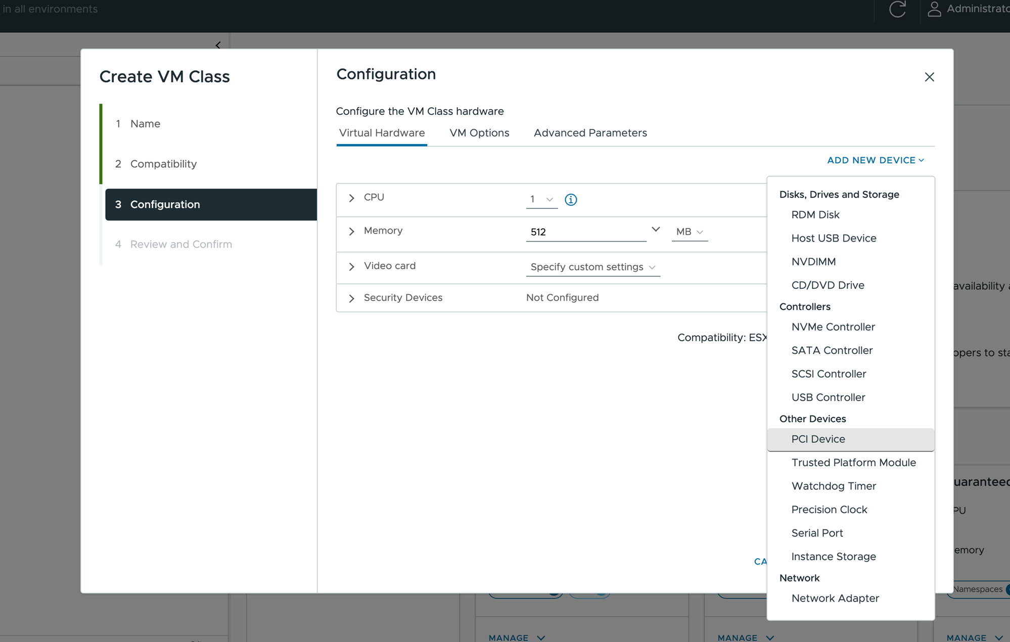
- From the list of available devices on the Device Selection page, select the NVIDIA GRID vGPU and click Select.
The device appears on the Virtual Hardware page.
- Click the Advanced Parameters tab and set the parameters with the following attributes and values.
Parameter | Value
pciPassthru0.cfg.enable_uvm | 1
pciPassthru1.cfg.enable_uvm | 1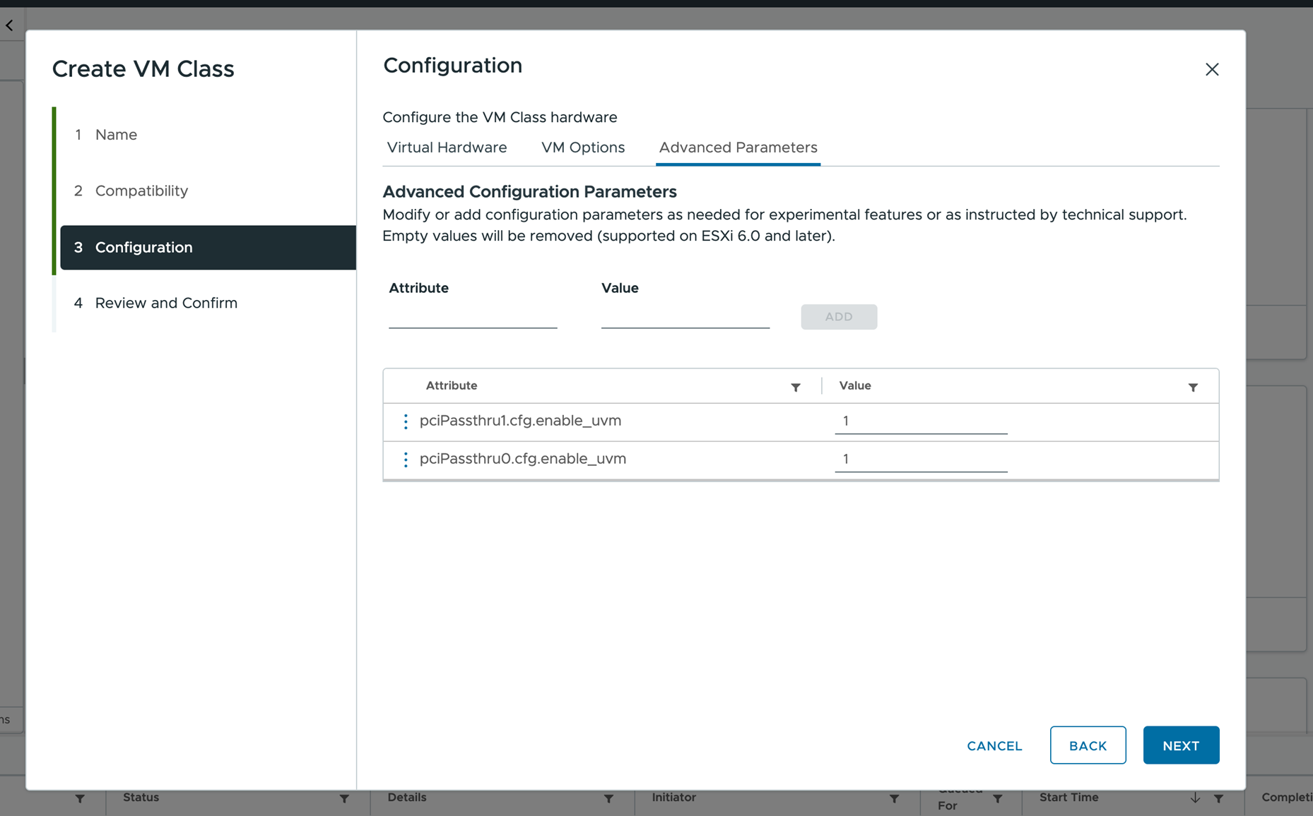
- Review your configuration and click Finish.
Results
A PCI Devices tag on the VM class pane indicates that the VM class is vGPU-enabled.
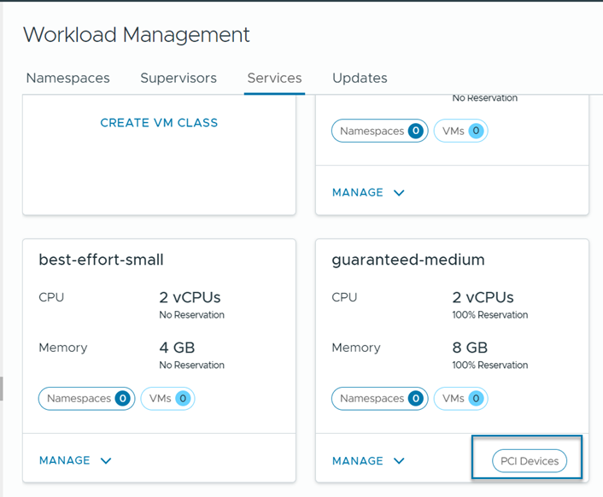

Add a vGPU Device to a VM Class Using Data Center CLI
In addition to the , you can use the Data Center CLI (DCLI) command to add vGPUs and advanced configurations.
For more information about DCLI commands, see Create and Manage VM Classes Using the Data Center CLI.
Procedure
- Log in to vCenter using the root user account and type dcli +i to use the DCLI in interactive mode.
- Run the following command to create a VM class.
In the following example, the my-class VM class includes two CPUs, 2048 of memory, and a VirtualMachineConfigSpec with two sample vGPUs profiles, mockup-vmiop-8c and mockup-vmiop. The extraConfig fields pciPassthru0.cfg.enable_uvm and pciPassthru1.cfg.enable_uvm are set to 1.
dcli +i +show-unreleased com vmware vcenter namespacemanagement virtualmachineclasses create --id my-class --cpu-count 2 --memory-mb 2048 --config-spec '{"_typeName":"VirtualMachineConfigSpec","deviceChange":[{"_typeName":"VirtualDeviceConfigSpec","operation":"add","device":{"_typeName":"VirtualPCIPassthrough","key":20,"backing":{"_typeName":"VirtualPCIPassthroughVmiopBackingInfo","vgpu":"mockup-vmiop-8c"}}},{"_typeName":"VirtualDeviceConfigSpec","operation":"add","device":{"_typeName":"VirtualPCIPassthrough","key":20,"backing":{"_typeName":"VirtualPCIPassthroughVmiopBackingInfo","vgpu":"mockup-vmiop"}}}],"extraConfig":[{"_typeName":"OptionValue","key":"pciPassthru0.cfg.enable_uvm","value":{"_typeName":"string","_value":"1"}},{"_typeName":"OptionValue","key":"pciPassthru1.cfg.enable_uvm","value":{"_typeName":"string","_value":"1"}}]}'

Install the NVIDIA Guest Driver in a VM
If the VM includes a PCI device configured for vGPU, after you create and boot the VM in your environment, install the NVIDIA vGPU graphics driver to fully enable GPU operations.
Prerequisites
- Deploy the VM with vGPU. Make sure that the VM YAML file references the VM class with vGPU definition. See Deploy a Virtual Machine on a Namespace in a Supervisor.
- Verify that you downloaded the vGPU software package from the NVIDIA download site, uncompressed the package, and have the guest drive component ready. For information, see the appropriate NVIDIA Virtual GPU Software documentation.
Note The version of the driver component must correspond to the version of the vGPU Manager that a vSphere administrator installed on the host.
Procedure
- Copy the NVIDIA vGPU software Linux driver package, for example, NVIDIA-Linux-x86_64-version-grid.run, to the guest VM.
- Before attempting to run the driver installer, terminate all applications.
- Start the NVIDIA vGPU driver installer.
sudo ./NVIDIA-Linux-x86_64-version-grid.run
- Accept the NVIDIA software license agreement and select Yes to update the X configuration settings automatically.
- Verify that the driver has been installed.
For example,
~$ nvidia-smi
Wed May 19 22:15:04 2021
+-----------------------------------------------------------------------------+
| NVIDIA-SMI 460.63 Driver Version: 460.63 CUDA Version: 11.2 |
|-------------------------------+----------------------+----------------------+
| GPU Name Persistence-M| Bus-Id Disp.A | Volatile Uncorr. ECC |
| Fan Temp Perf Pwr:Usage/Cap| Memory-Usage | GPU-Util Compute M. |
| | | MIG M. |
|===============================+======================+======================|
| 0 GRID V100-4Q On | 00000000:02:00.0 Off | N/A|
| N/AN/AP0 N/A/ N/A| 304MiB / 4096MiB | 0% Default |
| | | N/A|
+-------------------------------+----------------------+----------------------+
+-----------------------------------------------------------------------------+
| Processes: |
| GPU GI CI PID Type Process name GPU Memory |
| ID ID Usage |
|=============================================================================|
| No running processes found |
+-----------------------------------------------------------------------------+

Deploying a VM with PCI Devices in Supervisor Environment
In addition to vGPU, you can configure other PCI devices on an host to make them available to a VM in a passthrough mode.
Supervisor environment supports Dynamic DirectPath I/O devices. Using Dynamic DirectPath I/O, the VM can directly access the physical PCI and PCIe devices connected to a host. You can use Dynamic DirectPath I/O to assign multiple PCI passthrough devices to a VM. Each passthrough device can be specified by its PCI vendor and device identifier.
Note When configuring Dynamic DirectPath I/O for PCI passthrough devices, connect the PCI devices to the host and mark them as available for passthrough. See Enable Passthrough for a Network Device on a Host in the vSphere Networking documentation.

Deploying a VM with Instance Storage in vSphere Supervisor
Along with persistent storage volumes, a VM can use instance storage. Unlike persistent volumes that exist separately from the VM, instance storage volumes depend on the lifecycle of a VM instance. This storage is typically located on high-speed devices, such as NVMe, that are local to the host.

Instance Storage Lifecycle
At the VM creation, the system creates instance storage volumes and attaches them to the VM. Data in the instance storage volume persists only during the lifetime of its associated VM instance. The volume is deleted when the VM is deleted.
VMs with instance storage support host maintenance mode. The VM is turned off when the host enters maintenance mode and is turned on after the host exits maintenance mode.

Instance Storage VM Considerations
Consider the following items when you use VMs with instance storage:
- Supervisor with a VDS networking stack does not support instance storage.
- Three-zone Supervisor does not support instance storage.
- A warning appears if a vSphere administrator applies a VM class with instance storage to a namespace that misses an appropriate storage policy required for the instance storage.
- VMs with instance volumes cannot migrate to other hosts.
- You cannot edit the instance storage volumes when the volumes are already in use.
- If the vSphere administrator removes the instance storage policy from the namespace after the VM creation, the VM continues to run.
- As the DevOps engineer, you cannot delete or update instance storage resources. You cannot detach the instance storage volume from one VM instance and attach it to a different instance.

Workflow for Provisioning and Monitoring an Instance Storage VM
Step | Performed by | Description
1 | vSphere administrator | Creating and Managing Content Libraries for Stand-Alone VMs in vSphere Supervisor
2 | vSphere administrator | Create a vSAN Direct datastore.
3 | vSphere administrator | Create a storage policy compatible with vSAN Direct and assign it to the namespace.
4 | vSphere administrator | Create an instance storage VM class and assign it to the namespace.
5 | DevOps engineer | Provision a VM with instance storage in the namespace.
6 | vSphere administrator | Monitor Virtual Machines Available in vSphere Supervisor

Create a Datastore
As a vSphere administrator, set up a datastore to be used with such functionality as platform or VM instance storage. To create the datastore, use unclaimed storage devices local to your host.
You can create the datastore when enabling for your . The following task shows how to claim local storage devices as when is already enabled on the cluster.
Procedure
- In the , navigate to the cluster.
- Click the Configure tab.
- Under , click Disk Management.
- Click Claim Unused Disks.
- On the Claim Unused Disks dialog box, click the vSAN Direct tab.
- Select a device to claim and select a check box in the Claim for vSAN Direct column.
Note If you claimed the devices for a regular vSAN datastore, these devices do not appear in the vSAN Direct tab.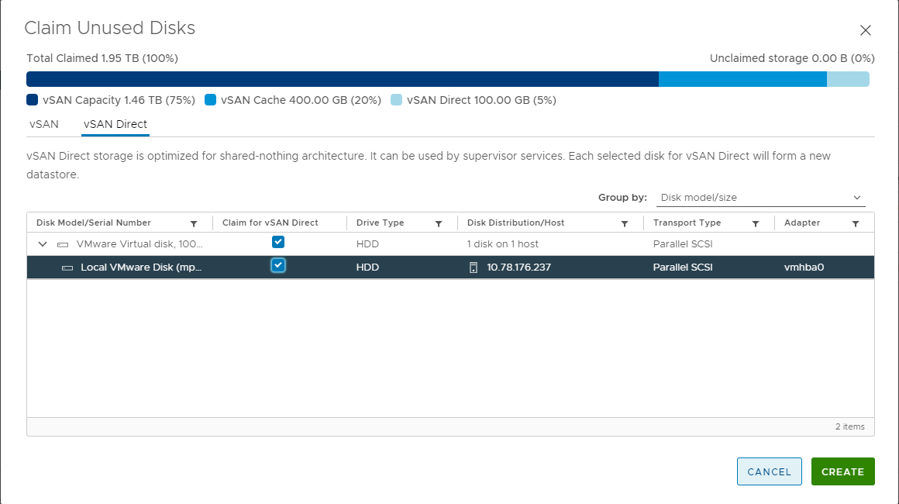
- Click Create.
For each device you claim, creates a new datastore.
- Click the Datastores tab to display all datastores in your cluster.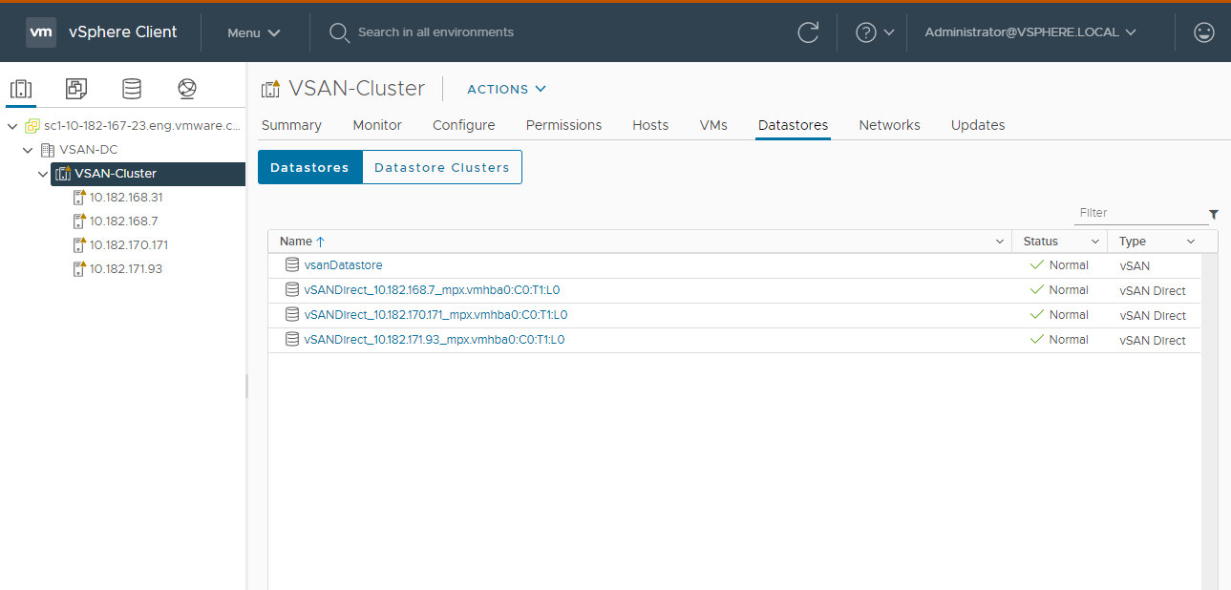

Create Storage Policy
If you use , create a storage policy to be used with a namespace. On the namespace that you associate with this storage policy, you can run workloads compatible with , for example, stateful services or instance storage VMs.
Procedure
- In the , open the Create VM Storage Policy wizard.
  - In the Home menu, click Policies and Profiles.
  - Under Policies and Profiles, click VM Storage Policies.
  - Click Create.
- Enter the policy name and description.
Option | Action
vCenter | Select the instance.
Name | Enter the name of the storage policy.
Description | Enter the description of the storage policy.
- On the Policy structure page under Datastore specific rules, enable rules for storage placement.
- On the vSAN Direct rules page, specify as a storage placement type.
- On the Storage compatibility page, review the list of datastores that match this policy.
- On the Review and finish page, review the storage policy settings and click Finish.
To change any settings, click Back to go to the relevant page.

Create a VM Class with Instance Storage
In the VM class, you reference the vSAN Direct storage policy and set the size of the volumes to be used for instance storage. After you create the VM class, assign it to the namespace that you plan to use for the instance storage VM.
Prerequisites
- Create a storage policy compatible with the vSAN Direct datastore.
- Add the vSAN Direct storage policy to the namespace you use for the instance storage VM. For information, see the Supervisor documentation.
- Required privileges:
  - Namespaces > Modify cluster-wide configuration
  - Namespaces > Modify namespace configuration
  - Virtual Machine Classes > Manage Virtual Machine Classes
Procedure
- Add instance storage when you create or edit a VM class.
Option | Action
Create a VM class | - From the home menu, select Supervisor Management.  - Click the Services tab and click Manage on the VM Service card.  - On the VM Service page, click Create VM Class.  - Configure the VM Class as needed, see Edit a VM Class Using the for the available options.  - To add instance storage, on the Configuration page, select Virtual Hardware then select Add New Device > Instance Storage.  The Instance Storage option appears in Virtual Hardware.
Edit an existing VM class | - From the home menu, select Supervisor Management.  - Click the Services tab and click Manage on the VM Service pane.  - On the VM Service page, click VM Classes.  - In the existing VM class card, click Manage and click Edit.  - To add instance storage, select Virtual Hardware then select Add New Device > Instance Storage.  The Instance Storage option appears in Virtual Hardware.
- Expand the Instance Storage option to edit the instance storage settings.
Option | Action
Storage Policy | Select the vSAN Direct storage policy.
Volume | Specify the size of the volume. You can add multiple storage volumes.
- On the Review and Confirm page, review the details and click Finish.
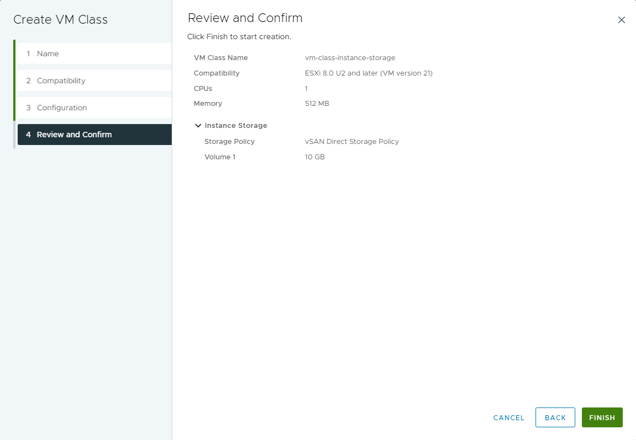
- Assign the VM class you created to the namespace you use for the instance storage VM.
See Associate a VM Class with a Namespace Using the.

Deploy a VM with Instance Storage
As a DevOps engineer, verify that you can access VM resources necessary to create an instance storage VM. Use the resources to deploy the VM.
When you deploy the instance storage VM, you follow general VM deployment steps. See Deploying a Stand-Alone VM in vSphere Supervisor. This procedure covers additional specific items that apply to the instance storage VM.
Procedure
- Verify the following items specific to the instance storage VM:
  - Your namespace includes the storage class compatible with the vSAN Direct datastore.
  - The instance storage VM class references this storage class.
When reviewing details of the instance storage VM class, make sure that it includes the instanceStorage section.
kubectl describe virtualmachineclassesvm-class-instance-storage
apiVersion: vmoperator.vmware.com/v1alpha2
kind: VirtualMachineClass
metadata:
name: vm-class-instance-storage
spec:
hardware:
cpus: 8
memory: 64Gi
devices:
...
instanceStorage:
storageClass: vsan-direct
volumes:
- size: 256Gi
- size: 512Gi
...
  - The VM YAML file points to the appropriate instance storage VM class.

Deploy VMs with Configurable OVF Properties in vSphere Supervisor
Typically, when a DevOps engineer provisions a VM in the Supervisor environment, an OVF template includes hard coded details such as basic network configuration. However, you might not know and often cannot assign certain values to the VM's OVF properties, such as such as IPAM provided network data, until after the VM CR is created. With template strings support, you don’t need to know network information in advance. You can use Golang based templating to populate the OVF property values and configure the VM’s network stack.
Procedure
- Make sure that for all properties to be configured, your OVF file includes the ovf:userConfigurable="true" entry.
This entry enables the system to substitute networking value placeholders, such as nameservers and management IP, with real data after the data gets collected.
Use the following example.
<Property ovf:key="hostname" ovf:type="string" ovf:userConfigurable="true" ovf:value="ubuntuguest">
<Description>Specifies the hostname for the appliance</Description>
</Property>
<Property ovf:key="nameservers" ovf:type="string" ovf:userConfigurable="true" ovf:value="1.1.1.1, 1.0.0.1">
<Label>2.2. DNS</Label>
<Description>A comma-separated list of IP addresses for up to three DNS servers</Description>
</Property>
<Property ovf:key="management_ip" ovf:type="string" ovf:userConfigurable="true">
<Label>2.3. Management IP</Label>
<Description>The static IP address for the appliance on the Management Port Group in CIDR format (Eg. ip/subnet mask bits). This cannot be DHCP.</Description>
</Property>
- Create the VM YAML file with template strings.
The template strings for bootstrap resources will collect the data necessary to populate the OVF property values.
You can use one of the following methods to construct template strings.
  - Use vm-operator-api.
For more information, see the following page on GitHub: https://github.com/vmware-tanzu/vm-operator/blob/main/api/v1alpha2/virtualmachinetempl_types.go.
The following is a sample YAML file:
apiVersion: vmoperator.vmware.com/v1alpha2
kind: VirtualMachine
metadata:
name: template-vm
namespace: test-ns
annotations:
vmoperator.vmware.com/image-supported-check: disable
spec:
className: best-effort-xsmall
imageName: vmi-xxxx0000
powerState: poweredOn
storageClass: wcpglobal-storage-profile
vmMetadata:
configMapName: template-vm-1
transport: vAppConfig
---
apiVersion: v1
kind: ConfigMap
metadata:
name: template-vm-1
namespace: test-ns
data:
nameservers: "{{ (index .v1alpha2.Net.Nameservers 0) }}"
hostname: "{{ .v1alpha2.VM.Name }} "
management_ip: "{{ (index (index .v1alpha2.Net.Devices 0).IPAddresses 0) }}"
management_gateway: "{{ (index .v1alpha2.Net.Devices 0).Gateway4 }}"
  - Use the following functions.
Function name | Signature | Description
V1alpha2_FirstIP | func () string | Get the first non-loopback IP from first NIC.
V1alpha2_FirstIPFromNIC | func (index int) string | Get non-loopback IP address from the ith NIC. If index is out of bound, template string will not be parsed.
V1alpha2_FormatIP | func (IP string, netmask string) string | Format an IP address with network length. A netmask can be either the length, for example, /24, or the decimal notation, for example, 255.255.255.0.  If input netmask is not valid or different from the default mask, it will not be parsed.
V1alpha2_FormatNameservers | func (count int, delimiter string) string | Format the first occurred count of nameservers with specific delimiter. A negative number for count means all nameservers.
V1alpha2_IP | func(IP string) string | Format a static IP address with default netmask CIDR.  If IP is not valid, template string will not be parsed.
V1alpha2_IPsFromNIC | func (index int) []string | List all IPs from the ith NIC.  If index is out of bound, template string will not be parsed.
If you use the functions, the YAML file looks like the following:
apiVersion: vmoperator.vmware.com/v1alpha2
kind: VirtualMachine
metadata:
name: template-vm
namespace: test-ns
spec:
className: best-effort-xsmall
imageName: vmi-xxxx0000
powerState: poweredOn
storageClass: wcpglobal-storage-profile
vmMetadata:
configMapName: template-vm-2
transport: vAppConfig
---
apiVersion: v1
kind: ConfigMap
metadata:
name: template-vm-2
namespace: test-ns
data:
nameservers: "{{ V1alpha2_FormatNameservers 2 \",\" }}"
hostname: "{{ .v1alpha2.VM.Name }} "
management_ip: "{{ V1alpha2_FormatIP \"192.168.1.10\" \"255.255.255.0\" }}"
management_gateway: "{{ (index .v1alpha2.Net.Devices 0).Gateway4 }}"
- Deploy the VM.
kubectl apply -f file_name.yaml
What to do next
If the customization fails and the VM does not get an IP address, inspect the VM using the vSphere VM web console. See Troubleshoot VMs Using the vSphere VM Web Console.

Import VMs into vSphere Supervisor
As a vSphere administrator, you can import an existing VM that runs in your vSphere environment into a namespace on Supervisor and have this VM managed by VM Service.
Prerequisites
Required privilege: Namespaces.View, Namespaces.Edit, and VirtualMachine.Supervisor.Transfer.
Procedure
- In the , navigate to the VM you want to import.
- Select Migrate from the right-click menu, and select Change Management Layer.
- Review the VM to be migrated, and click Next.
- On the Select destination page, select the destination namespace.
- On the Configure inputs page, select appropriate storage policy, network and guest OS inputs.
- Verify that the destination information is correct and click Finish to start the migration.

Monitor Virtual Machines Available in vSphere Supervisor
As a vSphere administrator, use the to monitor a VM that was deployed by DevOps in the Supervisor Kubernetes environment.
You cannot manage the VM lifecycle from the .
Prerequisites
A DevOps engineer has deployed a VM. See Deploying a Stand-Alone VM in vSphere Supervisor.
Procedure
- In the , navigate to the host cluster that has the Supervisor enabled.
- Under Namespaces, expand the namespace where a VM was deployed.
- Select the VM to view and click the Summary tab.
Make sure that you see the Developer Managed tag at the top of the Summary page.
The page displays information about the VM, including its guest OS and IP addresses.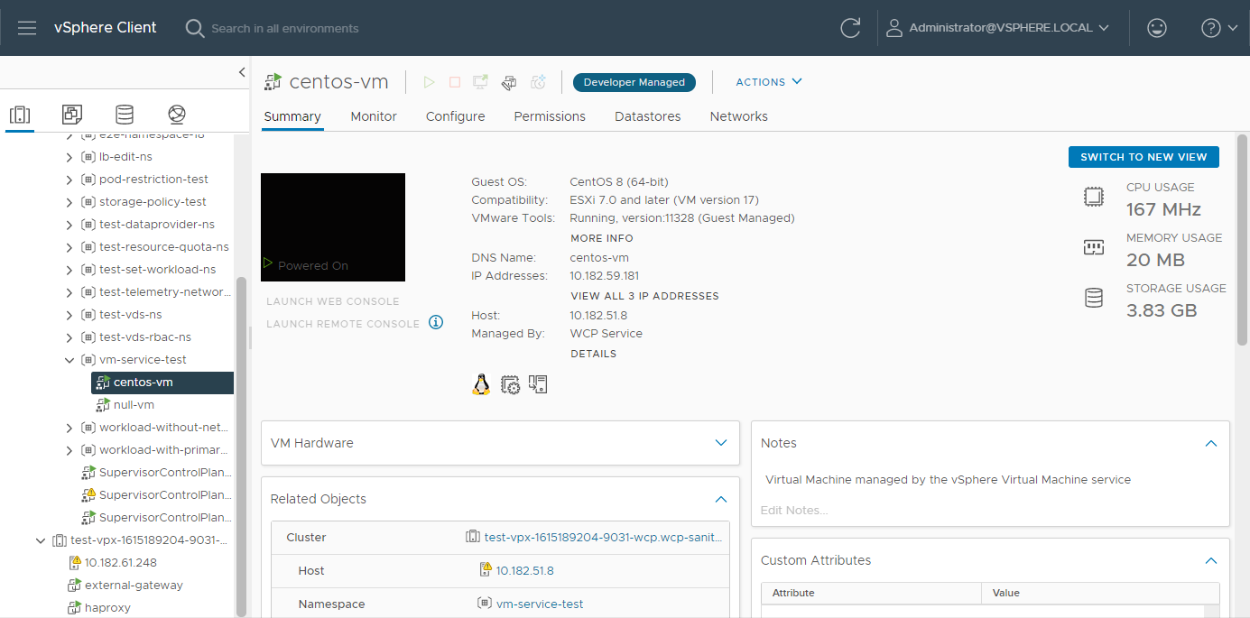
- Click Switch to New View in the upper-right corner of the page to display additional details such as the VM class and VM image, as well as the namespace, where the VM runs.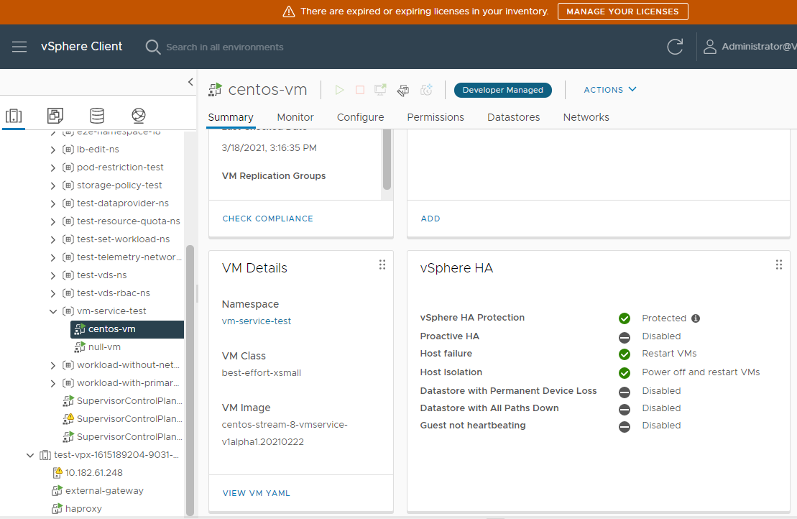

Troubleshoot VMs Using the vSphere VM Web Console
As a DevOps engineer, you can use the vSphere VM web console to access and troubleshoot problematic VMs. Using the VM web console can be helpful when VMs are not accessible through the normal network, for example, when the guest OS failed to configure the correct network settings during first boot.
The VM web console becomes especially useful when you deploy VMs with configurable OVF properties. For more information, see Deploy VMs with Configurable OVF Properties in vSphere Supervisor.
Prerequisites
Have edit or owner permissions on the namespace where the problematic VM is deployed. For information, see the Supervisor documentation.
Procedure
- Access your namespace in the Kubernetes environment.
See Connecting to Supervisor and VKS Clusters.
- Verify that the VM is deployed.
kubectl get vm -nnamspace-name
The output is similar to the following:
NAME POWERSTATE AGE
vm-name poweredOn 175m
- Obtain the URL to the VM web console.
kubectl vsphere vm web-consolevm-name-nnamspace-name
Note The command returns an authenticated URL to the VM's web console as output. If you don't use the URL within a non-changeable period of time, set to two minutes, the URL expires. After you open the URL to connect to the web console page, the session time is controlled by WebMKS and lasts longer.
- Click the URL and perform any necessary troubleshooting actions for your VM.

References
The following section lists the documentation resources which were used for this document.

References
For more information, see the following supplemental configuration and administration guides, white papers and best practices documents.

VMware Pro Cloud Services for Private Cloud Solution References
Remember Refine or add any additional links to product documentation
See the VMware Cloud Foundation Documentation (https://techdocs.broadcom.com/us/en/vmware-cis/vcf/vcf-9-0-and-later/9-0.html) for product documentation for Cloud Foundation.
The information is arranged by topics that include the following:
- VMware Cloud Foundation 9.0 Release Notes
- VMware Cloud Foundation Planning and Preparation Workbook
- VMware Cloud Foundation Design Guide
- VMware Cloud Foundation Deployment, Convergence and Upgrade Guide
- VMware Cloud Foundation Building Cloud Infrastructure Guide
- VMware Cloud Foundation vSphere Guide
- VMware Cloud Foundation vSAN Guide
- VMware Cloud Foundation NSX Guide
- VMware Cloud Foundation Lifecycle Management Guide
- VMware Cloud Foundation Fleet Management Guide
- VMware Cloud Foundation Infrastructure Operations Guide
- VMware Cloud Foundation Workload Monitoring and Observability Guide
- VMware Cloud Foundation vSphere Supervisor Platform Guide
- VMware Cloud Foundation Security and Compliance Guide
- VMware Cloud Foundation API Reference Guide
VMware Validated Solutions Guides:
- <Add as apporpriate>

